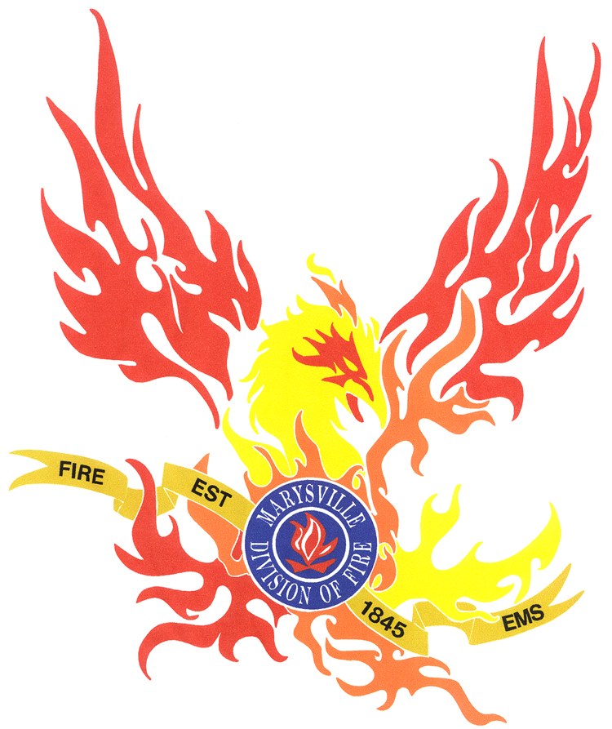

MARYSVILLE DIVISION OF FIRE

HEALTH AND PHYSICAL FITNESS PROGRAM

MARYSVILLE DIVISION OF FIRE
HEALTH AND FITNESS PROGRAM

Purpose

- To establish guidelines for all employees given pre-employment physical examinations by Occupational Health and successive exams as required by contract.
- To establish administrative and operational guidelines for the Marysville, Division of Fire’s Health and Fitness Program, designed to monitor and preserve the health and fitness of all division employees.
- To provide health and fitness guidelines to each affected employee.

Policy
The ultimate goal of the health and fitness program is to develop and maintain a physically fit force capable of responding to, and effectively and safely carrying out, their job responsibilities. During the 12-month period extending from December 15, 2002 through December 14, 2003, all uniformed members of the Marysville, Division of Fire will participate in a mandatory/non-punitive/Health and Fitness Program. The program requires the active participation of all members during their scheduled duty hours, to engage in some form of physical activity for a minimum of 30 minutes. 40-Hour personnel will participate in this manner every third duty day. This activity may include cardiovascular exercise, simple calisthenics, and/or weight training that contributes to the improved health and fitness level of the individual.

MARYSVILLE DIVISION OF FIRE

HEALTH AND FITNESS PROGRAM (HFP)

TABLE OF CONTENTS

- HFP Overview
- Overview of the HFP
- Scheduling of evaluations
- Medical deferrals
- BWC coverage
- HFP ancillary services
- Fitness incentive pay
- Fitness ribbon
- HFP evaluation process

- Physical Examinations
- Pre-employment physical exams
- Physical Exams during employment
- Physical Fitness Evaluations

- Compliance

MARYSVILLE DIVISION OF FIRE

HEALTH AND FITNESS PROGRAM

I. HFP OVERVIEW

The Marysville, Division of Fire’s Health and Fitness Program is designed to address the issue of good health and physical fitness for Firefighter/EMTs.

The objective of the program is to support and assist firefighters in the maintenance of good health and fitness by providing a periodic evaluation and assessment of their general physical condition.

The HFP is intended to be a four-phase program. The Fitness Development Phase, Stress Management Phase, Nutrition Phase, and Evaluation Phase will provide information that will assist firefighter/EMTs in the maintenance of good health and fitness.

It is an accepted fact in the medical community that one of the best recipes for continued health and fitness includes a combination of diet and exercise. Therefore, this policy provides information concerning the proper approach to eating and exercising as it relates to general health, physical fitness, and stress control.

The key to good health ad fitness lies in lifestyle. There is not a great deal that others can do to improve a firefighter/EMTs level of health and fitness. Each employee has an individual responsibility to maintain a level of fitness that permits him/her to carry out job responsibilities and safely handle any situation that may arise. More importantly, Firefighter/EMTs have a responsibility to their families when it comes to day-to-day safety and longevity.

The acceptance of this responsibility involves a commitment from each firefighter/EMT. Unfortunately, good health and fitness do not “just happen”; therefore, personal goals must be established and effort must be put forth to achieve them. A fitness plan, which includes goals in the areas of diet, exercise, and weight control, will pay great dividends if carried out.

This policy is also designed to assist and support firefighter/EMTs in establishing a health and fitness plan and carrying out the plan. The positive results will benefit the Division and the citizens of Marysville by ensuring a physically fit and well-trained force that is ready to respond to any situation. Each Firefighter/EMT will benefit from the additional safety factor that is present when one is physically fit. In addition, Firefighter/EMTs will be better able to perform day-to-day duties with a reduction of stress. Families of firefighter/EMTs will benefit from a continued level of health and fitness, which should contribute to a more positive and productive lifestyle, as well as a longer life.

In order to accomplish the goals of this program, each shift will have an appointed “Fitness Coordinator”. These personnel will be trained to the Peer Fitness Trainer Certification level. This certification has been approved by the IAFF/IAFC Joint Task Force. They will work with the shift officer to plan and oversee the fitness program on each shift. The trainer will work with each individual on a shift to develop a fitness training program specifically suited to his /her needs. After each evaluation, the trainer will go over the results with each individual on the shift and make recommendations for future fitness goals.

The Shift Fitness Coordinator (SFC) will develop and teach classes on nutrition and stress management. When funds are available, outside experts will be brought in to teach additional courses in these areas.

Scheduling Physical Fitness Evaluations

All personnel will be evaluated yearly during the month of September. Any firefighter/EMT may request a fitness evaluation at any time to evaluate his/her progress. The results of the best evaluation will be used as a basis for each firefighter/EMTs performance evaluation.

Medical Deferrals

When an employee is requesting a medical deferral for any portion of the fitness evaluation, the employee will submit a letter from his/her personal physician as to the reason for the deferral. Minimum information this letter should include would consist of the following:
    - Medical reason for the deferral.
    - Is the illness or injury chronic or acute
      - Acute – employee will recover with rehabilitation
      - Chronic – employee will never be able to perform a specific portion of the evaluation

If “Acute”, the individual will take that portion of the Fitness Evaluation when the injury has been rehabilitated or the illness cured. If “Chronic”, that station in the Fitness Evaluation will receive a 0% which will used to determine the overall fitness score. In addition to this policy, refer to other Division directives, labor agreements, and Rules and Regulations for applicable controlling language.

Bureau of Worker Compensation (BWC) Coverage

BWC coverage is applicable when firefighter/EMTs are engaged in any of the activities of the HFP while on duty.

BWC coverage is not applicable when engaged in any off-duty activities.

HFP Ancillary Services

The following services/equipment are available during specified hours at Station 271 to all City of Marysville employees.

- Physical Training and Exercise Equipment
- Blood pressure level check
- Pulse rate check
- Fitness trainer consultation

These services are subject to the availability of trained staff and will not be unreasonably denied nor will unreasonable requests be approved. Any use of these services by other than Division of Fire personnel is strictly voluntary and highly recommended.

Fitness Incentive Pay

The results of the Physical Fitness Evaluation in September 2003 will be used to determine incentive pay for the one time payout of grant funds specifically earmarked for that purpose. ($5,000)

Need final methodology/determination of incentive distribution.

Fitness Ribbon

Any firefighter/EMT who attains or surpasses the 60th percentile in an average of all seven stations of the Physical Evaluation will be eligible to receive the fitness ribbon. The 60th percentile is referred to in the Employee Performance Plan as the “Excellent” level.

In addition to the fitness ribbon, the fitness star will also be awarded to all who attain or surpass the 80th percentile in all seven areas. This level of fitness is referred to as the “Outstanding” level.

The Fitness Ribbon and Fitness Ribbon w/Star will be worn on the Class A uniform. This ribbon will rank in order of appearance on the uniform between the Medal of Merit and the Distinguished Service Award.

II. PHYSICAL FITNESS EVALUATIONS AND PHYSICAL EXAMINATIONS

Pre- Employment Physical Examinations

All applicants for the position of Firefighter/EMT whether Full-Time or Part-Time, after being offered the position, will be examined by a physician designated by the Division (Occupational Health). There will be no cost to the applicant for the examination.

The extent of the pre-employment physical exam will be determined by Division management in accordance with NFPA standards and OP&F rules.

Physical Examinations During Employment

Any physical examinations required of an employee after successful completion of his/her probationary period will in accordance with the current collective bargaining agreement between the City of Marysville and Local 3032 IAFF.

Physical Fitness Evaluations

Each employee will receive a Physical Fitness Evaluation annually in the month of September. Additional evaluations may be required to address issues with an individual’s performance evaluation. This evaluation will include the following:

- Step Test
- Bench Press
- Leg Press
- Sit Ups
- Push Ups
- Flexibility
- 1.5 mile run

The results of the evaluation will be based on the “Methods and Norms by the Institute of Aerobic Research”, which has been established and extensively researched throughout the U.S. by Dr. Cooper, the author. The results of this evaluation allow for age and gender in their computations.

These approved methods are used to evaluate each firefighter/EMTs Physical Fitness in the following four phases:

- Cardiovascular
- Strength
- Endurance
- Flexibility

Standards for all phases are categorized according to gender and age.

The percentage score for each of the seven events will be added together and divided by seven to come up with the overall Physical Fitness Score. This overall score will be used as the basis for rating the physical fitness job tasking on the annual performance evaluation.

Phase One: Cardiovascular Fitness

Cardiovascular fitness is determined by the 1-½ mile run and the step test. Current run test standards are stringent. Walk test is permitted under standard. Membership to choose one.

Phase Two: Strength

Upper body and lower body or leg strength are two primary components of physical fitness. The absolute strength will be determined by one repetition maximal bench press and leg press performed according to established protocol.

The bench press and leg press quantities represent the percentage of an individual firefighter/EMTs body weight.

Phase Three: Endurance

Endurance will be determined by counting the number of sit ups and push ups successfully attempted in 60 seconds. The sit-ups and push-ups will be performed according to established protocol.

Phase Four: Flexibility

A Thorough analysis of flexibility includes measurement of joint angles. The Division is most concerned with the flexibility of the lower back area. The standard measurement technique for this is the sit and reach test, which is conducted by established protocol.

III. COMPLIANCE

The shift officer on a daily basis will approve the prescribed time, so that the physical activity coincides with the priorities of the shift. When allowing personnel to work out during normal work hours (0730 to 1600), the shift officer will allow 60 minutes to complete the 30 minutes minimum physical activity required. This will allow the individual 10 minutes for dressing down for the workout, 30 minutes of actual physical activity, and 20 minutes to shower, dress, and return to duty. At no time will personnel be allowed to lounge in their workout clothing after physical fitness training. Personnel that meet the minimum requirement should be scheduled to work out during normal duty hours when practical. Personnel that normally work out for longer periods should be scheduled to work out after all the days mission requirements have been met. It is the responsibility of the shift officer and the Unit Fitness Coordinator to insure that all physical fitness training is properly performed and recorded.

The shift officer will have total control of scheduling physical fitness activities. The shift officer will make every attempt to insure that all personnel on duty are given the opportunity to perform their mandatory physical fitness activity. Requests for physical fitness activity time will not be unreasonably denied nor will unreasonable requests be approved. He will use the following as a guide to make scheduling decisions, prioritized as listed in the order below:

Fire and EMS runs will take precedence over all other activities.
Equipment Checks will take precedence over other activities.
At this point, the shift officer can start breaking off personnel
in groups of no less than two to work out, so long as it does
not interfere with his ability to complete the remaining shift
priorities.
Station maintenance will take precedence over other activities.
Fire and EMS training will take precedence over other activities.
Mission specific extra duties will take precedence over other activities.
Physical Fitness Training will take precedence over other activities.

At no time will physical fitness activity be scheduled after 2100 hours. The shift officer will be responsible for insuring that every firefighter/EMT that works any part of his physical fitness duty day (0700 to 2100) takes part in a minimum of 30 minutes of physical fitness activity.

At no time will an individual be pulled out of a fitness workout session to take a run when there are qualified personnel on station, that are not working out, that can take that run. The shift officer will insure that equipment assignments are covered.

