PASSWORD PROCEDURE

PURPOSE:
The purpose of this procedure is to provide guidelines for setting or changing passwords with consideration given to the security of user level accounts, web accounts, email accounts, screen saver protection and voicemail as referred to in the Computer User Policy section 3, Passwords.

DEFINITION:
Password: A secret word or code used to serve as a security measure against unauthorized access to data. The password is managed by the Server and workstation operating system. However, the computer can only verify the legitimacy of the password, not the legitimacy of the user.

PROCEDURE:
- All network passwords must be at least eight characters in length.
- All network passwords are forced to be changed every 90 days by default.
- We advise users to change their password when they receive notice that it has expired and there are six grace logins remaining.
- Passwords must not be inserted into email messages or other forms of electronic communication.
- All user-level and system-level passwords must conform to the guidelines described below.
  - PASSWORD CONSTRUCTION GUIDELINES:
Passwords are used for various purposes at the City of Airdrie. Some of the more common uses include: user level accounts, web accounts, email accounts, screen saver protection, and voicemail password.
Strong passwords have the following characteristics:
- Contains both upper and lower case characters (e.g., a-z, A-Z)
- Include numbers and punctuation characters as well as letters.
- At least eight characters long.
- Not words in any language, slang, dialect, jargon, etc.
- Not based on personal information, names of family, etc.
- Should never be written down or stored on-line. Try to create passwords that can be easily remembered. One way to do this is create a password based on a song title, affirmation, or other phrase. For example, the phrase might be: "This May Be One Way To Remember" and the password could be: "TmB1w2R!".
NOTE: Do not use either of these examples as passwords!

Page 1 of 4
Poor, weak passwords have the following characteristics:
- Less than eight characters
- A word found in a dictionary (English or foreign)
- A common usage word such as:
- Names of family, pets, friends, co-workers, fantasy characters, etc.
- Computer terms and names, commands, sites, companies, hardware, software
- The words “City of Airdrie”, "city", "airdrie" or any derivation
- Birthdays and other personal information such as addresses and phone numbers
- Word or number patterns like aaabbb, qwerty, zyxwvuts, 123321, etc.
- Any of the above spelled backwards
- Any of the above preceded or followed by a digit (e.g., secret1, 1secret)

- PASSWORD PROTECTION STANDARDS:
Do not use the same password for the City of Airdrie accounts as for other non-City of Airdrie access (e.g., personal ISP account, option trading, benefits, etc.). Where possible, don't use the same password for various City of Airdrie access needs.
Do not share City of Airdrie passwords with anyone, including administrative assistants. All passwords are to be treated as sensitive, confidential City of Airdrie information.
Following is a list of "don’ts":
- Don't reveal a password over the phone to ANYONE
- Don't reveal a password in an email message
- Don't talk about a password in front of others
- Don't hint at the format of a password (e.g., "my family name")
- Don't reveal a password on questionnaires or security forms
- Don't share a password with family members
- Don't reveal a password to co-workers while on vacation
If someone demands a password, refer them to this document or have them call the Information Systems Help Desk (ext 861).
Do not use the "Remember Password" feature of applications.
Again, do not write passwords down and store them anywhere in your office. Do not store passwords in a file on ANY computer system, including Palm Pilots or similar devices, without encryption.
Do not change your password remotely.
If an account or password is suspected to have been compromised, report the incident to Information Systems; then change all passwords.

Page 2 of 4
Password cracking or guessing may be performed on a periodic or random basis by Information Systems or its delegates. If a password is guessed or cracked during one of these scans, the user will be required to change it.

- HOW TO CHANGE YOUR PASSWORD:
- Sitting at the workstation that has your local profile, login to the network.
- On your keyboard, press and hold down the "Ctrl" and "Alt" keys then press the "Delete" key.
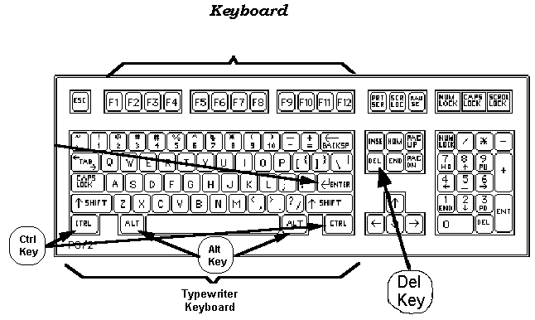

The Security window will open.
- Select the "Change Password" button in the bottom left corner.

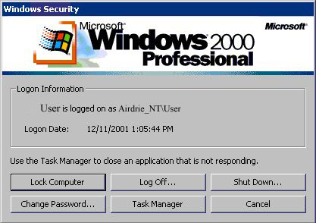
Page 3 of 4
- In the Change Password window, enter your old password
- DO NOT press “enter”, proceed using the “Tab” key or “mouse-click” to the next field.
- Enter your new password then confirm the new password.
- Press OK

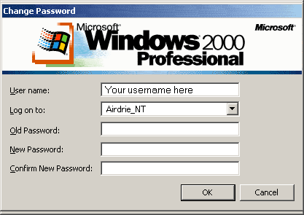

- There will be a pop up message confirming the password change has been successful; click OK.

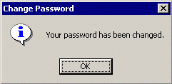

Page 4 of 4
Internet Access PROCEDURe

PURPOSE:
The purpose of this procedure is to provide guidelines and procedures for all staff who are deemed to require internet access to assist in the fulfillment of their position responsibilities and duties.
A further purpose of this policy is to make those persons responsible and accountable for the security and integrity of the corporate data and systems as referred to in the Computer User Policy section 5, Internet and Email.

DEFINITION:
Appropriate Use: Responsible, cooperative, community-minded behavior/use that protects the common good and promotes the legitimate goals of the City.
Inappropriate Use: Pornographic material (pictures, stories, etc), hate literature, propaganda, streaming video/audio/radio/stock ticker.
Personal/Recreational Use: Sports, entertainment, banking, employment

PROCEDURE:
- Employees must sign a User Agreement indicating their agreement to abide by the City’s regulations regarding its Internet use prior to the employee being granted access.
- Employees are allowed Internet access through the City for the purpose of City of Airdrie business during work hours.
- Employees are allowed Internet access through the City for personal/recreational use, except during work hours.
- Employees are not allowed Internet access through the City for inappropriate use at any time.
- Security of corporate data and resources is everyone’s responsibility – lock up, log out!
- Employees understand that information security and protection against viruses is crucial to the integrity of corporate data.
- Employees are allowed to download authorized files.
- Employees can update requests when prompted for; Media Player, Adobe, Quick Time. Employees are not allowed to accept any Windows related updates.
- Employees are not allowed to install any software at any time.
- Email must not contain password or security information.
- Email content should reflect appropriate business wording.
- Employees understand that email can contain viruses, email is not secure, and forwarded email can be altered.
Page 1 of 3
- Information Systems has the right to audit all Internet access through the City.
- Information Systems has the right to restrict Internet access to sites and other resources that contain inappropriate materials for employee use.
- Information Systems has the right to block email messages containing inappropriate words.
- Employees who breach the provisions outlined in the Internet Guidelines in any manner, will result in the following consequence:
- Team Leaders and Human Resources will be notified of the offence and the issue will be dealt with in accordance with the Personnel Policy, which may include denial of internet access for the individual or team.

EMAIL INFORMATION:
- Emails Live Forever. Deleting an email message from an account does not destroy the message. The email message does remain on the email server until it is eliminated. Only send emails that can live forever.
- Emails cannot be Controlled Once They Are Sent. Once emails are sent, there is no ability to control who sees them. Emails sent over the Internet cannot be “retrieved.” Always write emails assuming that they can be seen by anyone.
- The Internet/Email is a resource of the City of Airdrie. The Internet/Email is a valuable business asset. Personal/recreational use of the Internet is only allowed during non-working hours. All messages and files composed, sent or received using the Internet/Email are and remain the property of the City of Airdrie.
- Prohibited Uses of the Internet/Email. The general policies regarding employee communications also apply to communications made using the system. The Internet/Email should not be used to send, receive, store or display communications or files that:
- infringe any third party intellectual property or publicity/privacy right
- violate any law or regulation
- are defamatory, threatening, insulting, abusive or violent
- might be construed as harassing, derogatory, disparaging, biased or discriminatory based on a person’s age, sex, race, sexual orientation, religion, disability, national origin or any other protected classification
- are obscene, pornographic, harmful to minors, child pornographic, profane or vulgar
- contain any viruses, Trojan horses, worms, time bombs, cancelbots or other computer programming routines that are intended to damage, detrimentally interfere with, secretly intercept or expropriate any system, data or personal information, or
- are solicitations or advertisements for commercial ventures, religious or political causes, outside organizations or other non-job related activities. Under no circumstances may the Internet/Email be used to gain unauthorized access to third party resources.

Page 2 of 3
- Do Not Expect Privacy. Information Systems may access, read, monitor, intercept, copy and delete your communications; however, Information Systems would do so only when there is a legitimate business reason, for example, if suspecting any violation of law, breach of security, or violation of the policies. Communications may be disclosed to third parties if appropriate. Do not expect privacy in any email account or any communications on the Internet.
- Do Not Always Believe What Is Seen. Always evaluate the quality of information sources on the Internet. Since anyone can publish information on the Internet, do not assume that information available over the Internet is correct. If there are any doubts about the currency of material being viewed, please contact Information Systems.
- Help Maintain Security. Information Systems has measures in place to ensure network security but any network is not perfectly secure and is susceptible to break-ins. Therefore we need users help to maintain security.
- System Integrity. Do not use the System in a way that disrupts or degrades its performance, for example, attempting a large file download during peak usage periods. There are limits on the amount of data that can be stored on the System.
- City of Airdrie Communications. Every time an email is sent that contains our domain name (Airdrie.ca) or transmit files using our System, third parties may interpret these communications as official City of Airdrie communications or legally-binding statements of the City of Airdrie. Therefore, at minimum, avoid using the System to make any statements or take any action which might be interpreted as a press release or publicity statement without approval.
- Third Party Materials. Do not redistribute third party materials, particularly email attachments, without prior authorization by those third parties, Information Systems and, if necessary, our counsel. Articles, photos, graphics, sound files and other attachments are generally the intellectual property of some other party, in which case redistribution can create liability for the City. Do not assume that anything downloaded from the Internet is protected by intellectual property laws, and do not make further use without approval from Information Systems.

Page 3 of 3
Downloading Procedure

PURPOSE:
It may be necessary for users to download files from external sources to complete day to day activities. The purpose of this procedure is to make certain all users understand the risks involved and the procedures to follow to safely download files as referred to in the Computer Use Policy section 6, Workstation/System, Downloads.

DEFINITION:
Downloading: The process in which a computer receives data (save, copy, download) from an external source or the Internet.

Acceptable Downloads | Unacceptable Downloads
- Pictures  - Articles  - Microsoft Clipart  - Updates to; Adobe, Media Player, Quick Time | - Applications (Yahoo Messenger)  - All Executable (.exe)  - Media / Audio Players (RealPlayer)  - Browser Enhancements (skins)  - MP3’s / Movie Clips  - No Windows related updates

PROCEDURE:
To download a file from an external source, follow these instructions to decrease the risks or virus infection to the network.
- →Create a local Folder to receive the download.
- Double click My Computer →C: drive. When the C: Drive opens. Select File → New → Folder. When the New Folder is created, Name it Download.
- →Save the file download to disk in the local folder C:\Download.
- →Scanning for Viruses.
- Open the Download Folder. Right Click on the downloaded file. From the drop down menu, select “Scan for Viruses...”
- Open the new taskbar item. This is the Symantec AntiVirus window which will show the results of the virus scan.
- If the file is infected, the AntiVirus will display instructions on how to clean or delete the file.
- →Move the file to a Network drive.
- If application software needs to be downloaded from an external source, contact IS to assist. Contact Information System if any further clarification is required regarding what is safe or needs to be licensed.
Page 1 of 2
- Cautions and Risks:
- Downloading files from the Internet to a workstation could increase the risk of a virus infecting the system as well as the entire network
- Large downloads can overload the network bandwidth and increase the risk of systems failure
- Downloaded software may require a license to be purchased

Page 2 of 2
Remote Access Procedures

PURPOSE:
The purpose of this procedure is to ensure that guidelines are in place for remote access connection without violating the Computer Use Policy section 7, Remote Access.

DEFINITION:
Remote Access: Access to the corporate network from a remote location.

PROCEDURE FOR CITY EMPLOYEES:
- All employees requesting remote access must first be directed to their team leader who will in turn decide if the employee should receive remote access. Team leaders have a list of Core Value questions to ask. (see questions list)
- When remote access is approved by the team leader, the employee will be directed to the IS department. IS will give the employee the necessary paperwork to be completed and returned (see paperwork), as well as a list of technical questions to ask. (see questions list)
- Once the paperwork has been returned, the employee’s TS login will be activated and tested.
- After the testing, a training session will be scheduled on the employee’s local PC.
- The user will be provided with a training package.
- The employee is now ready for remote access.
PROCEDURE FOR VENDOR REMOTE ACCESS:
- All vendors requesting remote access, through employees, must be directed to the Information Systems department. They will contact the vendor to obtain the access details and forward the necessary documentation.

Page 1 of 1

Application Service Providers (ASP) Procedure

Purpose:
The purpose of this procedure is to ensure that only approved users and groups may use Application Service Providers as referenced in Computer Use Policy section 8, Application Service Providers.

DEFINITION:
Application Service Provider (ASP): Third-party companies that supply software applications and/or software-related services over the Internet.
- The ASP owns, operates and maintains the servers that run the application. The ASP also employs the people needed to maintain the application.
- The ASP makes the application available to customers everywhere via the Internet, either in a browser or through some sort of "thin client."
- The ASP bills for the application either on a per-use basis or on a monthly/annual fee basis. In many cases, however, the ASP can provide the service for free or will even pay the customer.

PROCEDURE:
  - If any employee requires the use of an ASP service or provider, please contact Information System.

Page 1 of 1

