2006 ICMA Annual awards program
community partnerships award submission

ENVIRONMENTAL EDUCATION and awareness program

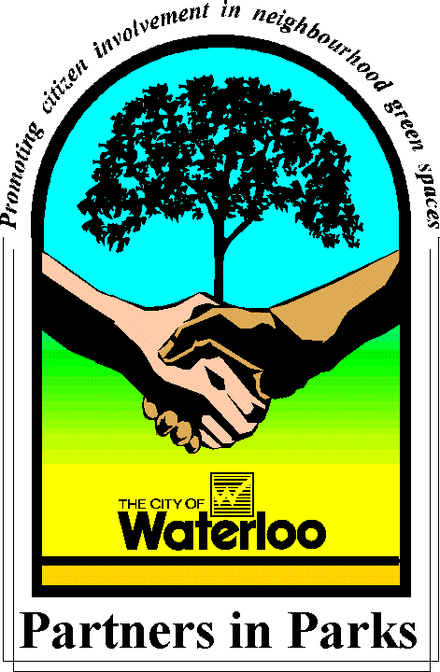
CITY OF WATERLOO
100 regina st s
waterloo
onTARIO, CANADA
n2j 4a8

ENVIRONMENTAL EDUCATION and awareness
- Problem assessment, the challenge or need that prompted the local government to develop the program
Providing an opportunity for the community to be involved in Waterloo’s greenspaces through the Environmental Education and Awareness Program has been a major strength of the City of Waterloo. This two part program includes Partners in Parks improvement projects and various environmental events which create public awareness, stewardship, and pride within our greenspaces in addition to monetary savings in operational activities.
Community partnerships are initiated through a program called Partners in Parks. Adopted in 1996, this program aims to encourage local residents in caring for their neighbourhood greenspaces through various improvement projects such as litter clean-ups and short or long-term planting and maintenance projects. This initiative was a pro-active approach in response to budget limitations and the need to increase community environmental awareness. Existing levels of maintenance are maintained by City staff, however, the Partners in Parks program provides an opportunity for Waterloo citizens to improve their local greenspace through these stewardship projects. To date, over 300 community partnerships have been developed within our community through this program.
In addition to the Partners in Parks program, the City of Waterloo organizes various environmental events including Earth Day, Arbor Day and Community Parks Week to create environmental awareness and education. A total of 28 special environmental events have been offered to Waterloo citizens since 1996.
How important are the services? Who benefited?
Positive public response towards involvement in the Partners in Parks program has substantially increased the number and types of projects available for the community since the program began 10 years ago. Waterloo citizens enjoy the improved aesthetics and health of their neighbourhood park, while playing a stewardship role. The cost savings for the municipality can be seen from community improvement of the parkland such as decreased amounts of litter, minor stream rehabilitation improvements and the contribution of additional plantings of native vegetation on public greenspace. A win-win situation is created through this program, whereby residents can carry out innovative projects with support of the municipality to achieve visible results.
By offering annual environmental events, we are able to create environmental awareness through various educational hands-on activities for the young and old alike. These fun-filled activities focus on a variety of environmental values and themes. Participants leave the events with knowledge and a sense of accomplishment that they have done something positive to improve our environment.
How has the program affected the lives of the service recipients?
The City of Waterloo’s Partners in Parks program provides an opportunity for environmentally-conscious citizens to play a role working in partnership with the municipality towards creating healthier, more aesthetically-pleasing greenspaces in Waterloo. Similarly, various environmental events offered free to the public contributes towards environmental awareness and action. The following community benefits are achieved through this program:
- Encourages volunteerism/community partnerships - working together to reach common goals
- Creates environmental awareness, understanding and respect for our natural amenities
- Creates a feeling of accomplishment, pride, and ownership in the community
- Creates community action and stewardship
- Improves the aesthetics of local parks for the enjoyment of neighbouring residents
- Support for volunteer initiatives is provided by the municipality through assistance with various resources, tools and technical advice
- Program Implementation and Cost
The following policies and programs have provided guidance and direction for the establishment and support of the Environmental Education and Awareness program:
Environment First Policy (1991) - The City of Waterloo is an “Environment First” community, which takes the environment into account during municipal operations. Several notable environmental accomplishments include the adoption of the Partners in Parks program.
Imagine! Waterloo (2000) - A community visioning process - “Imagine! Waterloo”, ranked the environment at the top of community values with “greening the city” as one of the key environmental directions.
Environmental Strategic Plan (2002) - Considerable discussion about the need to increase environmental awareness was outlined during the community brainstorming sessions and a number of key strategic actions focused on “greening our city” through community initiatives.
Environmental Land Acquisition Policy (1996) - This policy recommends implementing a public education and community awareness program in order to promote a sense of citizen stewardship through education and interpretation of environmental lands.
Urban Forestry Policy (1998) recognizes the importance of maintaining and expanding the urban forest due to the aesthetic, psychological, social and environmental benefits of trees. The Partners in Parks program and environmental events encourages planting native vegetation to assist in expanding our urban forest, with a target of increasing Waterloo’s forest cover from approximately 13.5% to 19%.
Program Costs
The Partners in Parks program involves hundreds of volunteers which contribute their time and efforts towards improvement projects on public parkland. The municipality provides a number of resources, tools and technical advice such as equipment, vehicles, and supplies for litter cleanups, planting events, and other activities in addition to staff support for planning and carrying out the project. Large projects require the community groups to obtain grant funding support. A minimal budget of $14,000 for the Environmental Education and Awareness Program is provided, in addition to one full-time staff person. Sponsorships and grant funding up to approximately $25,000 is provided to assist with the purchase of vegetation, equipment and other supplies, particularly for the environmental events. The Partners in Parks program and environmental events can easily be replicated in other communities.

- Tangible results or measurable outcomes of the program
Since the Partners in Parks program began in 1996, hundreds of volunteers have contributed their time and efforts towards improvement projects on public parkland. In addition to the increase in community awareness and partnerships within Waterloo’s greenspaces, some of the tangible results and outcomes of this program are listed below:
- In 2005, approximately 1300 trees, shrubs, flowers, and 1200 aquatic plants were planted in addition to 300 bags of litter removed from Waterloo’s greenspaces through the coordination of thirty-eight partnership projects involving approximately 1700 volunteers!
- Approximately 300 Partners in Parks short and long-term projects have been carried out since the program began 10 years ago, involving hundreds of volunteers
- Cost savings and environmental benefit due to the large number of additional vegetation planted on parkland, which was acquired through grant funding and donations

- Improvements to Waterloo’s greenspaces such as a reduction of litter, improvements to public trails through mulching, minor stream rehabilitation activity, additional vegetation
- Environmental Events: In 2005, over 1,500 people planted 1,000 native trees/shrubs and participated in drop-in educational activities by local experts during Sunoco Earth Day; approximately 80 volunteers lent a helping hand removing litter from Waterloo Park during the Tim Hortons Community Litter Cleanup, and over 100 participants planted native vegetation and enjoyed hands-on activities during Community Parks Week

- Lessons learned during planning, implementation, and analysis of the program
  - Increased communication with residents through signage or other means regarding specific Partners in Parks neighbourhood projects to gain community support
  - Increased pro-active community outreach is required to create public awareness and encourage action
  - On-going monitoring of Partners in Parks projects will ensure projects are maintained as per park standards and will strengthen community connections
  - On-going revision to the program as a means to further standardize the program and set out clear responsibilities, processes and guidelines for any future Partners in Parks project on municipal parkland

