

Project: City of Hickory Hmong and Hispanic Fire Education Program

Contacts:
Terri Byers, Fire Education Specialist
Claudia Main, Organizational Development Coordinator
City of Hickory
PO Box 398
Hickory, NC 28603
828.323.7447
828.323.7550 (fax)
cmain@ci.hickory.nc.us
tbyers@ci.hickory.nc.us



The growing diversity in the City of Hickory has led to some difficulty in delivering public services to non-English speaking residents. The Hickory Fire Department’s mission is to prevent fires, save lives, protect property, and to manage the department according to nationally recognized fire service standards. In order to provide this public service equitably to the increasingly diverse population in Hickory, North Carolina, the Hmong and Hispanic Fire Education Program was developed. First-year funding was made possible by a grant from the Federal Emergency Management Agency’s Office of Domestic Preparedness. The target audience of the project is Hickory’s Hmong and Hispanic population who will receive fire safety equipment and fire education services in their native languages to ensure they too understand fire safety procedures and materials. Because of its initial success, the Fire Department has included an operational budget request for funding for the program in FY07-08. The program will be coordinated with local groups serving the target populations.

The City of Hickory, North Carolina is located in North Carolina’s Piedmont Region and is 50 miles northwest of Charlotte and 80 miles east of Asheville. The City spans 28 square miles and many city services reach beyond city limits. With a population of 39,476 the City serves as a trade, manufacturing, distribution and service center of a four-county region. Hickory is located in Catawba County, which has a population of 151,641. Principal industries include cable and fiber optics, wholesale grocery, retail trade, communications, utilities, health care, textiles, real estate and furniture. A previously robust economy and a mild climate have attracted many Hispanic and Hmong residents to the area, making the population increasingly diverse. Approximately 3.9% of Hickory’s population is Asian, primarily Hmong; 7.7% of Hickory’s population is Hispanic or of Latino origin; 9.9% of Hickory residents are foreign-born; and 14.5% of Hickory’s residents speak a language other than English in their homes. The target audience of the Hmong and Hispanic Fire Education Program is the Hickory resident who does not speak English and is therefore at greater risk for injury, property loss or death due to fire in the service district.

The Hispanic and Hmong communities have grown over the past few years, and along with that growth came an increase in fires involving these populations. Fires have occurred because of unattended cooking, carelessness and malfunctioning fire detectors. The Fire Department did not have the means to effectively communicate with non-English speaking residents. As an example, on August 14, 2005, Hickory firefighters responded to a structure fire in northeast Hickory at 1:44 am. Upon arriving at the scene, the engine company reported smoke and fire coming from the structure. Firefighters also had several Hispanic people screaming for help and talking to them in their native language. Fortunately firefighters were able to figure out the situation and started searching for possible victims that were reportedly inside. The fire was very intense but firefighters continued to search until the victim was located. They then pulled the victim from the burning structure where other firefighters could begin patient assessment and treatment. The victim was barely breathing but emergency personnel transported him to a local hospital where he received treatment and was reported in stable condition. The victim in this fire was a Hispanic male. Firefighters had difficulty communicating with the neighbors. Since our firefighters also respond to medical calls, this type of incident occurs on a regular basis. Each time, firefighters have a difficult time communicating with patients.

Most fires occur in private residences and many of the incidents could have been prevented. Legally, the Fire Department cannot conduct code enforcement in private residences. The City of Hickory Fire Department chose to educate the public through a voluntary Home Inspection Teams (HIT) program. The program consists of conducting home inspections, reviewing home escape plans, and installing safety devices that include combination smoke/carbon monoxide detectors. To deliver this public service to the target audience, Hispanic and Hmong, the Fire Department applied for and received a grant from FEMA in the amount of $52,945.00 for the Hmong and Hispanic Fire Education Program.

The goals of the program for the target population are to:
- Decrease the number of residential fires
- Minimize residential property loss
- Install combination smoke/carbon monoxide detectors in identified high-risk residences
- Train associates to properly install safety devices and to conduct home inspections
- Hire Community Safety Coordinators who speak Spanish and Hmong to help identify needy residents and to implement safety programs
- Utilize existing Neighborhood Associations/ Department of Social Services/ Church organizations to identify potential clients for the program
- Develop educational materials and pamphlets for the Hmong, Hispanic and Asian populations
- Familiarize firefighters with residential neighborhoods and building layouts
- Develop personal contacts with citizens and encourage citizens to report home hazards

The effectiveness of the program will be evaluated using the following criteria:
- Number of households inspected
- Number of hazards identified
- Number of hazards corrected
- Number of programs delivered
- Average dollar loss in residential fires
- Number of residential fires
- Type and number of safety devices installed in residential units

Using the grant funds, the City has hired two new Fire Educators, one of whom speaks Spanish and another who speaks Hmong. They are reaching out to a group of citizens who previously were excluded from receiving fire safety education. One of the largest components of the program is the personal delivery of fire safety programs. Another important component is the development of multi-lingual fire education materials. Since the temporary positions were allocated by the grant over 150 days ago, a considerable number of programs have been delivered or implemented. (1) The Home Safety Literacy Program at Catawba Valley Community College, (2) tours in Spanish at the fire stations, (3) media relations with Latino newspaper, (4) fire safety classes at Centro Latino, (5) fire safety classes in English as a Second Language classes at CVCC, (6) Smoke Detector and Carbon Monoxide Safety Blitz at Thunderbird Mobile Home Park with 152 residents, (7) fire prevention activities during September and October, (8) Cub Scouts program, (9) assisted Lincoln County with translator services during detector blitz, (10) translated printed materials into Spanish for Catawba County 911 Communications Center, (11) instructed fire safety classes for kindergarteners at Oakwood Elementary, (12) participated in joint detector blitz with St. Stephens Fire Department at Dogwood Mobile Home Park with nearly 180 residents. The Fire Educators have worked closely with the Fire Department Public Information Officer and the City’s Public Information Officer to provide news releases to the media and to work with same on program promotions.

Our biggest success so far occurred a couple days after the Hmong Educator and Fire Education Coordinator installed smoke alarms in a Hmong family’s house. The wife was cooking some stew and was tired and decided to go to bed. Hours later the daughter-in-law was awakened by the smoke alarm, smelled smoke and saw the smoke coming from the kitchen. She ran to wake up her in-laws. The Hmong resident was thankful for our service. He said, "The whole family would have been dead if it wasn't for the smoke alarm." He thanked the Hmong Educator several times for our services.

The Hmong and Hispanic Fire Education Program is unique in that it is very dependent on partnerships within the community. Centro Latino, St. Aloysius Catholic Church and the United Hmong Association have been instrumental in identifying residents in the target population. The City of Hickory also has 11 Neighborhood Associations that meet on a monthly basis and assist in identifying needs. There was some risk that these coalitions would not work out, however, the program has been very successful and residents very responsive. The program is also unique in that it creates personal relationships with government and diverse populations for whom positive interaction with government is a new experience.

The overall costs of the program included $30,000 for supplies (Smoke Detectors), $15,600 for salaries, computer equipment cost of $4,345, and printing costs of $3,000 (educational materials and train-the-trainer manuals).

The Hickory Fire Department championed this innovation. We believe that by making personal contacts we have made the homes of our Hispanic and Hmong neighbors safer. The program has also allowed us to build strong relationships with a previously disconnected segment of our population.

Thank you for considering our submission for the J. Robert Havlick Achievement in Innovation Award.
Attachment 1
People that participated at the Dogwood Hill
Mobile Home Park activity.

- Terri Byers
- Tomas Raper
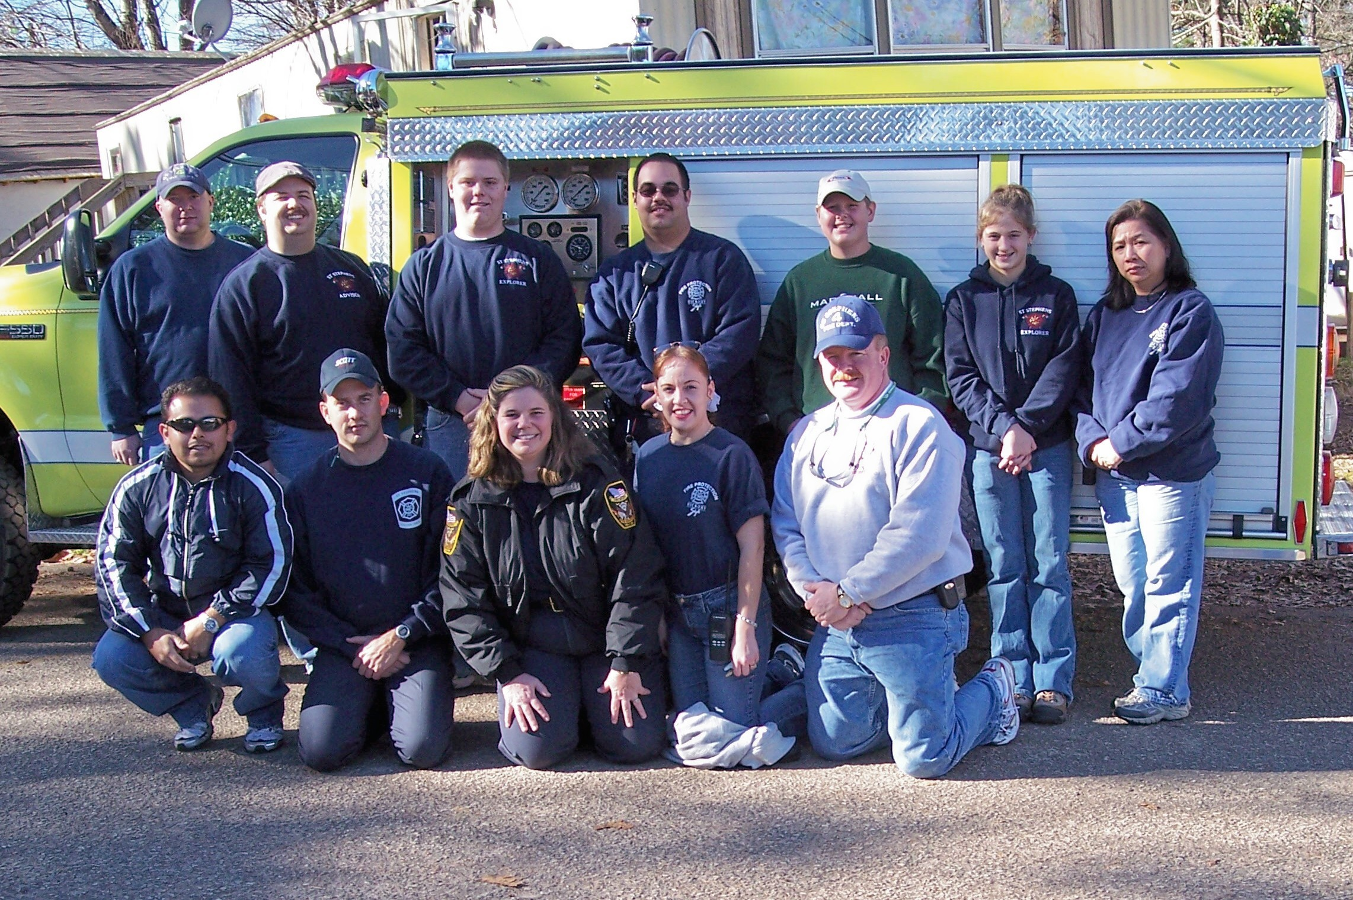
- Mai Yang
- Mabelisse Hernandez
- Johnny Hernandez
- Josh Randolph
- Josh Crump
- Rick Davis
- Matt Davis
- Ron Smith
- Amanda Smith
- Brian McCall
- Paul Exon
- Brad Champion
- Trevor Farnsworth

Thank you for your time and your help with this activity! I’m sure that all the persons in that Park feel safer now!

¡Muchas Gracias!

Mabelisse Hernandez,
Fire Education Coordinator

