CASE STUDY APPLICATION

○ Environment  Economy  Social Equity and Community
 Planning, Urban design, Infrastructure  Organization and Finance

Title of Presentation: Environmental Portal: A Window to Our Own Connectedness

Jurisdiction: Washtenaw County Project Leader: Bob Guenzel

Presentation Team Members: County Commissioner, Andy Brush, Knowledge Manager, Dick Fleece, Environmental Services Director

Street Address: 110 N. Fourth Ave.

City/State/Zip: Ann Arbor, MI 48107

Contact for case study submission: Mary O’Hare, Director of Organizational Development

Phone: 734-222-6560 FAX: 734-222-6573

Email: oharem@ewashtenaw.org

Synopsis

Background

The county of Washtenaw has a long history of supporting environmental stewardship as can be seen in the focus of the elected officials, local government staff, and not-for-profit organizations. Many Earth Day, watershed and other environmental awareness events celebrate our commitment and educate our citizens. The public’s commitment to the environment is shown through continued support for millages (taxes) for parks expansion, operation and the preservation of open space. A continuing challenge is to bring a wealth of information and passion together for easy access by the public.

Washtenaw County, located in southeast Michigan, has 1300 employees and 35 different departments, each providing an important set of services and leadership to the 340,000 citizens of the County. Individual departments have the responsibility to assess needs of customers, monitor mandated service, adjust business plans appropriately and shift staff and resources to address customer needs.

While the departments still have many individual responsibilities they are also organized into Communities of Interest to reflect common customers or outcomes. Washtenaw County has eight such communities of interest: Land Use and Environment, Public Safety and Justice, Housing and Homelessness, Children’s Wellbeing, Health, Civic Infrastructure, Emergency Preparedness and Support Services. The level of integration and coordination between departments in these communities of interest varies. Integration of the Land Use and Environment Community of Interest has been a major focus over the past 5 years.

Land Use and Environment was the first community of interest to be intentionally co-located to change the work environment and shift the mindset of the employees and leadership in those departments toward more collaboration. It was an attempt to co-locate all the programs and departments that “touch the land” together. This action was intended to allow for more natural connections to be made at the staff level where the day to day coordination happens. As with any potentially great idea, this one had its share of stops, starts and work-arounds. Many initiatives were started to encourage the integration of these departments including interdepartmental teams to encourage coordination of projects, technology to automate coordination and a joint management team for the campus. The co-location meant a long series of changes and compromises. The drive towards collaboration among a number of very different people and styles proved difficult at times and the scattered successes had not driven a substantial change in the way they did business.

The Environmental Portal Project
What we have learned many times over is that co-location in itself does not bring about better team behaviors and collaboration. Teams form in the process of accomplishing something, and in this case the momentum to work together came from doing something truly innovative that also reached the customer in a new way.
The project that was the culmination of much discussion, technical help, collaborative thinking and innovation is a portal simply providing “Environmental Tips to Homeowners”. It seems so obvious now that the product is complete and being used by citizens but the work to get this project off the ground was more about knocking down silos and taking a customer perspective than in creating the final product.
The departments involved in creating this portal are Planning & Environment (Environmental Services, Building Services, Soil Testing) the Drain Commissioner’s Office, MSU Extension, Public Health, Parks & Recreation, Support Services (Web content team) and the Board of Public Works.
Not only is this innovative environmental portal a public service that engaged all the departments across the Land Use & Environment community of interest, the story of this effort has a couple of great twists: an important incentive from the Board of Commissioners, and making the most of the talent we have internally in Washtenaw County.
The first twist is that Commissioner Mandy Grewal had urged the staff to make the web site “easier” to access and navigate. She put forth that people don’t think in terms of “departments or programs” when they need help, and that the web should indicate what we actually do in those programs.
The ensuing talks and ideas brought about the second twist: Tom, a Sanitarian with the Drain Commissioner’s Office, who spends his days inspecting wells and consulting with developers – also happens to be a very talented graphic artist. He was in on the initial discussions about organizing information in an engaging way and started doodling a picture of a house, a yard and a family and the picture concept, with the help of our information technology department became a reality.
So this very successful initiative was about horizontal communication across departments, as well as vertical alignment with the Board. It was about thinking of the consumer and finding ways to meet their needs. Bob Guenzel, County Administrator says, “I think the site is compelling enough that, once you get there, you want to stay and check it out. So, it offers an educational component, too.”
Our case study is about a product that can be duplicated by other local governments, it is about a creative process that pushed the limits of our normal way of doing business and about a transformation toward collaborative thought and coordinated action among departments with a common focus to serve the citizens of Washtenaw County. Washtenaw County - Environmental Portal

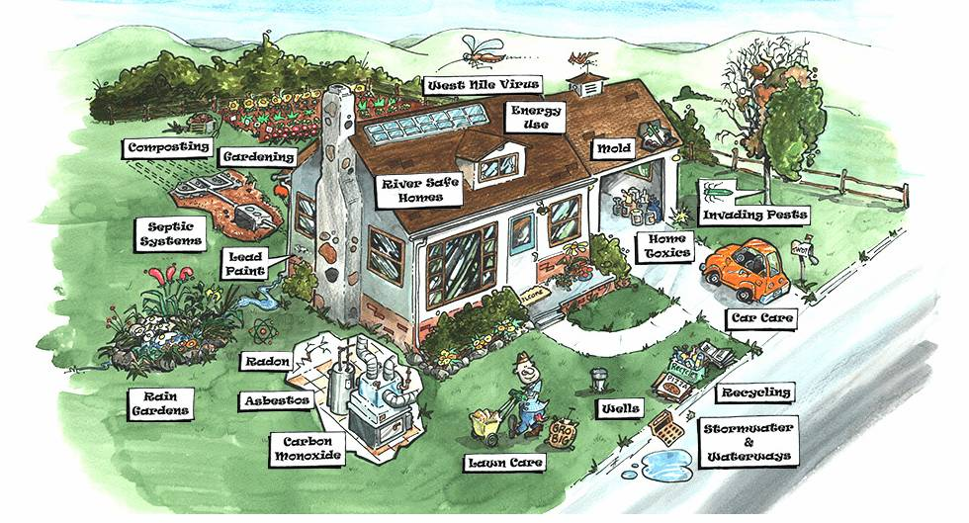
Components of Presentation

Innovation/Creativity

How did you unleash or encourage creativity in order to generate solutions?
What ideas or opportunities emerged during your creative process?
How did your concept stretch or improve the boundaries of ordinary governmental operations?

The departments that worked together to produce this all have a consistent history of producing quality educational materials and information to the public. Where the innovation was released was in thinking about reaching the customers in a different way. The push for this came from one of the commissioners who recognized that these departments created great products. She only wished that it was more easily accessible by the customer.

The cross pollination of thinking in this group allowed the departments to see where gaps existed in information that was available, issues that were addressed by more than one department but not in a coordinated way or addressing the crossover concerns.

More ideas have been sparked from this initial project such as portals for building and home improvement, agriculture and safe food regulations for restaurants. Once the group understood the technology behind it and a template was created the possibilities opened up.

Additionally this project sparked a new possibility for the redesign of the main Washtenaw County website. The new design is based more on an appreciation of the website visitor, engaging graphical images and text that connects with an end user’s goals. There is a new emphasis on seeing what we have to offer through the customer’s eyes and trying to create more ways to access our services and information.

Quality Management

What quality management principles, tools, and procedures were applied to your service delivery?

The project is outcome oriented and designed for education on all issues related to the environment in Washtenaw County. The information that is presented is done in a manner that is engaging to the audience but the messages are clear about environmental awareness and protection. The information is practical to the homeowner and is in alignment with the missions of each of the departments. This was one common purpose that connected all of the departments.

The Management principle that is most applicable concerns the principles of self directed work teams. There was a vision that drove the team toward its own success not a specific directive. That allowed for more creativity within the parameters of what was possible.

Value Proposition

What customer needs and expectations were identified and fulfilled? How did your initiative improve access to your government? How has the health of your community improved as a result?

The value to the customer/citizen is in easier access to information that is credible, easy to understand and useful. The portal is true to the concept of portals which is one-stop access to information from many places both internal and external to Washtenaw County government; however the information presented in the Environmental Portal is customized for our local or regional area and targeted to homeowners so the customers can find relevant information at their fingertips.

Additionally, the portal has a whimsical way of navigating the site which is appealing to customers. Visitors stay longer on the site and find more than they were initially looking for when accessing the site.

Building Organizational Capacity

How did you remove the barriers to innovation?

Removing the barriers to innovation began many years prior to this project but you can see the effects of this work in how the group was able to achieve success. First Washtenaw County has an Administration that is committed to continuous improvement and the meaningful role of public service in our community. Second, we have commissioners who are very connected to the public and who are focused on bringing the best of Washtenaw County to their constituents; they believe in and support the work of the staff. Third, our Information Technology web team has a foundational philosophy that information is created to be shared, everything that can be shared should be made accessible and that our role in Support Services is to fulfill the business goals of the departments. Fourth, we have very smart, innovative; risk-taking content experts who want a quality product and last, we have employees that are willing to give discretionary effort and talent beyond their normal job description.

All of these elements came together at the right time and right place to create this unique portal. We see the capacity of the organization increased in a number of ways. Operationally, more information accessible to the public means fewer phone calls and mailing of pamphlets and materials. Those answering phone calls have a ready resource to give consistent information to the public.

From a creativity perspective, the employees who worked on this portal and those that have used it can see possibilities that were not within their sights previously. What seemed a daunting possibility turned out to be easier and technically simpler than originally considered. That has opened up discussions to bigger and better “what ifs” which we hope will lead to greater innovation.

It was fortuitous that there existed a graphic artist in the position of a sanitarian. His involvement brought the picture to life. However, many organizations have those employees with multiple talents that are never tapped into. It is a culture of celebrating unique talents in your employees which makes those discoveries possible.

Management Philosophy and culture

What philosophy, literature, or body or research influenced your service delivery? How is it evident in your program/concept?

We follow emerging trends to inform our projects and find solutions. The trend in increased web use by our customers was something that we wanted to take advantage of in many of our services. Our Washtenaw County websites have seen a 10%-20% increase in visits each year. The on-going conversation is how we can serve these customers better by making our sites more content rich, useful and user friendly.

Additionally the role of knowledge management theories was important. Information that customers want should be made available directly to customers and to staff who serve them thereby streamlining the process of getting that information to customers. Another tenet of knowledge management is that lots of knowledge exists out there already, there is no reason to recreate if you can just find it and connect it.

Integrated Processes and Reengineering with the Use of Technology

What new technologies were necessary and what methods and/or applications did you incorporate? What business processes were used during the development of your program/concept? Was an outside consultant used?

From a resource perspective the beauty of this project is that we were able to use existing technologies and skill sets to do something different. It did not require consulting assistance or purchase of new tools.

The portal was created with basic web tools, including an image map which permits 20 links to appear in appropriate parts of the cartoon. We also used our content management system to create and publish the web pages.

Applicable Results/Real World Advice

What are the applications you could share, that would be of value to other local governments?

Organizational transformation is not easy and doesn’t always work the first time however, you know it when you are on the road to true transformation. This project doesn’t solve all the problems of collaboration including ownership, identity, sharing resources and communication but it has sparked a new realization of the benefits of collaboration.

Some lessons learned:

Be aware of the existing technology and resources that you have in your organization before going outside.

Don’t be scared of the technology – spend time on the concept and then determine the appropriate technology that will bring it to life

Spend enough time up front to know what you really want, before you get locked in by the design

One key to a good collaboration is to put in the same room: people who can describe the problem, people who can bring a potential solution, people who can authorize it and people who are passionate about the problem. With the right people in the room the creative solution will surface.

Innovation and creativity doesn’t just happen without the right cultural environment for the sparks to take place. What an organization does to create a work environment that recognizes the unique contributions of employees, takes seriously the role of public service and uses technology to enhance the great service provided to the customers is what sets it all in motion.

Measures of Success:

We can track, through Web Analytics, the number of hits for this site and determine the length of time spent on these pages. Our theory is that the longer they are engaged on this site the more exploring they will do. Washtenaw County has been in the top ten digital counties for three years in a row and we use these numbers on a regularly to enhance our site. By having good information about the pages of interest to our customers we can focus our energy on addressing those interests.

A second measure of success is the number of times this concept is utilized in other departments or for other programs. If it is truly successful with the public we expect to see additional collaborations for getting information on the web similar to this project.

Third, we will be tracking the use of the site by internal staff as a resource. The Customer Support team for the Land Use and Environment departments is watching for efficiencies in distribution of information to the public. Better information available directly to the customer should result in less printing and mailing costs of the same information.

