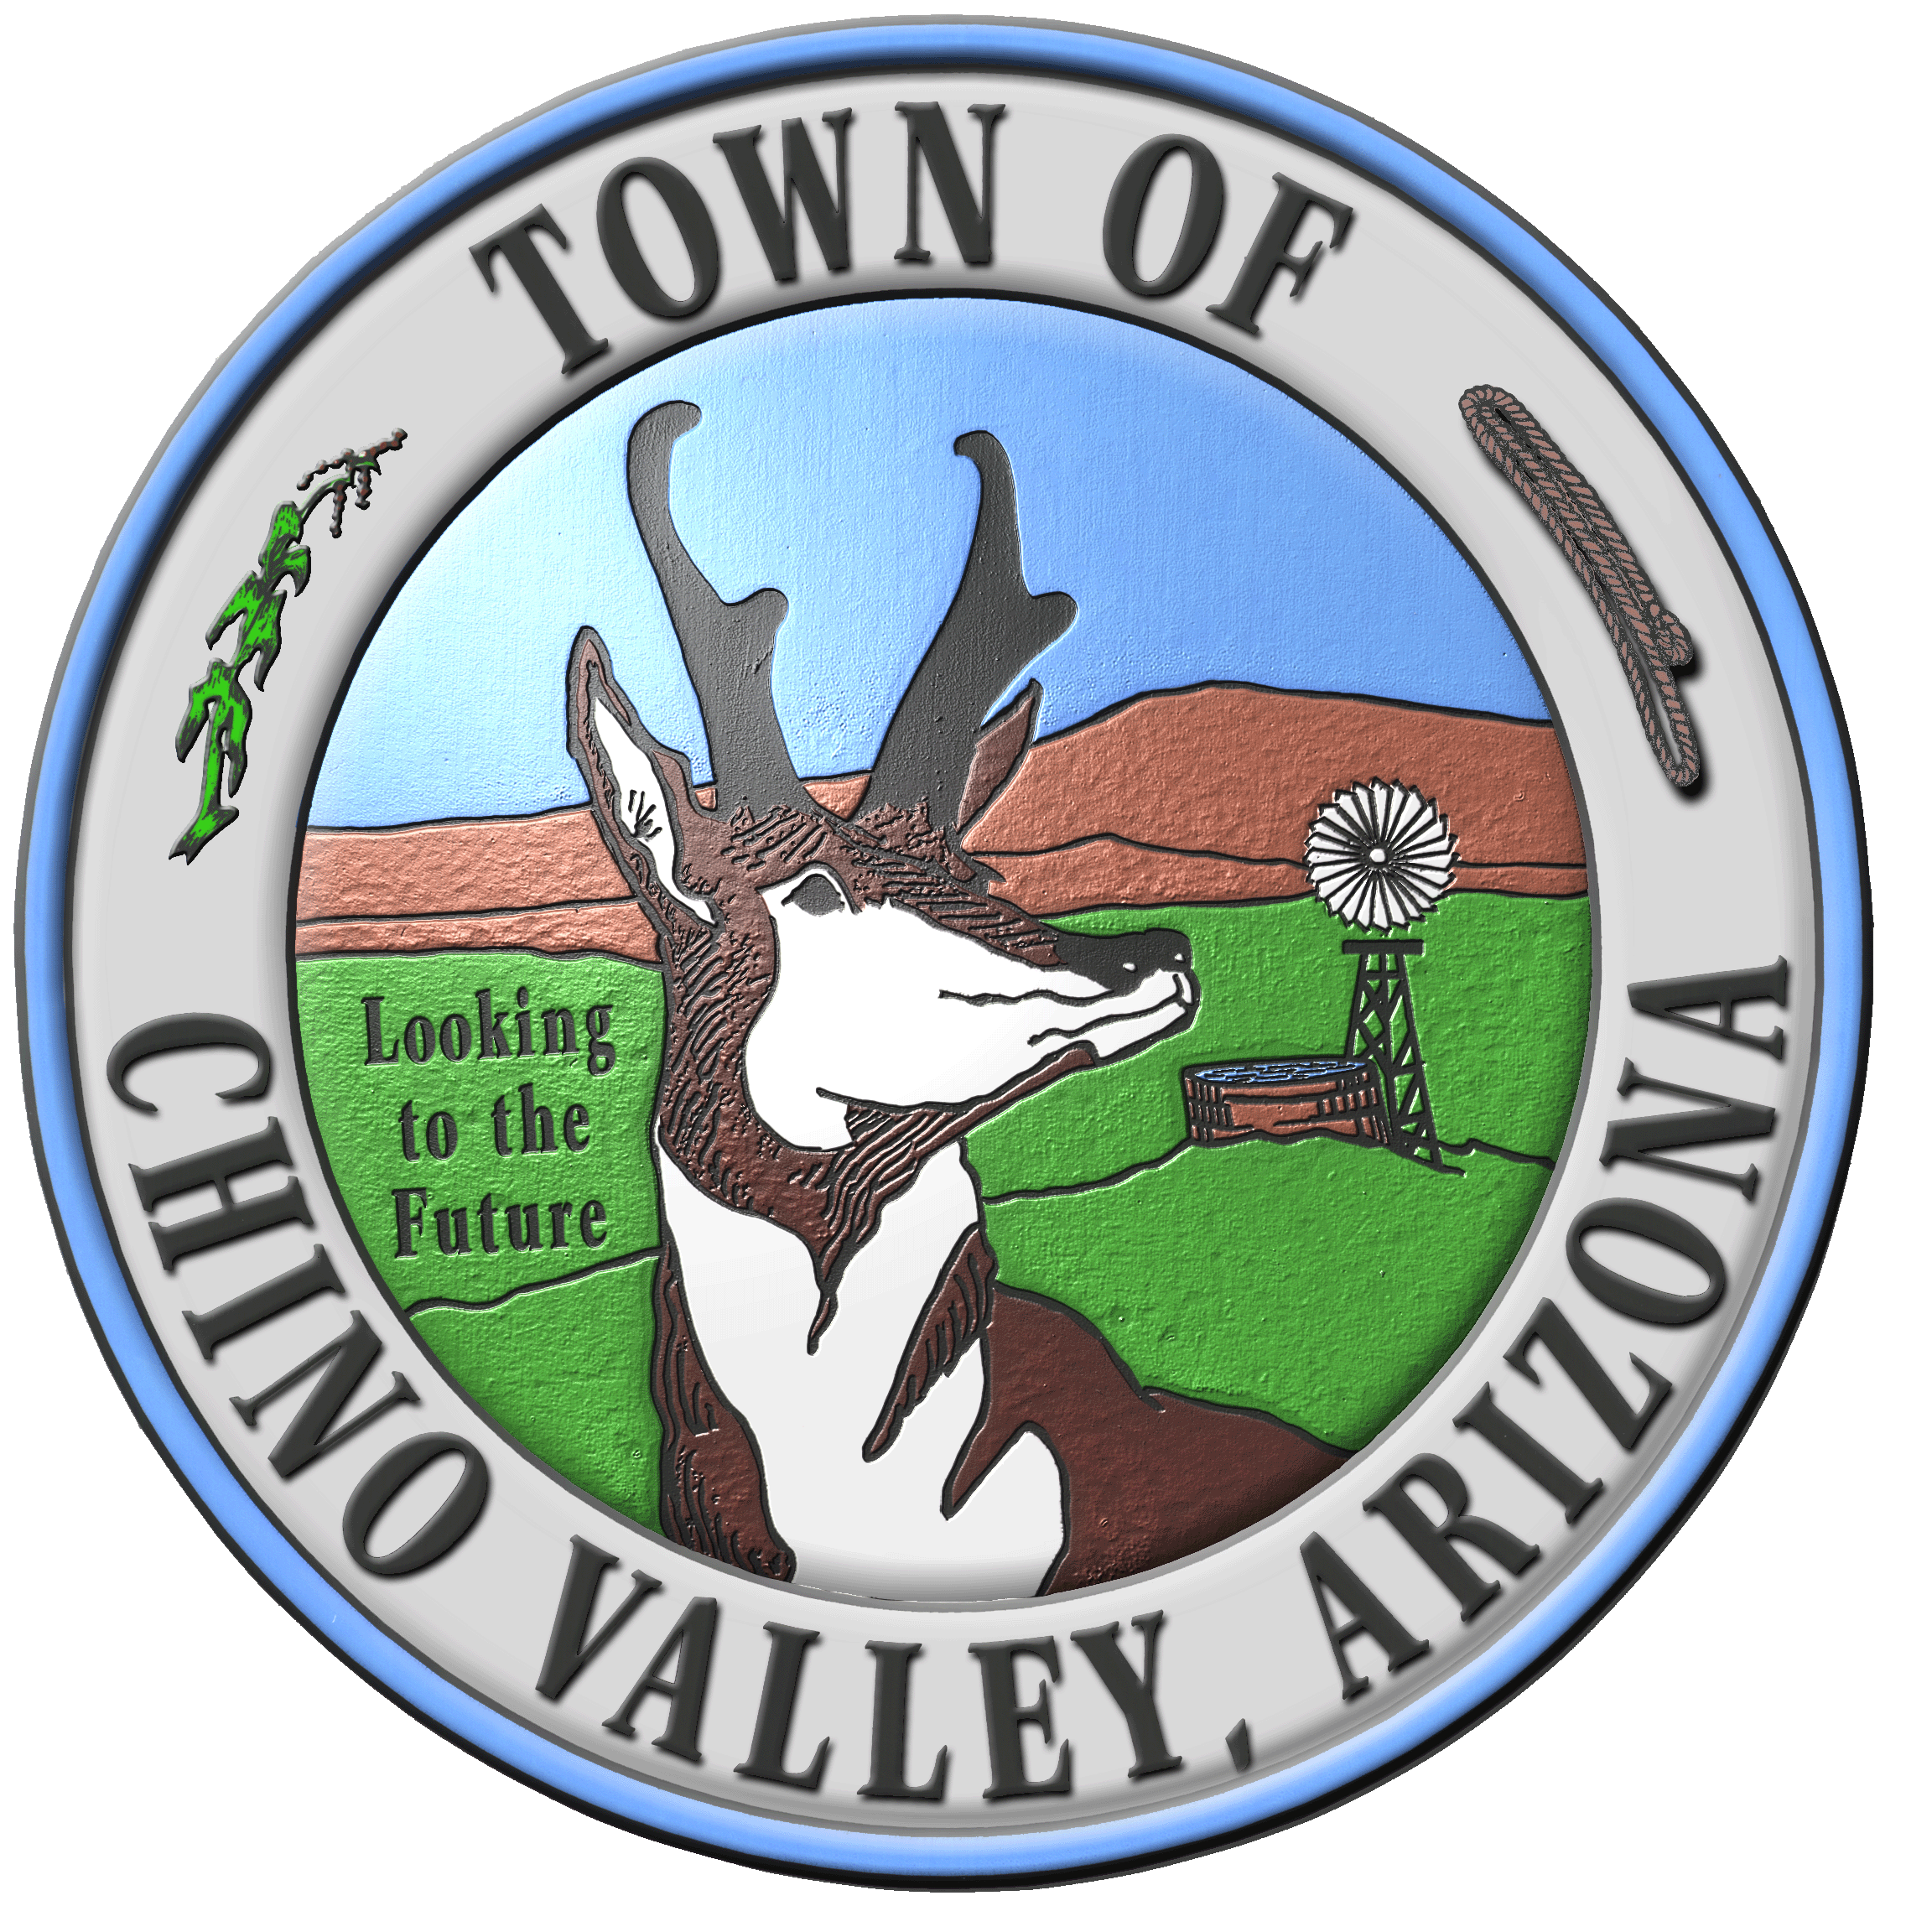

Town of Chino Valley, AZ

August 30, 2007

Alliance for Innovation
Transforming Local Government
411 N. Central Ave., Suite 400
Phoenix, AZ 85004-0606

Greetings and Salutations:

The Town of Chino Valley, Arizona is pleased to submit our application for the Alliance for Innovation, Transforming Local Governments Conference 2008. Chino Valley would like to submit under the Environment category; however, our project also crossed into the Planning, Urban Design, and Infrastructure category.

Below is the additional information regarding our project and the possibilities of presenting our project at next year’s conference.

Title: Creating a Sustainable Society for Free

Jurisdiction: Town of Chino Valley, Incorporated 1970

Project Leader: Bill Pupo – Town Manager

Presentation Team Members:
Mark Holmes – Water Resources Director
Bill Pupo – Town Manager
Karen Fann – Mayor

Street Address:
Town of Chino Valley
1020 W. Palomino Road
Chino Valley, AZ 86323

Phone: Email: mholmes@chinoaz.net
Office: 928-636-7140 bpupo@chinoaz.net
Cell: 928-830-6084

Sincerely,
Mark Holmes
Mark Holmes
Water Resource Director
ALIANCE FOR INNOVATION
TRANSFORMING LOCAL GOVERNMENT CONFERENCE 2008

SYNOPSIS

The Town of Chino Valley, AZ is the largest community regarding land area within North-Central Arizona. Chino Valley has a current population of 15,500, and is 65 square-miles of virtually dry land, meaning land that does not have any real assured water supplies for the next 100 years. Chino Valley is located within a 450 square-mile area known as the Prescott Active Management Area (AMA). An AMA is a geographic area that has been declared, by the Arizona Department of Water Resources (ADWR), as an area where there are limited and diminishing water resources and where more restrictive water management rules are imposed upon all proposed developments or uses of water resources. Our region is also unique in that our sole water supply comes from groundwater as opposed to other parts of the State which have access to the Central Arizona Project (CAP) water from the Colorado River. Chino Valley is experiencing enormous growth pressures similar to other parts of the State that are the fastest growing communities in the Nation.

Chino Valley, since its 1970 incorporation, has historically grown through wildcat subdivisions and lot splits with the proliferation of private exempt wells and septic tanks. The proliferation of exempt wells has contributed to the AMA water resource over-draft conditions while septic tanks have led to the prospects of polluting our sole-source aquifer. The Town has been analyzing all prospects of accessing new more plentiful water resources, and stopping or eliminating the proliferation of private exempt wells and septic tanks. As well, creating water resource and land sustainable growth plans to support the continued growth past the year 2050.

Since 2004, the Town has been purchasing small parcels of land, to the north in an adjacent groundwater sub-basin, that have been identified by ADWR as historically irrigated acres (HIA). Under current State Statutes a municipality may transport 3 acre-feet of water per acre of HIA lands if those lands are permanently retired from irrigation. However, currently we cannot fund the construction of a 10-mile water transportation system that is necessary to import the water and make it available within the community. On May 10, 2007 the Town entered into a private-public agreement with a significant ranch land-owner of 1000 acres of HIA lands within that sub-basin or the equivalent of 3,000 acre-feet of water that can be imported. This innovative and land-mark agreement, along with current sustainable efforts, will set the framework and serve as a model for all communities regarding sustainable growth within Arizona and throughout the Southwestern United States.

This agreement requires that the ranch-owner secure all the necessary finances to design and build a water transportation system at no cost or financial liability to the Town. Once constructed, the water transportation system will be dedicated to the Town, at no cost, for the purpose of transporting Town owned HIA and the ranch owner’s HIA water into the community. With this agreement the Town has a potential of importing 4,800 acre-feet of water annually. However, water commitments will only be sold to qualifying developments that will participate in alternative water supply systems and sustainable use plans. This means that HIA water will only be delivered to the interior of any qualifying development i.e. residential, commercial, or industrial and that HIA water will be restricted from any landscape watering or exterior water uses which are considered a direct loss. Developments will have to provide alternative water supplies such as integrating rain harvesting technologies within the development for all exterior landscape watering and exterior uses. The results are that rain harvesting systems will be utilized in tandem with xeriscape landscapes or similar landscape designs or plans. Also, the development will integrate the highest international building and plumbing code requirements for water saving fixtures, toilets, showers, sinks for buildings and water recycling and recirculation for commercial and industrial processes and uses.

Because water is only served for interior use it is expected that well over 90% of the water served can be collected, treated, and recharged back into the aquifer for replenishment. It is estimated that through these strict water conservation measures, the Town can achieve a gallons per capita per day (GPCD) usage of 57 to 60 GPCD. While other communities struggle to meet Arizona GPCD requirements within an AMA and communities continuously try and increase or adjust their GPCD values, Chino Valley is actively pursuing and implementing techniques, resources, and tools that actually reduce the GPCD values to the minimum use requirements possible.

The ranch owner has agreed to set aside 20% of the entire ranch, equivalent to 2,550 acres, as a conservation easement to be managed through a third party steward i.e. the Nature Conservancy. This conservation easement is in addition to the 1000 acres of HIA lands that will also be permanently retired from irrigation and set aside as a conservation easement.

The Morrison Institute at Arizona State University (ASU) and the Arizona Water Institute have been contracted to assist with the development of new sustainable water resource codes, policies, and administration requirements and to amend the Town’s General Plan for both water resource and land sustainable use plans.

In 2006 the Town applied to the State Water Infrastructure Finance Authority (WIFA) for loans regarding sewer and water expansion projects starting in 2007. In 2007 the Town was awarded the State’s highest two priorities for expansion of sewer and water infrastructure projects, which will protect the water quality of the sole-source aquifer. Also, by sewering the existing community the Town can more efficiently collect, treat, and recharge water back into the aquifer compared to its loss through septic tanks and leach fields.

ANSWERS TO COMPONENTS

INNOVATION AND CREATIVITY
An ad-hock committee was formed to primarily think outside the realm of traditional municipal government of who were all experts in local, regional, and State issues and related work disciplines. By understanding the known problems, the committee evaluated the unknown with respect to financials, water resource sustainability, and related logistical concerns. This allowed thinking outside the A-typical municipal government with every idea supported through legal, engineering, planning, private-public collaboration, and water sustainability disciplines.

EMERGING OPPORTUNITIES
- The ranch-owner realized that if he financed the water transportation system, he would have a substantial revenue source from this project as opposed to developing the land and that the value of water was more significant by transporting that supply to another basin.

- The Town realized that water resources could be used as a mechanism to shape unchecked growth into sustainable and smart growth plans.

- The Town realized that regardless of who owns the water, the water itself is the important commodity that would allow for not only sustainable growth but significant high quality commercial, industrial, or residential projects for this region that are not currently available due to a lack of water resources.

- All parties realized that through strict water conservation requirements five very important water resource aspects could simultaneously be achieved:

- A smaller amount of water was required to be purchased by development for each project so it had a significant economical incentive.

- Because less water is required for development it provides an instant sustainability component as water resources are stretched out further over time and more efficiently used.

- Because water was only served to the interior use of development the majority of it can be collected, treated, and recharged near the extraction point which provides relief of any concerns regarding withdrawals and impacts.

- Alternative water supplies for landscaping and exterior uses were endorsed and consistent with plans from concerned water organizations, agencies, and community groups.

- Developers can promote green-types of developments, which is an important component to home buyers within this region and the State.

The roles of the Chino Valley government went beyond the academic by researching sustainable growth concepts of this real-world sustainable growth application through conception and implementation. The role of our municipality has now crossed over into general planning utilizing sustainable smart growth concepts that have never been implemented to this degree within any municipal government entity until now.

QUALITY MANAGEMENT
Some distinct management principles were created that will lead to better quality of life within our community through better utilization of resources, land use, and no impact to the tax payers of our community. The old philosophy that you must give up something significant for a better quality of life does not apply here. Ultimately the community has better water resources for its current and future generation’s use, improvements to the water quantity and quality of our existing local aquifer, and resolved withdrawal concerns by designing the appropriate mitigation plan for recharging water resources near the point of extraction.

The Town Council now has an important tool to improve the quality and types of development that occur within the Town. Development will have to qualify and demonstrate that their development meet the criteria of sustainability, and are appropriate and important for the community. Also, through this agreement, the Morrison Institute and the Water Institute work, the Town will have an updated General Plan and new codes, ordinances, and policies that will be administered to all forms of development ensuring that each will conform to sustainable and smart growth.

VALUE PROPOSITION
The majority of all development has occurred within Chino Valley through wildcat subdivision and land splits due to the lack of water resources. These forms of development and land use have lead to chaotic land use, the proliferation of private exempt wells and septic tanks that have contributed to water resource over-drafting of groundwater and impacted the water quality of the sole source aquifer. The new available water resources provide the necessary tools for diverse and high quality developments to occur. The planning and water resources are now available to developments that were not previously available. Because water is more efficiently used, collected, treated, and recharged, it is improving the health and safety of the community by improving water quantity and quality of our drinking water supply. Also, by expanding the Town’s sewer collection system, the Town can increase both water quantity and quality of those existing well owners and participate in safe-yield solutions for the over-drafted aquifer.

BUILDING ORGANIZATIONAL CAPACITY
The Town removed the barriers to innovation by allowing its staff to be creative thinkers, by encouraging innovative thinking and more importantly nourishing all employee’s critical thinking processes and ideas. Because the Town is rather lean with departments, executive level management are working Department Heads, that is to say they make decisions and implement and provide their own administrative processes. This in turn has streamlined operations, saved taxpayer money, and designed better paradigms of operations. Because of an atmosphere of collaboration between Management, Elected Officials, staff and the Community, the Department Head is the key critical thinker, making the necessary decisions, and implementing those decisions into programs expeditiously in real-time

The execution process for critical thinking and problem solving aspects for this project were accomplished by an autonomous ad-hock group of department heads and attorneys who are considered innovative experts in water, engineering, and municipal law. The execution process followed an inverse solution approach with the following key components and ideas:

1. Achieve sustainable growth

2. Assess all desired results that are applicable
- Use water resources in a sustainable manner
- Use land resources in a sustainable manner
- Update the Town’s General Plan to incorporate sustainable concepts and plans

3. Execute a plan
- Developed a primary agreement and executed it on May 10, 2007
- Develop future required agreements

4. Develop strategies and objectives
- Establish water resources for importation
- Create a monitoring and mitigation plan
- Create conservation easements
- Hire sustainable consultants regarding water and land
- Establish codes, ordinances, and policies regarding water conservation

5. Investigate the Market
- Chino Valley is 65 square miles of virtually dry lands
- Chino Valley is growing rapidly and chaotically but not sustainably
- Water resources are the limiting factor to sustainable growth
- Water is a significant tool to control growth within a sustainable manner
- Significant commercial and industrial developments will not develop in Chino Valley due to limited water resources
- Revenues from water resource commitments could be used to expand the desperately needed sewer lines throughout the Town of Chino Valley

Because the project was intentionally conceived as a private-public collaboration, and funded by a private party, no special finance authority, bond election, or other loan processes was required. The only requirement was the creation of an Industrial Development Authority (IDA) which is commonly created by local governments that enter into private-public collaborations for a private entity seeking bonds.

MANAGEMENT, PHILOSOPHY, AND CULTURE
Because this region of the State has such little water resources, and those that are used are being consumed at a rate of twice the rate of their ability to be replenished. There are close to 20 concerned water related organizations at the federal, state, regional, and local levels. Also, within our region are the headwaters to the Upper Verde River, which recently was identified as one of the Nation’s top ten endangered rivers.

The Town has incorporated various organizational concerns, ideas, suggestions and possible solutions and included stakeholders in designing and implementing the various components of the project. Special considerations were given to all aspects of sustainable water resource use and management philosophies. Biological and environmental considerations were well thought-out regarding the Verde River’s riparian habitats, watershed open spaces, conservation easements, and protection to special areas that are critical for water resource sustainability. Also, land use components were considered in the natural and artificial water resource plans of sustainability.

The latest scientific reports and groundwater models along with historic information and trends were used to provide scientific support for proposed ideas and assess the benefits and costs for each sustainable component of the project. And, the latest water conservation techniques, technologies, including alternative water supply research was identified and utilized as the cornerstone for the new water conservation codes, ordinances, and policies changes. The water conservation measures are the strictest in the State of Arizona and probably the Southwestern part of the United States.

INTEGRATED PROCESSES AND REENGINEERING WITH THE USE OF TECHNOLOGY
Developments will be engineered to incorporate rain harvesting technologies and techniques that include both active and passive systems to provide alternative water resources for landscape and exterior use requirements. New engineering street standards will be incorporated with rainwater harvesting collection and storage systems for right-of-way landscape watering. Even rain harvested water will be used efficiently and sustainably through sensors and efficient drip systems in tandem with xeriscape landscape designs. Also, new building codes will require that all fixtures within each type of development exceed the newest International Building Codes (IBC) for water saving technologies. Therefore, the water resources used within homes, businesses or industry will be used to the greatest efficiency possible.

New technologies will be integrated not only in the water delivery metering but effluent discharge metering from each individual development to complete the cycle of monitoring and code enforcement. Also, integrated into every development’s covenants, conditions, and restrictions (CC&R) are strict rules applicable to each type of development that identifies specific mandates that must be adhered to which will ensure water sustainability. Also home owners association (HOA) fees will ensures that systems are maintained, repaired, and certified on a periodic basis to guarantee they are operating effectively and efficiently.

With all future landscape and exterior use watering supplied through alternative water supplies, the requirement for potable groundwater is significantly reduced and used more efficiently and prevents the seasonality of increased water demands. Therefore, the amount of water required to be pumped is constant and can easily be rotated through several wells allowing areas of the aquifer to rest and recover. This rotation will also prevent adverse impacts to the aquifer, lands or impacts to other groundwater users.

The Morrison Institute at Arizona State University (ASU) was retained to provide all the necessary components of sustainability within the Town’s General Plan both from land and water resource use planning. Also, the Arizona Water Institute (AWI) was retained to provide all necessary technical support in drafting the special codes, ordinances, and policies for water resource sustainability. ASU and AWI will also provide all the scholarly and technical consulting necessary to complete all the required plans for each component of the project. Both institutes have direct oversight through the three universities in the State and the Governor’s Office.

APPLICABLE RESULTS AND REAL WORLD ADVICE
Chino Valley has created an environment of maximum efficiency for a sustainable society that is growing very rapidly and did not previously have the resources to shape that growth into a smart community. Previously, an acre-foot of water would only build 2.5 homes while today that same acre-foot of water can build 6.5 homes. Previously, the Town served its limited precious potable groundwater resources for landscaping and exterior uses which are complete losses of groundwater through evaporation and transpiration processes. Now, an alternative water supply through rain harvesting will support landscaping and exterior uses. As well, the alternative water is being used wisely through low water use plants and xeriscape landscape designs for all forms of development. Previously, little land was left for open spaces, conservation easements or protected if deemed critical for natural or artificial recharge. Now significant areas are being set aside for conservation easements and open spaces or corridors through adjustments within development designs and natural and artificial recharge sites are protected or enhanced.

The water conservation practices now used through this project maximize groundwater resources to ensure the maximum use possible for potable groundwater supplies. Alternative water supplies are required for all forms of development for exterior landscape and use plans. This ensures that limited groundwater resources are not lost for these exterior uses. Because potable groundwater is only served to the interior use of developments, greater than 90% can be collected, treated, and recharge back into the aquifer for replenishment. Therefore, there is not a negative impact resulting from groundwater uses.

Both the quality and quantity of water resources have improved dramatically by incorporating the aspects of sustainable use and growth into the community. Water revenues generated from this project will increase the effectiveness and efficiency of collecting additional effluent within the community through the expansion of the Town’s sewer system. Ultimately, collection of effluent from existing developments will allow the maximum return of water resources to replenish the aquifer units and avoid any potential impacts from groundwater withdrawals from the same region of the Upper Verde River.

