COVER SHEET

2008 Transforming Local Government Conference
June 4-6, 2008

Muehlenbeck and Havlick Innovation Award Application

Title: Eagle Nest … Connecting Communities to Schools a Collaborative Partnership

Project Leader: Ms. Janet Meeks, Education Coordinator

Jurisdiction: City of Delray Beach

Street Address: 100 NW 1st Avenue, Delray Beach, FL 33444

Phone: (561) 243-7231 Fax: (561) 243-7221

Email: meeksj@ci.delray-beach.fl.us

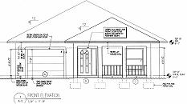
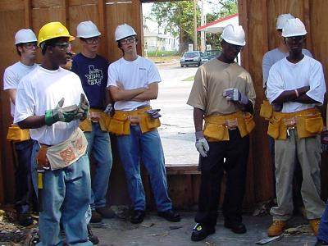
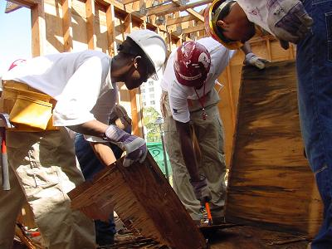
EAGLE NEST PROJECT

Palm Beach County is the 11th largest (K-12th) school district in the United States. It’s the 5th largest in Florida and contains 185 schools with an enrollment of 168,548 students. The City of Delray Beach has cultivated a two decade relationship with Palm Beach County School District to advocate for its students in this vast diverse school district environment. In fact, Delray Beach is the first municipality that sponsors an Education Advisory Board. They are the policy advisors for the City Commission to create and advocate for positive outcomes for its students and schools located in its municipality. This Board is staffed by a full time City employee – Education Coordinator that regularly meets to discuss and improve educationally related issues in the City. The City further distinguishes itself through its support of the Eagle Nest Construction program.

Given the immense and diverse number of students in the District, it’s no wonder the School District of Palm Beach County needed to form Career Academies with community support to generate an environment to hook student’s interest, foster student achievement, and offer creative educational opportunities to actively engage a student to stay in school. Three years ago, Atlantic Community High school approached the City with a proposal to build affordable housing with the support of the city. The project is called “Eagle Nest” being named after the high school Mascot the eagle. It is a student’s first example of how the Career Academy concept will work to engage them in their chosen field of endeavor long before graduating from high school. Eagle Nest is building a 3 bedroom, two baths, CBS construction home (1500sq. ft.). It is designed by students and built by students under the direction of a certified contractor and school instructors.

The process started when the City agreed to donate a vacant lot to the program through its “quiet title” program. The County offers property (at no cost) to the City on lots where taxes have not been paid. The City clears the title and uses these lots to facilitate construction of affordable housing units. To further support the initiative the City’s Community Redevelopment Agency is funding the Eagle Nest with a zero interest $150,000 construction loan. Eagle Nest agreed to sell the house through the City’s Renaissance Program as an affordable housing unit. With the profits from the sale, Eagle Nest will repay the construction loan and retain the remaining funds as seed money to become fiscally self sufficient in years to come.

While the City was working on the legal issues and agreements, a group of third year drafting students took on the task of designing the 1,500 square foot house with a garage and front porch. Four teams of students competed to come up with the best design and the winning layout was selected by participating architects, construction and building company representatives, and the City of Delray Beach Building Department staff members. The students, under the guidance of their high school instructor then concentrated on the building permit process. The professional construction industry participants will see the project through to completion. The house will be ready to be sold to a lucky family in late 2008. The project became so exciting in school that the Finance Academy is helping with bookkeeping and the home economics division will be helping to select final paint colors, fixtures and other interiors items. The entire school has become engaged in the process and is benefiting from the Eagles Nest program.

The innovative project is so successful that the City of Delray Beach received an Award by the Florida Career Pathways Network which recognized the Eagle Nest as a “Best Practice”. Eagle Nest has been named as a mentor program by the state of Florida with five schools across the sate following the Eagle Nest model in the “Matchmaker Grant” program.

1. Who has benefited from the innovation?

Eagle Nest is an excellent example of applied learning that students can do with industry and community support. The City believes in cultivating student citizenship and is willing to take a chance on what these students could do. The motto of the program is "Connect to Continue”. Eagle Nest provides a hand’s on learning experience for the students. It prepares students for employment in the building construction industry by providing them with the skills necessary to enter home building, general contracting and related industries which are looking for employees with experience.

The City benefits by helping students to obtain employable skills to realize good paying level jobs which in turn keep students off of streets and out of gangs. Therefore, the entire community is benefiting. As the building industry is so large in the State of Florida, the academy helps these students find jobs locally so they do not have to move out of the state to find employment. This helps keep unemployment levels low and supports a strong economy.

2. How was the innovation initiated and implemented?

This innovation was initiated through a community wide collaborative partnership. While Palm Beach County School District initiated the innovation of creating a construction academy, the construction of a housing unit by students could not have been implemented without the support of the City and other local community members in the construction industry. Interlocal agreements were created between the City and School District through series of meetings, while the project was being student designed. The students presented their design plans to City officials and have been part of the process from designing to permitting to construction.

3. What risk was associated with planning and developing the innovation?

The biggest risk associated with the project is the legal and safety issues associated with construction of a building located off site of school board property. In addition, the students are working on a job construction site under the legal age of 18, which poses both insurance and liability issues. Again, the City sees the students as an asset and not a danger. They worked out the details and drafted creative agreements with the school district. The City also waived the builders risk insurance. The greatest financial risk is that the Community Redevelopment Agency could be left holding the $150,000 loan if the project were to default and the City would be left with a half built home.

4. What was the environment in which the innovation was created and sustained?

As mentioned earlier in this application, the City of Delray Beach has 2 decades of collaboratively working with Palm Beach County School District which in turn has created trust over the years. The City has meant what it said and followed through on its promises. Since 1994, the City has spent almost 10 million dollars on school related projects through helping the district with negotiations of land deals including infrastructure improvements for new school sites. Further, the City has advocated for the implementation of special programming in the schools to enhance academic achievement. They have entered into interlocal agreements to maintain ball fields and enhanced lighting in associated parking areas. In fact, they relocated an entire neighborhood to make way for the new high school that now houses the Eagle Nest career academy. This is just to mention a few. The program will be sustained as the profits from the first sale of the affordable home will provide “seed money” to start the next project and so forth. This will allow the project to become self sufficient over time.

5. What were execution Costs and savings?
There were no costs associated with the residential lot. The cost of constructing the home is reduced by 50-60% using (free!) student labor. The school district can purchase building materials under their tax exempt status providing an additional 6 ½% savings. The Chamber of Commerce Education Foundation a 501 (c) 3, collects donated items providing businesses with tax deductions. The project is financed through a zero interest loan. All of these are realized cost savings thus dramatically reducing the overall costs of construction.
6. What lessons were learned that could be shared with other local governments?

The entire Eagle Nest model can be shared with other local governments. Almost all governments have access to lots for building affordable housing. The Eagle Nest project is really not different than building homes through Habitat for Humanity. However, in this case the construction is student designed and student built.

7. Which Departments and/or individuals championed the innovation?

Many Departments are involved in this collaborative partnership. However, the lead Department is Community Improvement. Legal staff members from the school district and the City of Delray Beach established inter-local agreements outlining each party's role in the Eagle Nest project. The City’s finance department helps with the Eagle Nest bookkeeping at no charge. The Delray Beach Chamber of Commerce accepts donations for Eagle Nest.

Additionally, the Chief Building Official and his inspection staff provide helpful “tips” to novice workers. City workers have also taken a special interest in the project as many of them know at least one student who is an Eagle Nest worker. Like all residential construction in the City, Eagle Nest must meet all building codes and land development requirements. Eagle Nest is not given any preferential treatment. City building inspectors can “red flag” the project at any time in the construction process, but that has not happened yet!

One day, a City inspector reviewed the student’s work on a porch column and after looking the column over carefully, the inspector shoved the column over. The inspector evaluated the work and said it was not straight. The stunned looks on the students’ faces reminded all of them that quality is an important part of the process and failure to meet standards is the best life lesson learned. As the inspector said “if it aint’t right, it ain’t right”!

