Mitigating Flood Risk Using Geographic information Systems (G.I.S.)

Nigel Forster

G.I.S. Superintendent

Information & Computer Services

City of Medicine Hat

Medicine Hat, Alberta. Canada

T1A 8E6

Phone: (403) 529-8101

Fax: (403) 5028574

nigfor@medicinehat.ca

Mitigating Flood Risk Using Geographic information Systems (G.I.S.)

Overview.
Any municipality, built on or in proximity to a river floodplain, will periodically be faced with a flood situation. City G.I.S. staff developed a computer mapping methodology, that allows Disaster Services team members to quickly and easily view water extents resulting from changing river levels during a flood. As conditions change, new scenarios can be simulated in near real time. The application allows the timely & accurate delineation of flood boundaries to reflect changing river levels. Based on river discharge reports from Alberta Environment, flood maps can be drafted, literally in minutes. Scenarios have been developed for all flood events, up to and including a 1:100 year flood.

Methodology.
Flood warnings typically coincide with snowmelt runoff from the foothills range of the Rocky Mountains in western Canada. Throughout the winter, snowpack conditions are carefully monitored to estimate the water equivalent that will be available during Spring melt. Based on the rate of melt and additional factors (including soil conditions and rainfall) flood advisories may be issued, typically in late May or early June. When the provincial government (through Alberta Environment) issues flood advisories/warnings, they predict the river discharge (m³/second) that will occur within the next 24 hour period for given locations, typically at river gauging stations. For Medicine Hat this value is the discharge that is predicted to occur at the gauging station on the City’s Finlay Bridge (Figure 1).

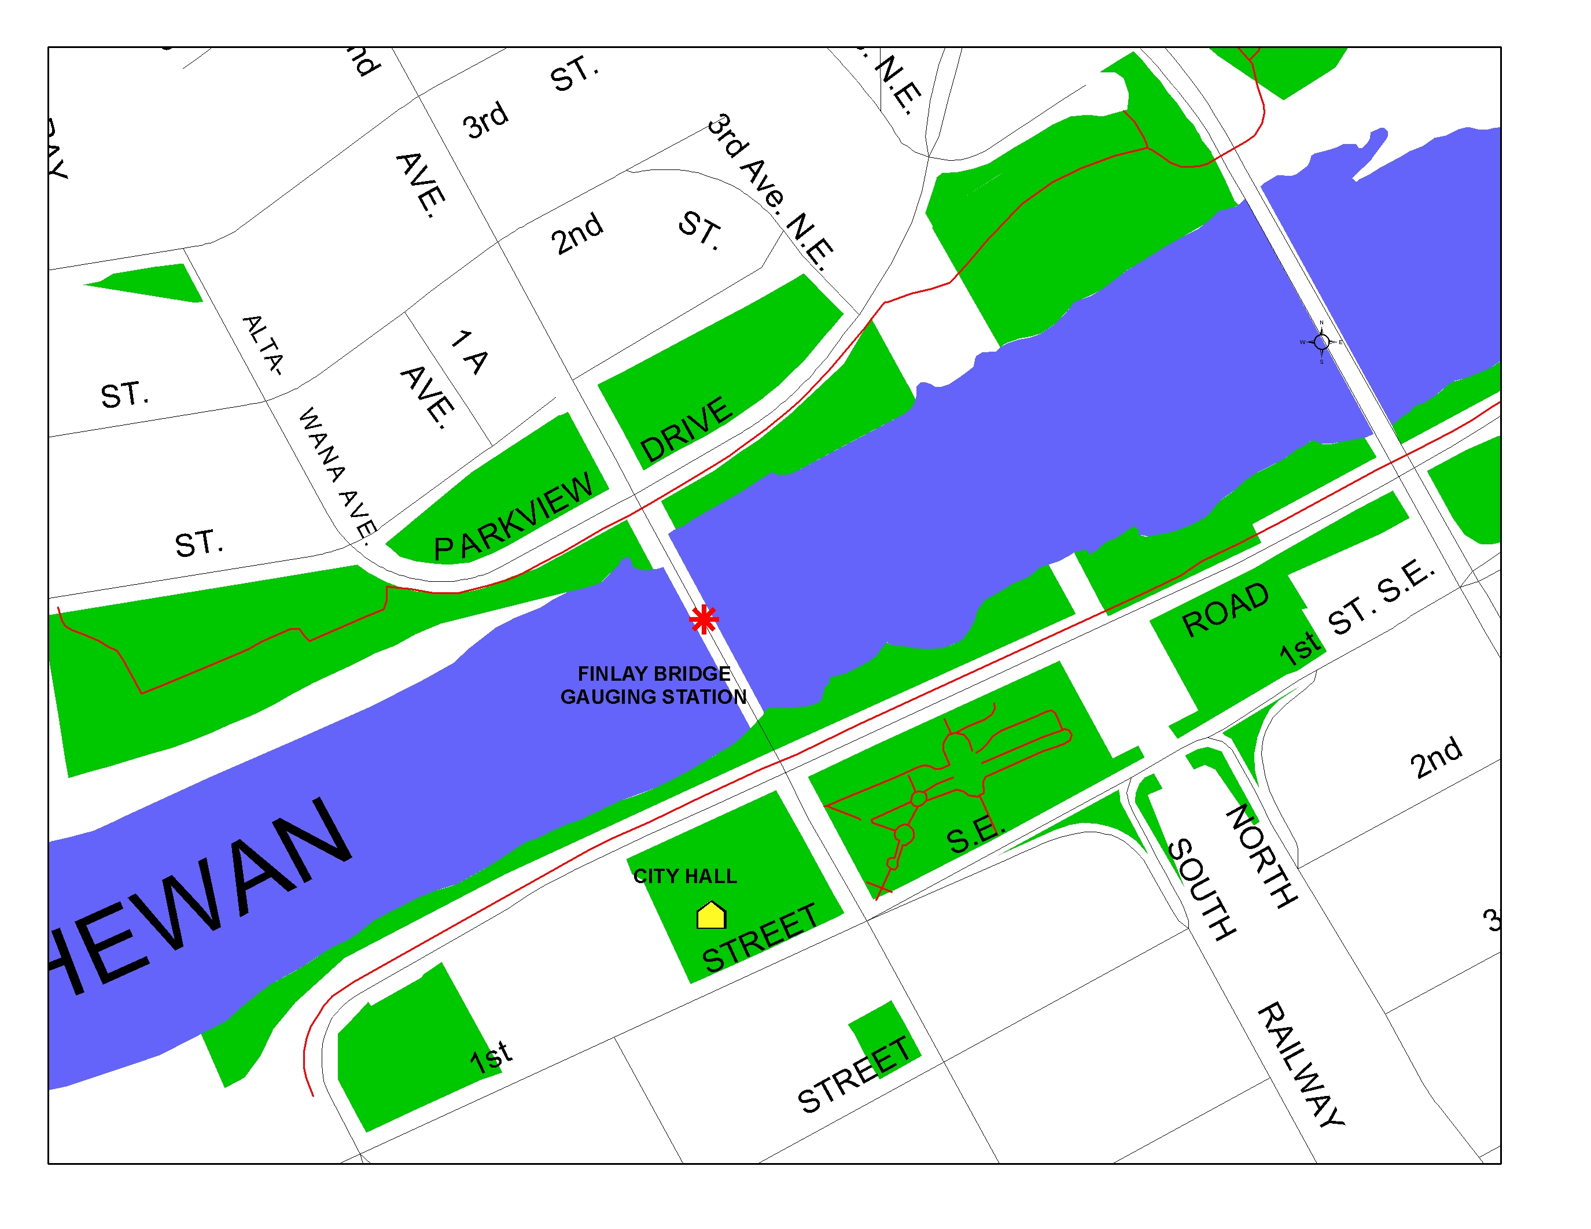

Figure 1: Alberta Environment gauging station. Finlay Bridge, South Saskatchewan River, Medicine Hat, Alberta.

The design process for the flood mitigation project involved correlating the data reported/predicted by Alberta Environment to actual ground surface elevations. Using a combination of historical data, detailed survey records from previous flood events and local 0.5 meter interval contours developed from a recent digital elevation model (D.E.M.), G.I.S. staff were able to develop a 'correlation matrix' (Figure 2) that tied river discharge to local ground surface elevations for various flood events. The contour lines adjacent to the river were used to develop a series of closed polygons, used to represent areas that could be at risk, should floodwater escape from the river channel.

Q (m³/s) | Frequency | Transect 20 | Transect 24 | Transect 27 | Transect 28 | Transect 29 | Transect 41
5230 | 1:100 year | 663.54 | 663.05 | 662.48 | 662.14 | 662.09 | 661.04
4880 | 1:50 year | 662.76 | 662.31 | 661.74 | 661.42 | 661.36 | 660.43
3740 | 1:25 year | 661.94 | 661.51 | 660.94 | 660.65 | 660.58 | 659.71
3170 | 1:15 year | 661.23 | 660.81 | 660.28 | 659.98 | 659.88 | 659.20
2750 | 1:10 year | 660.70 | 660.33 | 659.74 | 659.49 | 659.43 | 658.74
2010 | 1:5 year | 659.94 | 659.52 | 658.97 | 658.66 | 658.55 | 658.12

Figure 2: Correlation matrix, linking river discharge (Q) with local D.E.M. ground surface elevations. All elevation values are in meters above sea level.

Where: Q = river discharge (m³/second). Alberta Environment gauge data, Finlay bridge.
Frequency = estimated return period for a given Q value.
Transect = river transects for the South Saskatchewan River in Medicine Hat.

These criteria were then used to forecast potential water levels, to help identify and delineate areas of the City at risk during floods. The purpose of utilizing the river transects (Figure 3) is to account for the change in gradient of the river through the City, and to allow for more accurate delineation of areas of concern for specific areas. The value of this methodology is that once the City has received notification from Alberta Envionment of an impending river rise, the predicted Q value is used to load the appropriate elevation polygons developed within the G.I.S. system. The maps generated provide a very quick visual reference of areas at risk from floodwater, and allow appropriate emergency measures to be put in place. Preparing the maps within the G.I.S. system also allows response staff to identify infrastructure at risk, and to plan for preventative measures such as evacuating residents, closing roads, disconnecting utilities and covering manholes. The application was implemented with tremendous success during the flood of 2005, and maps created during the analysis very closely matched the conditions observed in the field. This resulted in a high degree of confidence when developing response plans.

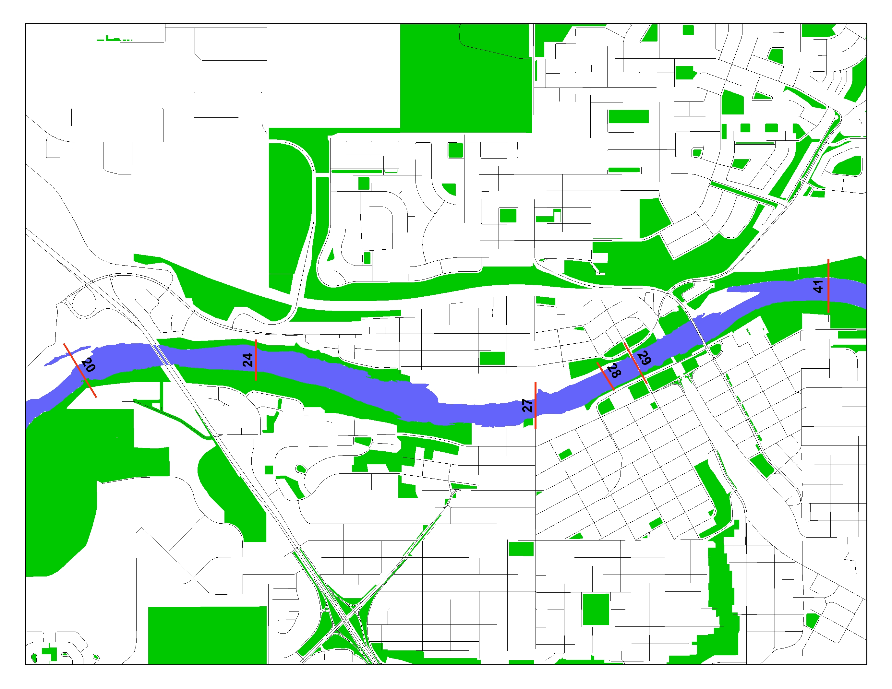

Figure 3: River transects used for the discharge/elevation correlation matrix.

Jurisdiction & History.

Medicine Hat is a community of 55,650 people, located along the banks of the South Saskatchewan River valley (Figure 4). Although the river valley provides for a very pituresque setting, areas of the City are are at risk from periodic flooding. In 1995 for example, the local College became a temporary shelter for 2,000 people evacuated from their homes because of flood warnings. In that year (1995) Southern Alberta's floods cost an estimated $100 million. There was another ‘flood-watch’ in early June, 2002. While the South Saskatchewan River did rise significantly, water largely remained within the river’s banks and minimal impact was felt. However, what did come to light was a lack of preparedness with regards to predicting potential flooding. Although G.I.S. technology was expected to play a major role in forecasting flood extents, no clear corporate action plan had been developed following the major flood in 1995. Roles and responsibilities were unclear, and in some cases efforts were duplicated by two or more departments due to lack of communication. This “mear miss” in 2002 identified the need to have an application in place. An application to provide the Disaster Services team the ability to predict water levels under a variety of flood scenarios and to initiate mitigation strategies accordingly. Advance notice is limited to approximately 24 hours, so a methodology was required that would provide the City's Disaster Services team as much lead time as possible, allowing them to implement preventative measures .

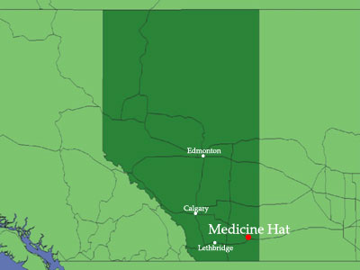

Figure 4: Location of Medicine Hat, Alberta.

Research using historical data was conducted, and stakeholders consulted to help correlate the flow data from Alberta Environment with actual ground surface elevation. Historical data was obtained from the Flood Damage Mitigation Study prepared for the City following the 1995 flood. In addition to this, there was a wealth of data collected by City survey crews during the 2002 flood advisory. Once the application methodology was developed and refined, it was demonstrated internally to the various stakeholder groups for feedback and modifications. The Spring of 2005 provided the opportunity to test the new methodology, as flood advisories were issued for much of southern Alberta. Water levels for the South Saskatchewan River were considerably higher than those experienced in the Spring of 2002. Post flood discussion and analysis concluded that the map predictions were very accurate in identifying specific areas and properties at risk of flooding, and that the application played an integral role in allocating resources to flood affected areas. Without exception the comments and feedback received from Disaster Services, Senior Management, City Council and staff were extremely positive. While there were no evacuations in Medicine Hat, residents in several neighbourhoods were advised to move valuables out of their basements and to be prepared to move at short notice. A number of roads and City parks adjacent to the river were inundated and had to remain closed for a number of days.

Importance, Impacts & Benefits.

Arguably the most significant advantage of this application is its ability to provide fast and accurate predictions for impending flood events. Although the lead time for flood arrival is typically limited to 24 hours prior to the event, flood risk maps can be quickly and easily produced to initiate preventative measures and to minimize damage. This application allows Disaster Services teams to evaluate "what if" scenarios in real time by changing the elevation parameters interactively within the application. Through this process initiatives can be proactive rather than reactive.This practice is innovative and progressive in that it leverages additional value from existing (G.I.S.) data to enhance flood preparedness and mitigation measures. Existing in-house G.I.S. applications also allowed lists of residents in flood prone areas to be generated, printed and distributed to field staff to go door to door to notify and forewarn residents. The address point database used to generate the list of affected residents also provided a direct link to utility data information, allowing the deployment of resources to potentially affected areas of the City. Individual properties could be identified and measures taken in advance to mitigate damage. Residents can be warned to move valuables from lower floors, to evacuate if required, utilities can be disconnected and other preventative measures taken to minimize water damage.
The practice is very broad in that it uses standard out of the box G.I.S. software that could be utilized by any other municipality prone to flood risk, provided they have accurate D.E.M. data for their local area. Direct benefits of the innovation have been to the various City departments that respond in times of crisis. By accurately predicting where flooding could occur, resources can be deployed where they are needed, and the necessary preventative measures implemented in a timely fashion. Indirectly residents of Medicine Hat will benefit from this innovation, in that they will be more effectively served by disaster services personnel in times of a flood emergency.
G.I.S. staff, in consultation with City stakeholders, took the initiative to design and develop this G.I.S. based solution using software and data that was already maintained within our (S.D.E.) database. The application was designed as one that could be used on any City workstation with standard (ESRI) G.I.S. software installed. Although the initial application was developed to run on any G.I.S. enabled workstation connected to the City network, a "stand alone" version has also been developed. This version was designed to run on a laptop or similar portable device, in the event that either the City computer network fails or the need arose to run the application from a remote location.
This approach could be used by any municipality with access to G.I.S. software and accurate (local) digital elevation data to predict the affects of flood scenarios within their municipal boundaries. In the case of Medicine Hat, all data used for mapping and analysis already existed internally. The approach is simple to implement and very quick to run. This allows Disaster Services personnel sufficient time to proactively assign resources to affected areas and to formulate an effective disaster management plan prior to the flood event.

