Alliance for Innovation
Case Study Application

Conroe Lean
City of Conroe, Texas

Jerry McGuire & Sherrie Matson
(936) 539-4431, (936) 522-3048
jmcguire@cityofconroe.org, smattson@cityofconroe.org
300 W Davis Street, Conroe, TX 77301-2803
Synopsis
The City of Conroe has adopted an innovative culture-changing methodology that has been fully supported by employees, citizens, and council. The Lean methodology, which relies on the knowledge of line workers, has led to over $1.7 million of savings over the past two years.
Lean focuses on satisfying three objectives: cost, quality, and service delivery. In many government operations, managers can achieve one or two of these objectives, but not all three. “We produce accurate building permits at a reasonable cost, but our lead time is over three weeks. If we want to shorten that lead time without an increased number of errors, we have to add people.” This is a common response when addressing any of the three objectives: solve one problem objective by compromising another. Lean methodologies compromise nothing. Never sacrifice quality, as poor quality will cost drastically more in the long run. Also refrain from throwing money or additional labor at a problem. Instead, look at all of the activities in the chosen process and eliminate or reduce any activity that does not add value. A Lean tool called Value Stream Mapping focuses on exactly this task.
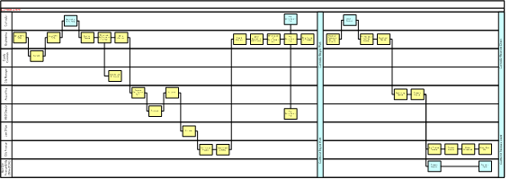
Value Stream Map
The first step in creating a value stream map is, not surprisingly, to document each step. Capture each detailed activity of the process. If a contract is transferred to another department via the internal mail system – document it. If copies are made and filed after sending out a bill – document it. If the internal auditor records the dates of all approval signatures – document it. The more detailed the map, the more useful it will be.
After the initial map is complete, analyze each step and identify each as value added, non-value-added, or non-value-added but necessary. Value added (VA) is the term used to define a process step that a knowledgeable customer is willing to pay for. Conversely, non-value-added (NVA) is a process step that the same customer is not willing to pay for. These are the steps that we want to reduce, if not eliminate. Non-value-added but necessary (NVAN) steps are not value added but required through a current system, statute, or law.
To further illustrate these concepts, look at a process for paying a contractor. The physical steps of writing and mailing the check are value added. In this process the contractor is the customer, and he or she cares about this step. The contractor does not care, on the other hand, that the invoice has to sit in a bin waiting for a runner to take it from engineering to finance. That step is non-value-added. An example of a non-value-added step that may be required under applicable laws or regulations is having multiple sign offs on contracts over $10,000.
Assigning these value indicators to each step of the process is often difficult. Participants making the map may become defensive regarding their part of the process. It is hard to admit that there may be better ways to do the job that they have been doing for years. It is not easy to say that many of the steps are NVA. However, as you will see below, the more objective the map in assigning value, the more effective it will be in identifying opportunities to eliminate waste and cost.
Value indicators (VA, NVA, and NVAN) serve as targets for improvement with the intent of eliminating or drastically reducing the steps that do not add value. Addressing each non value added step greatly facilitates the improvement idea generation process. However, this is another difficult component of Value Stream Mapping, because it requires complete objectivity. Often people are so close to the process that they think the current way is the only way. A paradigm shift is necessary to reach the full potential of Value Stream Mapping.
With a current state map and a list of improvement ideas, a future state map can be created. This map is what the process should look like six to twelve months down the road after incorporating the brainstorming ideas. The future state should be ambitious, but it should also be a realistic target.
The final part of the Value Stream Mapping process is bridging the gap between current and future state maps. This step is relatively easy, because it simply spells out all of the improvement ideas in an implementation plan. The plan assigns responsibility and a timeframe for each improvement. It is the component of Value Stream Mapping that holds the organization accountable for the process improvements. After everything is completed, the implementation plan and the two maps should be displayed in a visible place in the organization so that everyone can view the progress.

Principles of the Conroe Lean Program
The Conroe Lean Program is a system of Lean thinking designed by Jerry McGuire, the City Administrator for the City of Conroe, Texas, based on the approach of process evaluation presented by David Krings and Michael Sticklen with TechSolve.

Successful programs are those that are encouraged by management at all levels and are well-known and understood by employees throughout the entire organization. Conroe strives hard to promote continued awareness of lean concepts.

The City Administrator and the Arts & Communications Coordinator worked with an artist to design a logo, theme, and flyer that would depict the essence of the Conroe Lean Program. The logo consists of silhouetted figures of several people with arms raised together in victory. The Conroe Lean Team theme “Working Together” – “Building Efficiency” exhibits the message that the Lean process cannot be done by one person alone; it takes team work.

To add additional meaning to the title “Conroe Lean” an acronym was created to further explain the Lean-thinking goals. This information was posted on a flyer with the Conroe Lean logo and the City of Conroe logo, which is displayed throughout the city buildings where employees will see it on a daily basis.

C ontinuous Improvement
O ur Responsibility | L eading by Example
N ew Ways to Serve | E xceeding Expectations
R esearching “Best Practices” | A chieving Great Results
O versight of Public Dollars | N ever Accepting the “Status Quo”
E veryone’s Job
Conroe Lean was presented to all of the employees of the City of Conroe, Texas, through a festive picnic. This picnic was planned by a team of volunteers brought together by the Arts & Communications Coordinator. There were decorations; plenty of food for everyone; prizes of shirts, hats and barbells with the Conroe Lean logo; and a guest speaker who explained the long-term impact of saving just one minute of time each day. It was at this picnic that the employees were informed of the Conroe Lean plan of action. Future events are to occur on an annual basis to give recognition to the departments, and the individuals who have been a part of the Conroe Lean process by putting Lean plans of action into practice. Awards are also giving to the department and the individual with the best and/or most processes to put Lean thinking into action.

The Arts and Communications Coordinator for the City of Conroe works with the Information Technology Department to have motivational, Lean-driven messages appear on the employees computer screens when the computer is turned on. The messages are changed periodically to maintain interest and capture the attention of the computer user. These motivational quotes are specifically geared to help inspire employees to be aware of possible ways to be Lean in their jobs. It is a form of daily promotion for the Conroe Lean Program.

The Assistant City Administrator coordinates articles each month for the City Employee Newsletter. The article is always on the front page, where the exposure is greatest. Different people throughout the City take turns writing out what Lean thinking means to them and how it has impacted their work area. This helps to explain the benefits of the program, while showing how the principles may be used in a variety of areas. Quite often people benefit from the concepts of the ideas of others, even when the details of application differ.

The Human Resources Director oversees the “Bright and Lean Ideas” process whereby individual employees submit their ideas for how to improve processes and/or save the City money. In common employee areas (like meeting rooms, break rooms, or copier rooms) in every city building, there are brochures set out that employees may take and complete in order to submit their ideas to help make the City Lean. These brochures are submitted to a committee who reviews them and may ask additional questions prior to making the determination to recommend the idea to the City Administrator. Should the City Administrator approve of an idea that has been recommended by the committee, he will determine the cash award that will be presented to the employee who submitted the Bright and Lean Idea and will give the employee public recognition for their contribution to the program. The employee will also receive a thank-you gift from the committee for submitting their idea, so that they know that their ideas have received attention and are considered to be valuable to the City of Conroe.

While not all ideas will be able to be put into action, the City strives to maintain an atmosphere of encouragement towards these ideas. Even some bad ideas can be the foundation for good ideas that will spur on great ideas. The concept is to seek out ways to improve processes throughout the City. If an individual has a generally good idea, but it needs to be fine-tuned, it behooves the City to look into ways to help the employee improve on their idea, provide them with the resources to make improvements, allow them the recognition for being an innovative person, and become a contributing factor of the Lean process. The more the City encourages employees and provides them with a sense of ownership in making the City better, the more ideas will occur.

The Internal Auditor heads-up the Conroe Lean Process Review by scheduling different processes for various departments to be reviewed through the year. Teams are created from these different departments utilizing a perpetual team concept to expose a greater number of employees to the concepts of Lean process review. Each Process Review Team will consist of two to three people from the various departments within the City and each person will serve on the Process Review Team for three sessions.

The first time a person serves on the team will be to review another department and learn the process in a non-threatening environment. The second time a person serves on the team will be to have a process or processes reviewed from their own department. Because they have already seen the process work, they are not as intimidated about having their department reviewed by others. (In fact, some departments are excited about getting help from their coworkers to provide them with ideas to make improvements.) The third time a person serves on the team will be to help provide leadership to the other persons on the team, as one who has been through the process twice and can provide innovative ideas and input to spur their teammates on.

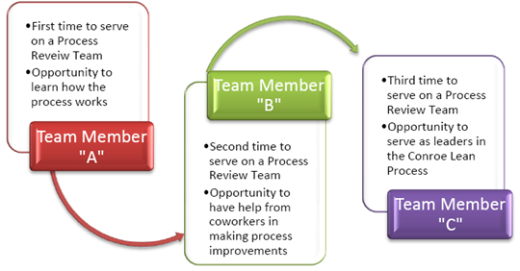
Conroe Lean Process Review

The added benefit of using a perpetual team is that the City can reach more employees with this concept and these team members can go back to their own departments and help their coworkers to become more aware of ways that improvements can be made in their own tasks.

The City of Conroe has found that it helps to calculate the improvement impact when the “B” Team members come prepared with data, such as the number of occurrences or items, related to the process under review. Teams that are prepared by knowing who does what task and when in the process a person performs the task will decrease the length of time it takes to set up the process review.

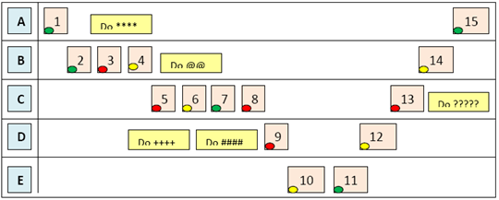
Swim-lane Concept

The basic concept of the process review as taught by the representatives from TechSolve, David Krings and Michael Sticklen, are simple and easy to incorporate. They utilize a swim-lane concept where each lane is a different person in the process under review. Each task of the process is placed in the applicable lane in the order that it occurs. Once the current process order has been established, the next step is to record the length of time it takes to perform each task and the amount of “wait” time that occurs between each task. At any time the team is encouraged to ask questions to get a thorough understanding of the process under review. Then the team jointly decides the value of each task as it relates to the “customer” (person or department for whom the process ultimately serves). The options that the team uses are “adds value,” (green) “does not add value, but is necessary,” (yellow) or “has no value” (red). After customer values are established, the team then records ideas they have and problems that they see. When everyone has had ample opportunity to provide input, the problems and ideas are discussed by the team. The team will then decide the best ideas to put into action and a task list is created to assign the work involved to move the ideas into reality. With this information, a new process is designed so that the team has a visual goal to remind them of what the future process should be. The department will then report to the Internal Auditor on a regular basis to provide information on how the changes are being accomplished and if they are successful, following the Plan, Do, Check and Act Model of process evaluation. We want to continuously review our processes for efficiency and effectiveness (Why do we do what we do the way we do it?).

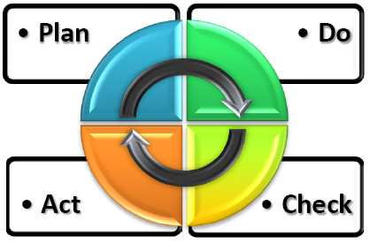
Process Evaluation Model

Just like the concept in the business world that you must spend money in order to make money, sometimes a government may need to spend some money in order to make improvements that will be cost effective over time. The expenditures for such things as improved technology when compared to the value of the time saved, is used to make the decision as to the benefits of an idea. To illustrate the importance of maintaining balance in the decisions the City makes, below is a diagram that the City of Conroe uses in the Conroe Lean Process Review Sessions to provide a visual for the three basic concepts to be considered in the process.
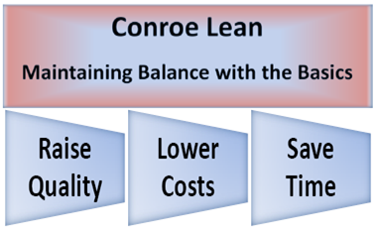
Process Review Concepts

The five types of wastes are also introduced, with visuals that will assist team members in seeing different ways that money is lost within an organization.

W | aiting – anything that causes an employee to wait to do a process step
A | ccuracy / Adequacy Defect – mistakes and incomplete work
S | taffing – unqualified staff, insufficient training and non-competitive pay
T | ransport – poor layout of space and inefficient batching and poor filing
E | xcesses – over stocking, duplicated work and unbalanced work loads

The City of Conroe has an initial estimation of hard and soft dollar savings of approximately $1,700,000. As a fast-growing city, the soft-dollar savings are important in that it allows more work to be accomplished with the staff already in place, through improved efficiencies. Below are some highlights of the processes that have been reviewed and the initial savings estimates:

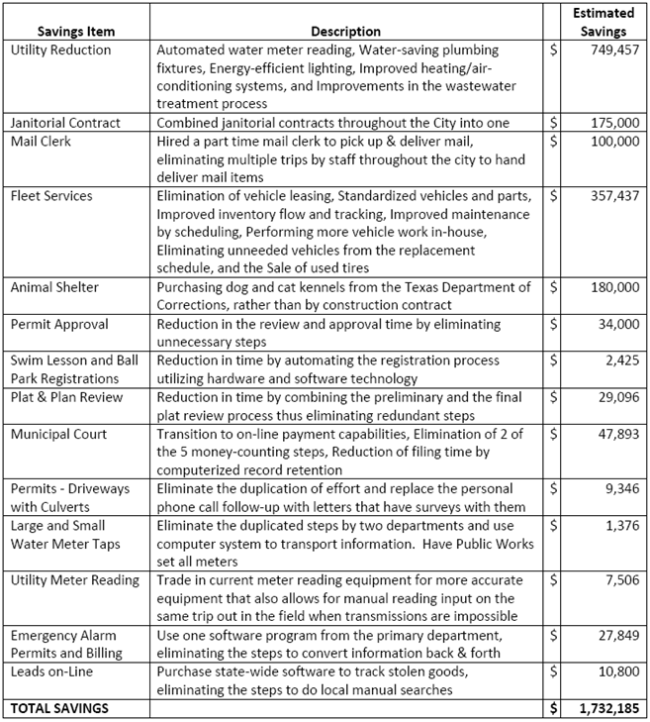

2008 AFI Innovation Award
City of Conroe for Conroe Lean

