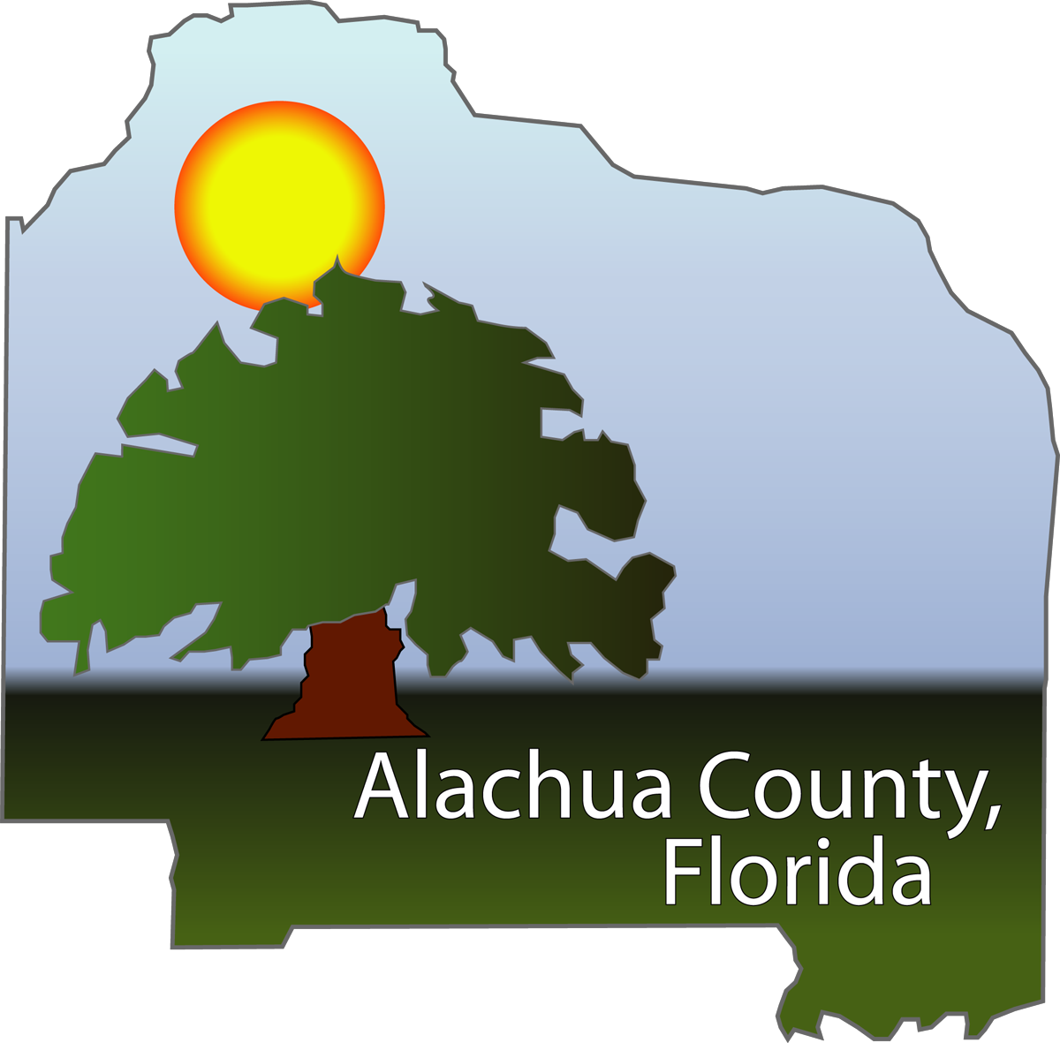

2009 TLG Case Study Application

Title: Comprehensive Wildfire Mitigation Program – moving from reaction based response to proactive mitigation measures.
Jurisdiction: Alachua County Board of County Commissioners
Project Leader: Jeff Bielling, Wildfire Mitigation Officer
Presentation Members: Jeff Bielling, Wildfire Mitigation Officer
Chief Will G. May, Director of Public Safety (tent.)
Others as deemed appropriate
Mailing Address: 913 SE 5th Street
Gainesville, FL 32601
Phone: 352-384-3101
Fax 352-334-0832
E-mail: jbielling@alachuacounty.us
Synopsis:

Alachua County:
Alachua County was incorporated in 1824 and encompasses 977 square miles with a population of approximately 240,000. The Alachua County Board of County Commissioners has 800+ employees that provide services in such diverse areas as Community Services, Fire and Rescue, Public Works, Environmental Protection, Growth Management, and Court Services. Our collegiate community, including both the University of Florida and Santa Fe Community College, blends very nicely with our unique natural surroundings and features such as Payne’s Prairie State Park and numerous natural springs, lakes, and preservation areas.

History:
Alachua County takes pride in preserving native, natural, and green spaces within the County. However, the continued development of housing into areas that had been historically used for rural land uses such as agriculture and timber lands or that are in a native condition creates a set of conditions known as the wildland/urban interface. Most plant communities within Florida have been shaped and are maintained by fire. With these fire-adapted plant communities the question of wildfire is not “if” but “when” and “how bad.” In the wildland/urban interface this mixture of land uses and native plant communities increases the vulnerability of structures to wildfire.

The whole state of Florida has experienced high drought conditions over the past decade – Alachua County in north central Florida has also experienced these similar conditions. 1998 was a particularly bad fire season in Florida with every county in the State sustaining significant wildfires and one county [Flagler County] entirely evacuated due to wildfires. During the 1998 fire season Alachua County encountered an extremely severe period where wildfires started and grew to the point an entire town within Alachua County was under threat of severe damage or loss from wildfire. The severity of this fire season and the subsequent 2000-2001 fire seasons dictated the need for a comprehensive Wildfire Mitigation program that focused on proactive measures, partnerships, implementation of Best Management Practices, and the cooperation of the building community. The Alachua County Comprehensive Plan was amended in 2002 to create a wildfire mitigation program. After the amended Comprehensive Plan became effective in May 2005, the Alachua County Department of Public Safety began developing a formalized Wildfire Mitigation program in late 2005.

Wildfire Mitigation Program:

The Wildfire Mitigation Program is established in the Conservation and Open Space Element of the Alachua County Comprehensive Plan. The Program relies upon development review, code enforcement, public education, and direct fuel management activities to mitigate the severity of the wildfire hazard in Alachua County. The development review process is used to assure that new development at risk from wildland fire will employ design and construction features and ongoing wildland fuel management activities to provide passive protection of improved properties from exposure to wildland fire. Through a public education effort, the Mitigation Program provides support and guidance to established neighborhoods and communities at risk from wildland fire to reduce their vulnerability to wildfire through the application of wildfire mitigation strategies and activities similar to the Firewise Communities Program. Periodic fuels management activities [such as through the use of prescribed fire and mechanical treatments] on public and private land are key to lessening the severity of wildfire and protecting communities and natural resources from catastrophic wildfire.

Currently the Mitigation Program has the ability to provide mechanical and treatment methods to manage wildland fuel levels. The primary short-term focus of the Mitigation Team has been upon the restoration and management of County-owned and managed land in coordination with the Alachua County Forever Program, the Environmental Protection Department, and the Public Works Department. The primary management task of the Wildfire Mitigation Team on County-owned lands has been the application of prescribed fire as part of an overall restoration and/or management plan. Fuel management on at-risk privately-owned lands in the wildland-urban interface is the long-term goal of the Program. Alachua County Department of Public Safety fuel management activities are coordinated with Florida Department of Agriculture and Consumer Services, Division of Forestry as practical and appropriate to create a long-term synergism between state and local wildfire mitigation programs.

The Wildfire Mitigation Team is trained and equipped so that it can augment and support the Department’s incident response capabilities. The Mitigation Team is a resource available to the Fire Rescue Operations Section as needed for incidents such as large wildfires, or large storm events. The Mitigation Team also provides support to the Emergency Management Section when the Alachua County Emergency Operations Center is activated.

Innovation/Creativity:

A desired outcome of the Wildfire Mitigation Program is to increase public safety and reduce the need for extra-ordinary suppression response during large wildfire events. Rather than perpetuating the continued reliance of residents upon fire suppression forces – which can be quickly overwhelmed in a large wildfire incident with resulting loss of structures - the Wildfire Mitigation Program seeks to use the County’s land use oversight authority, public education efforts, and direct land owner assistance to by enlisting the residents of Alachua County to take more responsibility for their own well-being by reducing the vulnerability of their homes and businesses to wildfire. The typical relationship of a local government as provider of protective services to residents as passive recipients is revised to form more of a partnership where residents assume more responsibility for the safety of their own homes.

A feature of the Alachua County Wildfire Mitigation Program that sets it apart from other wildfire mitigation programs that may be conducted by local governments is the use of the local government comprehensive plan and land development regulations – which in Florida have the force of local law – to establish wildfire mitigation requirements for all new planned developments (after August 2005). These wildfire mitigation requirements will be in place for the life of a development project or until wildfire hazard no longer exists for the project. Periodic site inspections are utilized to ensure that development projects comply with requirements for ongoing fuel maintenance, to advise homeowners about necessary mitigation activities, or to determine that wildfire is no longer a concern for a particular community due to changing circumstances such as changes in land use patterns.

The Wildfire Mitigation Program makes use of various tools and resources target its efforts such as geographic information systems [GIS], global positioning systems [GPS], and wildfire hazard mapping tools. Given the resource constraints typical to most local governments the Mitigation Program gathers and adapts existing information as needed rather than generating the same information. A primary example is the use of the Fire Risk Assessment System developed by the Florida Division of Forestry. The Fire Risk Assessment System is a GIS-based mapping system developed to identify areas that are susceptible to negative impacts from wildfire.

The Alachua County Department of Public Safety Wildfire Mitigation Program is supportive of other Alachua County Programs and functions which ultimately benefits all the programs. In the case of Alachua County a county program exists to purchase land that is to be restored, enhanced and managed for conservation and recreation values. The Alachua County Forever Program is a voter-approved local land acquisition program. The Wildfire Mitigation Program supports the Alachua County Forever Program by providing land management expertise, preparation of county-owned lands for prescribed burning and public use [trail creation and maintenance, fireline creation and maintenance, mechanical fuel treatment], and directing and executing prescribed burning activities on county-owned lands. The Mitigation Program provides similar support to the County’s Department of Public Works on County parks and county-owned land. The interaction between these County departments and programs enhances the individual programs by allowing for the sharing of personnel and equipment resources.

Citizen Outcomes:

Successful implementation of the Wildfire Mitigation Program helps to ensure the protection of neighborhoods and communities from exposure to wildland fire as well as reducing the demand for intervention by fire protection or suppression services by diminishing the severity of wildland fire within Alachua County. These results will reduce the threat to life and property for citizens and to the safety of firefighters. A cost savings to the public can also ultimately be realized through the implementation of the Wildfire Mitigation Program as the suppression effort needed for wildfires is lessened. When local fire suppression resources are overwhelmed and out of county or out of state resources are called the public costs escalate very quickly. When the severity of wildland fire is lowered through mitigation and fuel treatment activities local fire suppression resources are better able to suppress these fires at a lowered cost to the public as well as lowered exposure of life and property to loss from wildfire.

The local government land use oversight and development review process is used to assure that new development at risk from wildland fire will employ design and construction features and ongoing wildland fuel management activities to provide passive protection of improved properties from exposure to wildland fire.

Outside of the Development Review Process, the Wildfire Mitigation Program provides a consultative service to citizens planning on building within the unincorporated areas to evaluate potential wild fire hazards and suggest mitigation actions which to reduce structural vulnerability to wild fire damage. The Program also performs public education and outreach to neighborhood groups and/or home owner’s associations and provides information of wildfire mitigation via the County website.

In addition to this consultative function, the Program can perform direct fuel treatment activities (fire lines, prescribed burning, mowing, etc) on high risk parcels where potential for structural damage exists. Fuel management on at-risk privately-owned lands in the wildland-urban interface throughout Alachua County is the long-term goal of the Program.

Applicable Results & Real World Advice:

The Alachua County Wildfire Mitigation Program could be readily translated to other units of local government in whole or part. The Program’s three basic components – development review, public education, and fuel treatment/landowner assistance – work best when applied in unison. The regulation of development activities to address wildfire mitigation followed with periodic site inspections should yield the most complete, long-term positive benefits. However, programs such as the Firewise Communities Program have shown that public education and outreach can yield significant results.

With limited personnel and resources we would advise that the development of a wildfire mitigation program at the local government level be done sequentially:

1) Establish the planning and legal basis for the program such as through a local government comprehensive plan or land development regulations. Development regulation will have a large impact and provide lasting results as well limiting the continued development of structures and neighborhoods at risk from wildfire. Fortuitously, Florida’s growth management framework provides a ready means to integrate wildfire mitigation – or any other hazard mitigation – into the local government decision-making process.

2) Form partnerships with other local government programs and activities. As noted above, the Wildfire Mitigation Program provides land management expertise and direct activities to support the Alachua County Forever Program through prescribed burning. Similarly the Mitigation Program also supports the activities of the County’s Public Works Department by providing land management assistance.

4) There is a wealth of information available - make use of it. In Florida we are fortunate that we have agencies and organizations such as the Department of Agriculture and Consumer Services, Division of Forestry, the Department of Community Affairs, and the Florida Fire Chiefs Association that have provided support and resources such as the Fire Risk Assessment System noted above, and the document Wildfire Mitigation in Florida, Land use planning strategies and best development practices.

