Re-writing the Rules for Effective Local Government:
Performance Management and the Founding of a City
City of Doral, FL

Craig Yokopenic, EMA, Inc.
1970 Oakcrest Avenue, Suite 300
St. Paul, MN 55113-2624
Phone: 651-639-5600
Fax: 651-639-5730
Email: cyokopenic@ema-inc.com

Synopsis
The City of Doral was incorporated on June 24, 2003. It is a home rule city with a Mayor-Council-Manager form of government, one of 34 municipalities in Miami-Dade County, Florida. Covering about 15 square miles, Doral is home to about 30,000 residents and regularly hosts more than 100,000 people who work in the city. There is a significant need to support non-English speakers, as the majority of the citizens speak Spanish as their first language. City services include: Community Development, Public Works, Parks and Recreation, and Police, in addition to business services such as Finance, IT, HR, and other supporting services. The adopted budget for FY07-08 anticipates total revenues of approximately $54.3M. Presently, there are about 270 employees working at the City, with some additional hires planned during FY08-09.
In 2008, Doral engaged EMA, Inc. for a two-part consulting assignment, the scope of which includes:
1. Implementing a performance management system that identifies and establishes departmental performance measures and implements these measures into an electronic dashboard management system. The dashboard system will become a management tool grounded in measures, which will increase the efficiencies of the City’s service offerings in a near-real-time delivery.
2. Assessing the current IT environment and developing a multi-year Strategic IT Plan to support the City’s growth
Because Doral is such a new and rapidly changing city, this project affords them a unique opportunity to create their corporate culture and information technology in a planned manner. The information technology tools and practices are designed to accommodate the City’s evolution.
To complete these tasks, EMA began by performing a series of interviews with department heads and front-line employees. The active interviewing process was essential, as it assisted EMA in better understanding the context of the City, future goals, processes, and technology used in order to meet the demands of the growing constituent base. The interview and workshop process also allowed the City and EMA to holistically establish departmental measurement criteria, which also included the initiatives set forth by City Council, Mayor, and the City Manager.
The performance measurement objectives are to:
- Provide concise, accurate, and relevant city-wide performance management measures shared by all managers, workers, and constituents
- Have the department managers provide relevant communication and action on the progress achieved against these predetermined measurements
- Ensure accountability of City resources, including productivity metrics
- Measure the effectiveness of the impact of City service offerings
- Effectively manage projects from beginning to end
- Provide a top-down window into each department and their operating health
- Automatically update the dashboard by tapping into existing applications to avoid re-keying of data
These objectives, combined with measurement criteria, provide the City’s management the ability to:
- Rapidly allocate and distribute city resources where needed
- Determine and understand root-cause analysis of issues
- Increase the city’s organizational knowledge and improve departmental knowledge sharing
- Identify and implement new technologies needed to improve constituent service delivery.
- Develop effective tactics and strategies to deal with dashboard identified issue management
- Evolve the city into a more consistent methodology where manual processes should be the exception, not the norm
- Move the city into a continuous improvement model where city employees use data for analysis for the ongoing decision-making process
To complete the second task of delivering a multi-year Strategic IT Plan, EMA worked closely with City management to determine what was working well and discussed opportunities to increase efficiencies through the use of new technologies. When problems were identified, EMA and management turned these problems into opportunities to implement solutions either through updated practices, re-alignment of current resources, or through the use of new technologies. The Strategic IT Plan identified seven general recommendations and a total of 14 project-based recommendations each with their own business case. These recommendations will be discussed further in the response to Question One.

Components of Presentation
Question 1 - Innovation/Creativity: How did you encourage creativity in order to generate solutions? How did your program/concept stretch or improve the boundaries of ordinary governmental operations? Were new technologies necessary and what methods and/or applicates did you incorporate? Was an outside consultant used? If yes, indicate the level of involvement and identify the firm.
During the course of the consulting engagement, EMA and City of Doral employees worked together to identify creative methods in the solution identification process. Using interviews and an interactive workshop methodology, EMA and the City workers developed a series of departmental measurements and determined how these measurements should best be presented in the dashboard. Depending on best-fit, the metrics could be presented as a hierarchical scorecard, chart, or graph. When available, the dashboard would be integrated to the City’s business applications so automatic data collection could be performed without having it be manually keyed in by City workers.
EMA also assisted Doral by documenting the “as-is” Information Technology state. The as-is state was used to baseline the performance of the City’s departments and how IT supports the various lines of business. Figure 1 displays the City departments and the programs the departments use. The arrows between departments depict data flows. After creating a visual representation of each department and applications used, EMA assisted the City in developing a much more streamlined and efficient IT system that would allow the departments to move out of their information “silos” and into an information sharing state known as a “knowledge organization.”
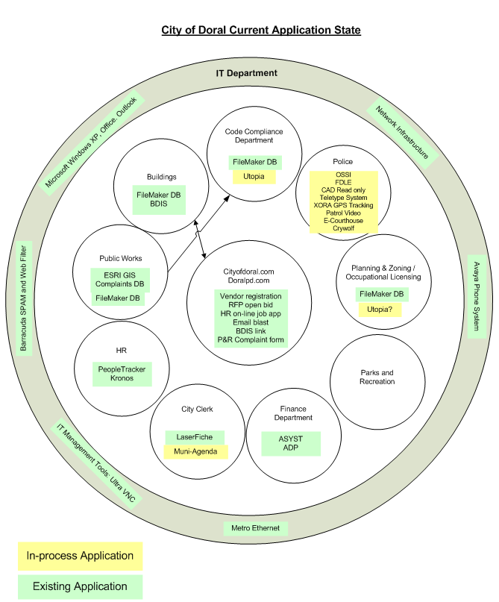
Figure 1 – City of Doral Current Application State
After defining the as-is state, EMA worked with City directors to help determine the “to-be’” state. After completing workshops and helping to determine the City’s priorities, EMA helped the City develop its Strategic IT Plan, which laid out many initiatives and provided a roadmap to a much more efficient to-be state for all departments. Listed below are the general- and project-based IT recommendations to be undertaken during the next four years:
General Recommendations
- Create an Information Technology Steering Committee (ITSC): Establish a mechanism for the City’s leadership to provide Information Technology investments, management direction, and oversight.
- Establish Agreed-Upon IT “Rules of the Road”: Establish a set of well-known, agreed-upon rules that guide decisions and enable more rapid decision-making, increasing the likelihood of good, consistent IT-related decisions.
- Systematize the IT Help Desk Processes: Problems will be clearly identified and quickly resolved based on business priorities. Users can find their own solutions (self-help) and address the root causes of frequently recurring problems.
- Establish and Implement a Project Management Discipline for all IT Projects: Apply project management principles (for example, establishing and communicating clear project schedules, budgets, scopes and goals) to IT projects.
- Establish a Common Methodology for all Enterprise Systems: Apply a common methodology to the City’s IT projects.
- Selectively Implement Best IT Practices: Carefully apply leading IT business practices. Select two or three practices on which to focus during each fiscal year.
- Alignment of IT Staff: Hire two new positions (Business Analyst and GIS Specialist) and re-align existing and proposed staff to meet Doral’s future needs based on the Strategic IT Plan.
Project-Specific Recommendations
- Select and Implement a Vendor-Provided Enterprise Resource Planning (ERP) Package: Replace the current non-integrated financial application (Asyst) and HR application (People-Trak) with an integrated package – an ERP. Include, at a minimum, financial, human resources, and payroll functionality. Benefits include less re-keying of data, improved data accuracy, and timelier reporting.
- Create and Maintain a Consistent Web Site Strategy: Develop a comprehensive external-facing web strategy that addresses the needs of Doral’s constituents, leverages the City’s IT investments, and presents a consistent “brand.”
- Continue to Develop and Integrate the Dashboard to Show a Consolidated View of Key Performance Measures: Ensure that the required organizational capabilities are developed, that processes exist for Dashboard continuous improvement, and that the tool itself evolves to meet new needs.
- Refocus Laserfiche Project: Adopt a benefits-driven approach (along with the current legal compliance/risk management approach) in the integration of existing records management project (Laserfiche) with other systems (for example, BDIS, GIS, Utopia, and potentially the ERP and cityofdoral.com web site). This includes addressing ease-of-use for searching and retrieval of documents to support day-to-day operations.
- Establish a City of Doral Intranet Site Using Microsoft Office SharePoint Server 2007 (MOSS): Facilitate the storage and communication of data, information, knowledge, wisdom, and ideas throughout Doral. Example applications include: automated employee surveys, suggestion box, a consolidated location for key City files, department or employee Calendar of Events, and IT Help Desk support.
- Implement the Planning and Zoning Modules of Perconti’s Utopia Community Development Management Technology: After go-live and stabilization of the Utopia community development management technology in the Code Compliance Department, evaluate the Planning and Zoning modules’ fit, and implement the appropriate modules.
- Develop and Implement a GIS Strategy: Develop a GIS strategy; create a supporting organization structure; hire a GIS specialist; create a centralized spatial data repository; design Doral-specific feature classes (data layers); establish GIS data maintenance practices; collect GPS field data; and implement web and mobile GIS viewers.
- Deploy OSSI: Implement an integrated Records Management System, Computer Aided Dispatch (CAD), and mobile field reporting system that addresses the Police Department’s functional requirements and integrates with other City applications.
- Upgrade Systems to Support Constituent Inquiries and Service Requests: Review and update constituent call flow handling, and implement technologies to enhance their experience as well as Doral staff efficiencies. This includes use of an Interactive Voice Response (IVR) system and Constituent Response Management (CRM) system.
- Consolidate Cell Phone Administration and Support: Unify cell phone administration, procurement, and support into the IT department to achieve economies of scale and improved support.
- Stabilize, Strengthen, and Secure the Network: Upgrade the current City network to provide a robust and secure network infrastructure capable of supporting the City’s business and other IT and technology initiatives (both voice and data).
- Conduct an Annual, Formal Review of the IT Disaster Recovery Response Plan: ensure that the IT disaster recovery plan performs its intended function.
- Formally review and update the IT Strategic Plan every year: ensure that the ITMP is carried out and maintained over time.
- Data Integration: “Glue” existing applications together so that users are able to carry out their work very efficiently, using data from several applications to have an accurate, timely and comprehensive view of data and a minimum of re-keying.
- Select and Implement a Parks/Rec Package: The purpose of this recommendation is to provide support for more efficiently managing recreation activities, classes, and events. This includes memberships, leagues, work orders, inventory, receipts, reservations, and reporting.
Figure 2 displays the to-be state of Doral’s departments and their applications.
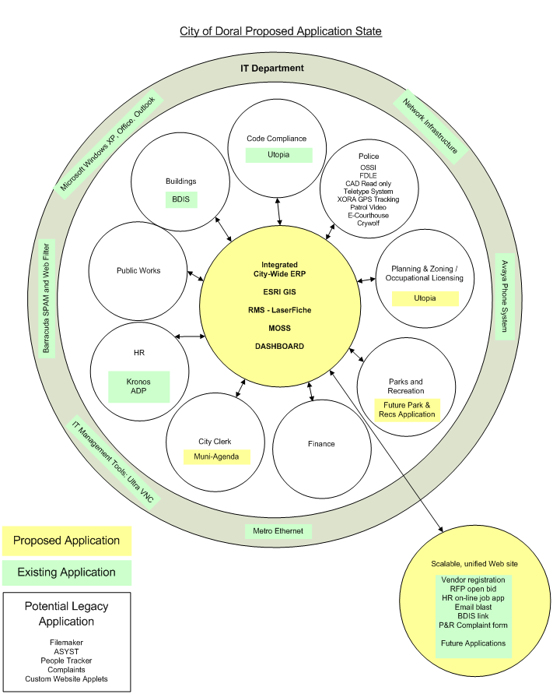
Figure 2 – City of Doral To-Be Application State

Many new technologies were identified during the course of developing the future state. Ultimately, many of these new technologies will be implemented by City workers, and some will be implemented by consultants. This mixed implementation approach will allow the City to balance their employee project workload and use consultants in special needs situations when expert knowledge is needed.
Question 2 - Citizen Outcomes: What customer needs and expectations were identified and fulfilled? How did your initiative improve access to your government? How has the health of your community improved as a result?
One of the main expectations of the consulting engagement was to improve constituent communication and make access to City service offerings more efficient. This directive was addressed by aligning the IT systems to ensure that both front-end customer web systems were directly connected to back-office systems. This eliminates manual interfacing processes as well as the re-keying of data by City employees. Another IT theme focuses on data integration: making sure the future core systems “talk” to each other and data can be shared and accessed between them. For example, the dashboard will be able to “talk” to the Buildings Department database to provide near-real-time metrics.
Another example can be found in both the Department of Buildings and Occupational Licensing Department. When constituents would visit, they would fill out paper forms, which were handed to clerks who then validated them and typed in the data. It was identified that by having constituents and contractors fill out electronic forms on computerized kiosks, it would eliminate the paper process and manual re-keying of data. In certain situations, customers could even perform these functions through the web without having to come on-site.
An opportunity was also identified to require the constituent seeking a new business license to fill out an electronic survey whose data would then feed into the City dashboard. The survey results allow the Economic Development Manager to better understand the needs of the customer. By using electronic surveys, the City is in a much better place to understand the needs of the evolving customer base.
The IT initiatives and examples described above will allow the customer a more seamless and non-bureaucratic approach to procuring City services.
Question 3 - Applicable Results and Real World Advice: What are the applications you could share that would be of value to another local government? What are the results/outcomes? If performance measures were used, please describe those results.
Doral City Government has grown significantly since June 2003 and has transformed into a more mature government structure. During this consulting assignment, EMA has been able to assist in shaping the culture of the overall workforce while the City designs their government and city services. While many of the initiatives are based at increasing IT effectiveness, the benefits of achieving those goals will cascade throughout all of the City’s departments.
Culture Shift and Governance
By assisting in the creation of an Information Technology Steering Committee (ITSC), the city is in a much better position to discuss and evaluate solutions in a broad context. Previously, IT based solutions were determined by the respective Department Director working with the IT Director. This sometimes resulted in a point product solution that could not grow at the same pace as the city. The establishment of the ITSC and their respective oversight gives the city a more uniform approach to technology investments by providing the much needed insight from different Departments’ perspectives. The creation of this governing body minimizes risk and maximizes technology investments which ultimately results in savings and efficiencies to the constituent.
Dashboard and Data Integration
Properly defined measures and electronic dashboards are paramount to a city’s ability to effectively react on a timely basis. These measures also display the health of a department in relation to the city’s overall performance. Data integration between core applications increases the effectiveness and delivery of city services. For example, a licensing and inspections database should be tied to the city’s GIS system in order to leverage planning and zoning metadata. Additionally, the dashboard should cull data from other existing databases.

