Water Conservation Education with a Personal Touch
Manatee County Government, Florida
Ed Hunzeker, County Administrator

Project Leader
Brenda Rogers, Director
Agriculture and Resource Conservation Department
941-722-4524
brenda.rogers@mymanatee.org
1303 17th Street, West
Palmetto, Florida 34221

Presentation Team

Jack Tichenor, Extension Agent
Agriculture and Resource Conservation Department
941-722-4524
jtichenor@ifas.ufl.edu
1303 17th Street, West
Palmetto, Florida 34221

Vicki Zimarino, Water Conservation/Reclaimed Water Program Manager
Utilities Department
941-792-8811 ext. 5416
Vicky.zimarino@mymanatee.org
4410 66th Street, West
Bradenton, Florida 34210

Situation:

Approximately 50% of the water used in a typical home is used outdoors, mostly for irrigation. Studies in the Tampa Bay area have shown that 30% of the water used for lawn irrigation is wasted due to poor irrigation system design and management. As our population increase begins to outstrip dependable, sustainable supplies of fresh water, Florida’s over pumped wells facilitate the intrusion of salt water polluting wells especially along the coast. Alternative water generating sources such as the reverse osmosis water treatment plant in Tampa that convert seawater to fresh water are costly, about three times that of traditional sources pumped from the aquifer. Reducing water wasted by landscape irrigation can significantly reduce our daily consumption rate (129 gallons/day/person) and thereby conserve our precious resource over time. Residents seem generally unaware of the impact their landscape water consumption has on municipal drinking water supply, and generally have little knowledge of water efficient landscape alternatives. For new residents expectations of lush, tropical landscapes with thick, dark green lawns come with the environmental costs of large amounts of irrigation water, fertilizer and pesticides required to sustain exotic plants and thirsty grass. Most new homes are landscaped with sod and equipped with automatic irrigation systems to support these thirsty plantings. New residents are usually unfamiliar with their new landscapes and irrigation systems, their care or water requirements. A typical, inefficient, poorly managed lawn irrigation system could waste over 15,000 gallons of water monthly adding an additional $67 to the monthly water bill. Education on water conservation is paramount in this process.

Manatee County Government adopted an outdoor water conservation rebate program in March of 2003. Financial incentives up to a total of $1500 for implementing water-saving improvements in their landscapes and irrigation systems are offered to utility customers using over 8,500 gallons of potable water per month. Nine rebate categories are available including conversion to alternative water source, installing a rain shut-off switch, soil moisture sensor control, repairing or replacing a defective irrigation system and retrofitting landscape plantings to be more water efficient. The Manatee County Utilities Department and Manatee County Extension Service have partnered to deliver this rebate program. The Extension Service operates a mobile irrigation lab for landscape & irrigation evaluations and provides educational workshops for participants to help them understand how to properly operate and maintain their irrigation systems for optimum water savings. While the rebates are targeted for specific customer profiles, the educational programs including the personal lessons obtained through the mobile irrigation lab are available to all residents.

Outcomes and Impacts:

As a result of receiving landscape/irrigation evaluations for their properties, 319 County residences, businesses and churches with water meters realized a 24% drop in their annual water use or about 39,000 gallons per property per year. Improvements were due to implementation of water saving recommendations received from county staff running the mobile irrigation lab and participation in classes which focus on plant selection and irrigation efficiency. This data came from a comparison of individual water meter readings taken 12 months before and 12 months after the mobile irrigation lab visit. There were another 612 properties without water meters that received landscape/irrigation evaluations during this same 2001 – 2008 period which should have realized similar water-saving results but their water use could not be measured.

Citizens want to do the “right thing” but, many do not even realize they waste water in their landscapes. Since the program began over 22,000 residents have participated in at least one educational opportunity through the program. Surveys taken by the program participants indicate an average of 88% will change their landscape irrigation practices as a result of the training. While the actual reduction in water use is not measureable due to the fact that the majority of these residents use unmetered alternative water sources for irrigation even a 10% reduction in water use can have significant impact on local water supplies.

Cost of Program:

These programs are funded by enterprise funds generated by the upper levels of a tiered water fee schedule and fines imposed for watering violations. The annual budget includes $276,000 for staff, vehicle, and supplies plus an additional $300,000 allocated for rebates.

Savings Realized:

Residents save on their water bills, Manatee County Government saves water, our communities experience increased knowledge and focus on sustainability. If the water savings data from the 319 residents with water meters was representative of all 931 landscape/irrigation evaluations completed from 2001 through 2008, an estimated total reduction in use would be approximately 36 million gallons annually. Exact dollars saved by the 319 participants receiving water bills is difficult to pinpoint due to a tiered rate schedule but a conservative estimate would be about $220 per participant for a total of about $70,000 annually.

Innovative Characteristics:

The program provides a one on one opportunity for homeowners to learn to be efficient in their landscape, with their irrigation equipment. The mobile irrigation lab is a very popular service, appointments are booked months in advance. Cancellations are rare! Seminars are held regularly that address, choosing the right plant and maintaining an irrigation system.

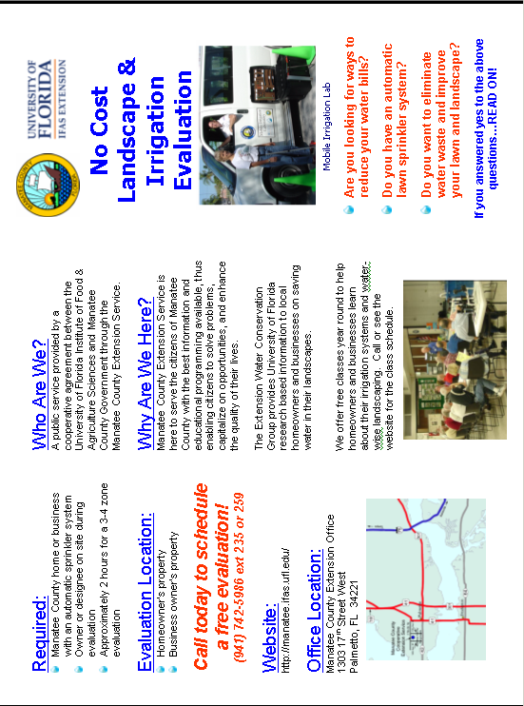
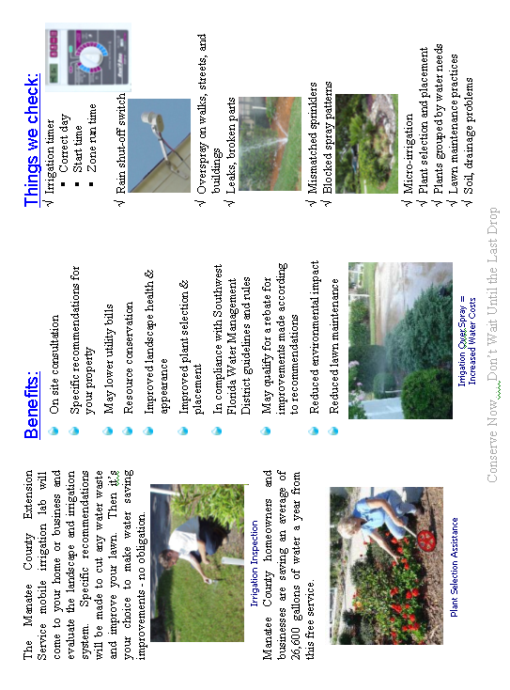
Presentation Components

- Innovation/Creativity
  - The unique components of this program are the one on one education literally “on their turf” with residents and the rebate incentive program which creates awareness even when non eligible residents inquire about the opportunities.
- Citizen outcomes
  - As described above, participating homeowners have realized a 29% reduction in water use.
- Applicable Results and Real World Practicality
  - Practical applications include setting up a rebate program, running a mobile irrigation lab, and a tiered billing strategy for water customers encouraging conservation practices.
  - Water conservation is a concern of governments all over the nation; consequently the topic would be relevant to just about any government with a water utility.
  - Citizens share their positive experiences maximizing the perception of government/citizen collaboration.
- Case Study presentation
  - A video of the mobile irrigation lab landscape assessment (video on demand).
  - Handout materials including a monthly guide for irrigation equipment maintenance and water needs, Water 101 Guide, other materials available electronically via flash drives or cd.
  - Power point with talking points
  - Demonstration on calibrating irrigation system for efficiency
  - Program evaluation strategies including citizen feedback.

