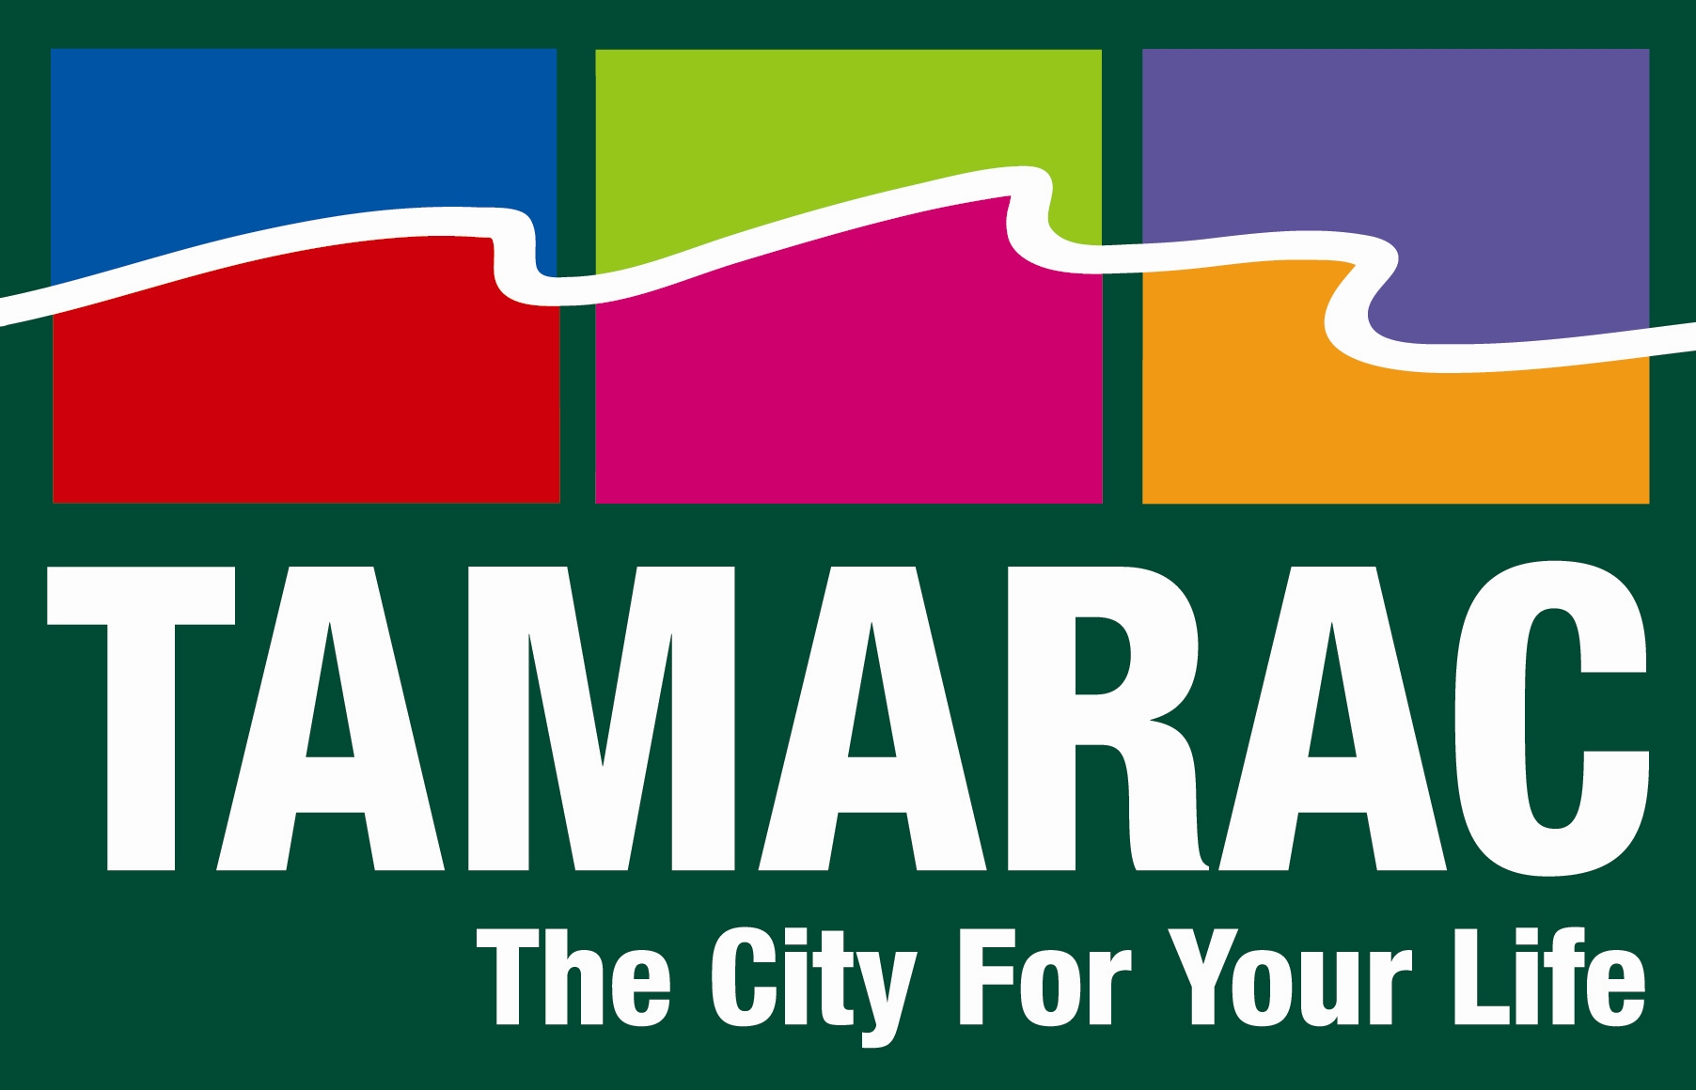

2009 TLG Case Study Application

Case Study Title:
“Beyond Citizen Academies: Keeping them coming back for more.”

Jurisdiction:
The City of Tamarac, Florida

City Manager:
Jeffrey L. Miller

Project Leader/Contact:
Chad Quinn
Public Information Specialist
Public Information Office

City of Tamarac
7525 NW 88th Avenue
Tamarac, FL 33321
Direct: 954-597-3523
Fax: 954-597-3525
Email: chadq@tamarac.org

Presentation Team:
Unknown

Tamarac University is like many citizen academies across the country in that it was created as a way to involve the City’s residents in their government by giving them the behind-the-scenes look that most people never experience, much less think about.

Founded in 2007, Tamarac University was, and continues to be, an effective way to educate a group of residents about the inner workings, intricacies, and nuances unique to local government, and about their City specifically.

What sets Tamarac University apart, and makes it unique from other citizen academies, is the way in which graduates are engaged even after the program ends – through a yearly refresher course, focus-groups, and an innovative alumni program TU graduates have the potential to stay connected to the City long after they receive their certificate of completion.

Background
Since the dawn of Democracy, governments have sought to develop and maintain an educated citizenry. History has proven that the best communities, and thereby governments, are those with an informed and engaged population. The City of Tamarac deeply appreciates this historical trend and employs Tamarac University as one of many tools to build not only community relationships, but more importantly community partnerships.

Tamarac University, is a free, eight-week program that provides competitively-selected participants with a unique view of local government. The program strives to educate participants (residents and business owners) about their local government, but more importantly about their roles as citizens in the process of building the best possible community. Drawing on lessons learned by citizen academies around the nation, Tamarac University affords participants opportunities that extend well beyond the eight-weeks that constitute the core course.

The motto for Tamarac University is: Share. Interact. Represent. Each of these three actions personifies the goals of the program.

Share
The primary purpose of Tamarac University (TU) is to increase participants’ understanding of how their local government functions. Each week, students learn about two Departments from the Directors as well as key personnel. Departments are allotted fifty-minutes to use whatever techniques they deem most appropriate to educate the participants. Departments’ techniques vary almost as much as the areas they oversee, ranging from a monopoly-like game for Finance to a “day in the life” experience for Fire Rescue.

Since the inception of the program, the City has sought to create a collaborative classroom for participants. Rather than use TU as a venue for “selling” a City program or policy, the City instead capitalizes on the opportunity to get unadulterated feedback from the organization’s primary stakeholders – citizens. Additionally, the sharing of information is not confined to those in attendance; each week participants are tasked with sharing what they learn with friends, family, and neighbors.

Recognizing that Tamarac’s government and community are dynamic and ever-changing, each November a “graduate session” is held where alumni are provided the opportunity to refresh what they learned during the program. These annual sessions also provide an opportunity for the rekindling of partnerships that may have waned in the absence of weekly classes and for the City to share new developments. The timing of the graduate session was strategically chosen. It occurs after the City’s new fiscal budget has been adopted [in October of each year] as a way to highlight the changes for the graduates – this has proven to be very helpful as the City, like many cities around the Country, has struggled with decreased tax revenues and cuts in services, programs and personnel.

Interact
While developing TU, the City understood that for the program to be most effective, partnerships must be formed not only between the City and the participants, but also between the participants themselves. The first thirty minutes of each class are non-scheduled, providing time for networking between participants and informal exchanges between participants and City staff. A neighborhood “watch & clean” program was created by participants during this non-scheduled period; a perfect example of what the City hoped would happen.

In addition to using the individual sessions as a thermometer for citizens’ perspectives on City functions and initiatives, current and former students are invited to TU-only focus groups. Recognizing that TU graduates have a more in-depth awareness of how the City works, the group is optimal for “first runs” of presentations and having candid discussions that would be almost impossible absent the civic-education they acquire during the program. In an environment where resources are increasingly less abundant and where service level optimization is the aspiration of all governments, having a group of educated, engaged stakeholders is invaluable.

Represent
Citizen Academies can be found all across the nation and no two are exactly the same; however, one dilemma unites them all – how best to utilize the participants after graduation. The City of Tamarac’s remedy has been the Tamarac University Alumni Ambassador program. Those who elect to become an Alumni Ambassador instantly become the “go to” pool of citizens for things such as focus groups, program improvement, and volunteering. Alumni Ambassadors have provided invaluable input on topics such as taxation and strategic planning. Furthermore, TU has improved each year because of the comments and suggestions from past graduates. Whether or not graduates choose to become an Alumni Ambassador, the role they play as a TU graduate in their community is priceless. In fact, an applicant’s potential for serving as a formal or informal ambassador weighs heavily in the minds of the Tamarac University Selection Committee.

In the short time that TU has been in existence, there have already been some impressive accomplishments by graduates. Several alumni have been inspired by the program to take more active roles in their neighborhoods, becoming Homeowners’ Association (HOA) presidents, HOA board members, and organizers of neighborhood-improvement initiatives. An even larger percentage of past graduates have become “regulars” at City events, whether the event is a City Commission meeting or the annual Holiday Lighting ceremony. It is a refreshing sight to see the increasing number of attendees at any given event wearing their easily identifiable powder blue Tamarac University shirt.

The best example of success beyond graduation came on November 4, 2008, when Pamela Bushnell was elected a Tamarac City Commissioner. Ms. Bushnell had contemplated running prior to taking part in Tamarac University. She cites her TU experience as being the defining moment when running for office transformed from an option to a necessity. It is understood that not every graduate aspires to run for office; however, if a small percentage of the passion that overtook Ms. Bushnell can be imparted in each student, the program is succeeding.

Continuous Improvement
In keeping with the City’s high performance initiative, opportunities for learning were built into the TU framework (by both participants and those who administer the program). Evaluations are conducted at the conclusion of each weekly session, with participants numerically ranking components of the evening’s presentations and providing feedback on what they liked most and least. Additionally, students are able to submit questions and areas of interest for the upcoming class. This information is then cataloged and used the next morning during a “review and prepare” session. The review and prepare session is attended by both the previous evenings’ and upcoming presenters. These weekly sessions allow for continuous tweaking of the program in order to provide the most enjoyable and productive environment for participants. Moreover, each spring a meeting is held whereby Alumni Ambassadors are solicited for comments regarding the curriculum for the upcoming TU program. This meeting has provided valuable information on everything from food choices to course schedule.

Another tool used for improving the program year over year are the pre and post test participants are given the first and last evenings of the class. The pre test helps us to evaluate what areas we need to focus on and clarify over the course of the eight week program. The post test gives us an idea of whether we were able to accomplish those goals – year after year the post test shows an improvement of the classes’ knowledge of their City.

Budget
The budget for Tamarac University is minimal and covers the cost of course materials (notebooks, etc.) as well as light snacks. Salaried staff run the program and make presentations. Due to budget constraints the cost of the program has decreased year over year by reducing the cost of refreshments.

Conclusion
The City of Tamarac had one central goal when Tamarac University was created – “to educate a group of citizens about what we do, so that they can help us do a better job.” To date, the City has almost 100 graduates who are equipped with the knowledge and resources to assist Tamarac in pursuit of its mission of being Committed to Excellence…Always. Tamarac University and the Tamarac University Alumni Ambassador program can be implemented in any community and at very little cost. The greatest expense comes in the form of staff time, formulating the most educational and effective explanation of how their Department impacts the community – a worthy exercise in its own right. Furthermore, with demographics shifting nationwide and civic engagement widely fluctuating, initiatives to educate and establish community partnerships are essential.

After each Tamarac University graduation ceremony, Tamarac’s Mayor offers the graduates three sentences that accurately sum up the goal of this program, “Share your knowledge. Interact with your neighbors. Represent your City.”

Presentation Components:

- Innovation/Creativity:
  - How did the program/project/service, etc. improve the organization?

Tamarac University has improved the organization through the feedback we receive from the participants. This includes everything from suggestions for improvements to the TU experience to suggestions for improvements to the delivery of actual services provided by the City. All feedback and comments are noted throughout the course, talked about at the weekly staff review and prepare sessions, and taken into consideration.

Additionally TU has helped to improve the organization by assisting us in addressing two of our five strategic goals: Inclusive Community and Clear Communication. With regard to Inclusive Community it has helped us to better identify our customers and their needs, gather and use feedback to continually refine programs and services for the community, provide community education and outreach, and develop partnerships. With regard to Clear Communication TU has helped us to increase citizen awareness of the role of local government, encourage citizen participation in local government, sustain an open dialogue with the community, and enhance city visibility of city programs and services.

- Citizen Outcomes:
  - What customer/community needs and expectations were identified and fulfilled?

The need for greater understanding by the average citizen about the workings of their government was a key component of the implementation of the Tamarac University program. In addition, the Alumni Ambassador Program and yearly graduate sessions were born from the need to keep the graduates involved and connected to their community and the local political process.

Every two years the City of Tamarac conducts a Business and Citizen Survey to identify the requirements and needs of our community. The City also conducts a SWOT (Strength, Weakness, Opportunities, Threats) Analysis which is sent to a select group of residents, including TU participants. The information we received from these analysis showed that our City’s demographics were changing and that our residents could benefit from a citizen academy designed to not only educate the average resident about how their government works, but also to help encourage involvement in their communities. Tamarac University was designed to fill that need.

  - Did the initiative improve access to your government?
  - If yes, how?

Access to government has been improved through the involvement of our residents in the program. The surveys they fill out at the end of the program consistently rank access as a key benefit of the Tamarac University experience. Each presenter distributes their business card with direct contact information – whether a department director or code enforcement officer – so that the class participants can feel the direct connection with the presenters and the City as a whole and continue that relationship long after the last class has ended.

In addition to the direct involvement of the participants, access to government in our community has been improved by the knowledge TU students take back to their communities and share with their neighbors.

- Applicable Results and Real World Practicality:
  - What practical applications could you share if selected?

If selected, we would share our experience on how to keep residents who participate in citizen academies connected and involved. This is a key part of the Tamarac University program, one that has evolved since the program began. Often the question of “what do we do with them once the graduate?” would come up… the Alumni Ambassador Program and graduate course became the answers and have proven to not only be popular, but effective. TU graduates make the best ambassadors for the city within the community – they help to disseminate information without the potential of a propaganda slant and dispel rumors because they know the facts and have been able to form educated opinions.

In addition, we would share our evaluation methods, from the pre and post test to the weekly evaluations, Tamarac University is an organic program that is able to constantly improve and be tweaked to the needs of the current class and their areas of interest. The modifications made throughout the program, coupled with the results of the test and evaluations, help us to improve the program year to year.

  - How applicable is the project/program/service to other local governments?

Citizen academies are very applicable to other local governments, but even more so, for those that utilize them, the benefits of keeping the participants engaged and active with the City is immeasurable. Any local government looking for a way to engage and educate their residents, for a way to open up the lines of communication, for a way to build a dynamic program responsive to the needs of both the participants and the presenters and able to change as those needs change, would surely find the Tamarac University model to be very applicable.

  - What results/outcome will you be able to share?

We will be able to share our unique experience of keeping graduates engaged and active participants of the City and the political process as well as the intense and constant evaluation process which allows for improvements and customization of the curriculum, not only from year to year, but from week to week during the program.

  - Please include any performance measures, if applicable.

The performance measures for Tamarac University include pre and post tests as well as weekly evaluations of the topics and presenters. The combination of these test and evaluations helps to improve the program from year to year and from week to week. It allows for the tailoring of the curriculum based upon the specific needs of the class participants.

- Case Study Presentation:
  - Briefly describe what your case study presentation might include.

We will include a PowerPoint presentation, video taped interviews/testimonials from past Tamarac University participants as well as sample handouts, brochures, and mailings.

