Animal Services – Creating a Win-Win
Reducing Costs While Improving Customer Service and Public Support

Washoe County, Nevada
Katy Simon, County Manager

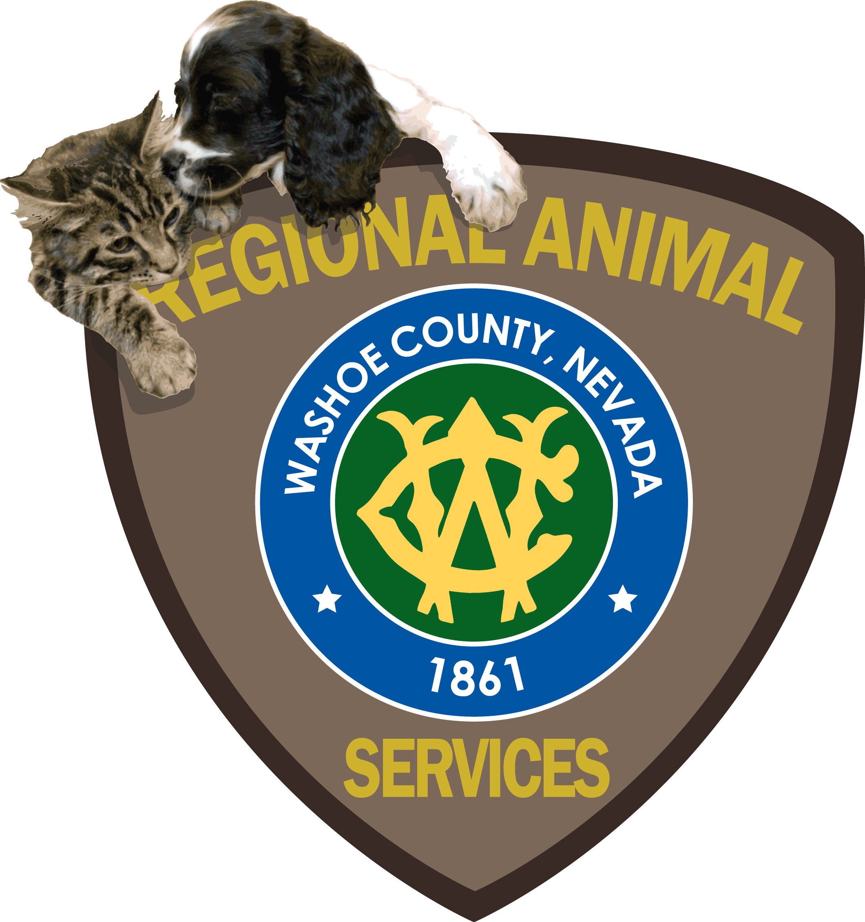

Project Leader: Mitch Schneider
Manager
Washoe County Animal Services
(775) 328-2142
mschneider@washoecounty.us
P.O. Box 11130, Reno, Nevada 89520

Other Presenters: Bonney Brown
Executive Director
Nevada Humane Society
(775) 856-2000 ext. 319
bonneybrown@sbcglobal.net
2825-B Longley Lane, Reno, Nevada 89502

Dr. Diana Lucree
Veterinarian
Community Cats (feral cat program)
(775) 742-0489
dlucree@yahoo.com
P.O. Box 60284, Reno, Nevada 89506

Animal Services – Creating a Win-Win
Reducing Costs While Improving Customer Service and Public Support
By Lt. Mitch Schneider

Introduction
If reducing costs for your animal services’ program, while improving customer service and public support, interests you then Washoe County, Nevada may provide some ideas that can benefit your program. Washoe County Regional Animal Services (WCRAS) has been gaining some national attention for having one of the lowest euthanasia rates in the country. This success is due to a combination of a collaborative relationship with the local animal rescue organizations, its use of technology and its pet friendly policies. This combination is not only providing better customer service and garnering strong public support but it is also proving to be cost effective; creating a true Win-Win for the community.

Background
The first step in Washoe County’s transformation was voters passing a referendum in 2002 that funded the construction of a new facility and animal services’ operations. As part of that referendum Washoe County also consolidated the cities of Reno and Sparks animal services departments into a county operated regional program and, at the same time, entered into a formal partnership with Nevada Humane Society (NHS). This public-private partnership provided for both agencies sharing the new facility which opened in 2006.

WCRAS focuses on the public health and safety concerns while also protecting the wellbeing of animals and NHS accepts the owner surrendered pets in addition to saving as many of the animals abandoned at WCRAS as possible; then working tirelessly to re-home them. NHS also provides a hot-line to assist pet owners in addressing many of the common pet behavior problems, and other concerns, that frequently result in an owner abandoning a pet.

Understanding the Priority – Reducing Pet Abandonment
Abandonment of animals is a major source of cost to a community’s animal services’ program. In Washoe County nearly 5,000 dogs and almost as many cats are impounded at the shelter each year; of the 5,000 dogs impounded, approximately 50% are abandoned by their owners. This could result in a significant amount of funding being spent on the euthanasia of the abandoned animals if not for working closely with the animal rescue groups. When an animal services’ program recognizes the economic and social costs of animal abandonment, tackling this problem becomes a priority.

Compounding the problem, many traditional animal services’ programs follow an approach that parallels parking enforcement. In some parking enforcement situations a vehicle is towed and impounded and held until the costs of the towing and impound fees are collected. This makes sense when you have a vehicle that is worth a substantial sum of money but it doesn’t work quite as well when you’re talking about an animal that, more often than not, has little or no monetary value. This approach to recovering costs of animal services often increases the need for more shelter space and increases the abandonment and euthanasia rates, which in turn increases the cost of the program. Additionally, this approach fails to recognize that most people consider pets to be a family member and therefore the traditional business model does little to garner public support.

Focusing on the Priority - Collaboration
Many animal services’ programs and animal rescue groups focus on the difference in their primary missions; animal services’ focus being public safety and animal rescue’s focus is saving animals. By doing so, they often fail to recognize the commonality in their missions and resist working with each other, either intentionally or through conflicting policies and practices. As a result, some animal services’ program may be overlooking a significant opportunity to reduce costs and increase community support. WCRAS is embracing the efforts of animal rescue groups and has found that working closely with these groups has dramatically reduced the need for euthanasia. Last year NHS transferred 3,762 dogs and cats from WCRAS for adoption, with the other rescue groups saving another 1,461 for a total of 5,223 dogs and cats. Their tremendous accomplishment resulted in a significant cost savings for the animal services’ program, increased public support and reduced stress for the staff members that perform euthanasia duties; reducing “staff burnout” and subsequent turnover. WCRAS tries to make it easy for the rescue groups to take pets who are not reclaimed by waiving any fees.

In Washoe County, NHS and a number of other local animal rescue groups are working together to create a “No-Kill” community by reducing the need for euthanasia of healthy, adoptable animals. This initiative, also seen in many other communities, is receiving strong public support and therefore it will be important for WCRAS to continue to work closely with these groups to ensure polices, practices and laws work in harmony with their efforts in order for the community to reap all of the benefits of this endeavor. Communities and/or organizations that want to work toward reducing euthanasia may also qualify for grants from Maddie’s Fund; to find out more about this program visit their web site at www.maddiesfund.org.

Another program that also involves collaboration with an animal rescue group deals with feral cats. WCRAS works closely with Community Cats, a Trap-Neuter-Return (TNR) program run by Diana Lucree, DVM. This program offers an effective approach to dealing with feral cat problems within the community; something most communities struggle with, at least in the more temperate climates. WCRAS has found that approximately 90% of people reporting a concern with feral cats would rather handle this problem through a non-lethal program. This approach is gaining strong public support and many animal services’ programs around the country are now turning to TNR. In addition to reducing euthanasia it also greatly reduces shelter expenses for housing these cats. Note: Maricopa County (Phoenix area) requires citizens use the TNR program for feral cats or pay a $96 fee for each cat brought into their shelter.

Focusing on the Priority – Policies and Practices
To reduce the likelihood of needing a larger shelter facility in the future, at a cost in the millions of dollars, WCRAS policy directs Animal Control Officers to make every reasonable effort to return animals to their owner instead of impounding the animal. In addition to checking the pet for identification (tags or microchips), officers will check lost reports and/or with area residents in an attempt to determine if anyone knows were the animal lives. In addition to reducing sheltering costs, this policy also reduces animal abandonment and enhances public support. A dog license is promoted as “Your Dog’s Ticket Home”; providing a true benefit for licensing increases voluntary compliance, further reducing shelter needs and the inherent potential for abandonment. Note: upon returning the animal to the owner all laws are enforced and warnings or citations issued as deemed appropriate.

Another traditional practice in animal services that increases abandonment is the policy of not allowing an owner to redeem their pet if they can’t pay all of the fees at the time of redemption. Continuing to hold the animal until all of the fees are collected simply increases the redemption fees for the pet owner, increases the need for shelter space; it may also reduce public support and increase abandonment and euthanasia rates. To address this issue Washoe County has established a billing system; this is only done with supervisor permission to ensure that it is only offered as a last resort and kept to a minimum.

Typically, for a variety of reasons, it is difficult to make good use of volunteers in animal services work. However, they can be invaluable as a Pet Detective, where they can have a positive affect on reducing abandonment. Volunteer Pet Detectives at WCRAS assist pet owners in looking for their lost pets and comb lost pet ads in the local paper to look for possible matches with pets in the shelter. The program provides a valuable service to those that have lost their pet and also reduces the need to have paid staff dealing with this somewhat time consuming public assistance. Volunteers find it rewarding as they get to perform a function that is challenging while also helping to increase redemptions. A program of this type can also play an important role in reducing the likelihood of receiving negative media attention and/or reduce the potential for civil liability stemming from the accidental euthanasia of someone’s lost pet.

Focusing on the Priority – Technology
To increase licensing, Washoe County dog owners have the convenience of licensing their pets on-line through the county’s web site at www.washoecounty.us/animal. Additionally, photos and descriptions of all the animals impounded at the shelter are posted to the county’s web site so that pet owners looking for a lost pet can do so from any computer with internet access. Pet owners without a computer can ask a friend, neighbor or relative to look for their pet online. Without the associated time and expense of driving to the shelter everyday, people will continue to look for their pets for longer periods of time. Citizens can also file lost or found animal reports online. Making it more convenient, less costly and less stressful for pet owners to find lost pets or to license their pets can reduce animal abandonment, it also reduces the staff time spent assisting citizens. Increasing pet redemptions also reduces the pressure on animal rescue partners who have the task of re-homing abandoned animals.

Imagine what the world of law enforcement would be like if vehicles didn’t have VIN numbers and/or license plates, that’s been animal services’ world, until now. The MICROCHIP has been around for roughly 20 years yet this device is still not understood by many pet owners; less than 20% of pet owners microchip their dog or cat. This is tragic because microchips will likely prove to be the single most important technology and step towards reducing the abandonment of animals, not to mention the value they provide in helping pet owners recover lost animals. As such, it is important for animal services’ programs to do as much as possible to promote this product and encourage pet owners to avail themselves to the benefits of the microchip. A microchip is particularly valuable to cat owners who tend to be reluctant to put a collar on their pet and should also be promoted as an important element of any pet owner’s personal disaster preparedness plan. WCRAS recently succeeded in getting state regulations modified so that licensed Euthanasia Technicians can implant microchips without a veterinarian, this dramatically reduces the cost since shelters are able to purchase microchips for as little as $5. This reduction in cost will allow the county to consider programs and laws to further promote the microchipping of pets. Note: State of Illinois requires that all animals impounded be microchipped upon redemption or adoption.

Operational Principals
- Collaboration with community animal rescue groups can reduce program costs
- Establishing niche volunteer opportunities can reduce costs and improve customer service
- Impounding pets, unless absolutely necessary, is not in anyone’s best interest as it:
  - Increases the need for a larger facility to house more pets
  - Increases stress for the owner and animal alike
  - Increases staff needed for care of the animals
  - Increases abandonment and the associated euthanasia costs
  - Reduces public support
- Returning animals to owners in the field and issuing the appropriate warning or citation is a more cost effective approach and increases public support
- Increasing pet registration is necessary to reduce the need for impounding of pets
- Pet identification through licensing and microchipping initiatives can have a very positive affect on a program’s costs and is an important part of an animal services’ business plan; the City of Calgary funds their entire program through licensing fees for dogs and cats
- Promoting Trap-Neuter-Return for feral cats reduces costs and increase public support.
- Encouraging spaying and neutering through differential licensing fees helps to address the pet over-population problem
- Providing problem pet behavior assistance through a help line and other educational materials is helpful in reducing the abandonment of pets
  - Pet behavior problems cause people to “fall out of love” with their pet and is a major reason for abandonment at shelters
    - Common reasons for abandonment are barking, house-training, chewing, digging and repeatedly running away

Conclusion
With a willingness to move away from traditional practices when necessary, by utilizing current technology to its fullest and collaborating extensively with local animal rescue groups an animal services’ program can reduce costs, increase public support and create a pet friendly, Win-Win program for their community.
PRESENTATION COMPONENTS

Innovation/Creativity
The public-private partnership between the Washoe County Animal Services Center and the Nevada Humane Society has resulted in a win-win for our community, our community’s animals and county government itself. Consolidating animal services under county government and using voter approved funding to build and operate a regional animal services center which was supplemented with $2 million of private funding from the Nevada Humane Society has enabled Washoe County to reduce the cost of service to the citizen while improving service at the same time. For example, of the nearly 5,000 dogs which are impounded at the shelter annually, nearly 50% were returned to their owner which reduced shelter costs, euthanasia rates, and stress on county employees who must care for, and ultimately, euthanize animals that are unclaimed. Our partner, Nevada Humane Society, and other animal rescue groups, saved a total of 5,223 dogs and cats by finding adoptive homes for them.

Community support for the County’s animal services has also been greatly enhanced by this partnership as it supports the Nevada Humane Society’s advocacy of a “no-kill” community. The County’s policy and practice of a “pet-friendly” community has garnered support for the County’s program by the influential animal advocacy groups in the area. These are the same animal advocate groups that created a grassroots public awareness campaign that helped get the 2002 animal services bond passed by nearly 60% of the voters.

Technology has played a major role in Washoe County’s ability to meet the goal of reducing the number of animals in its shelter and, thus, the community’s euthanasia rate. For example, every pet that is either reclaimed from the County’s shelter or adopted through our co-tenant, the Nevada Humane Society, must be neutered/spayed and microchipped. Although only 20% of all pet owners chose to microchip their pet, Washoe County believes microchipping is the single most important technology and step towards reducing the abandonment of and recovery of animals. The County was successful in getting state regulations changed so licensed euthanasia technicians, rather than veterinarians, can implant these microchips thereby reducing the costs. Allowing pet owners to license their pets on-line via the County’s website as well as search a photo database of animals in the shelter are other examples of ways Washoe County uses technology to find innovative ways to match available animals with responsible pet owners.
The partnership agreement between Washoe County and the Nevada Humane Society, the creation of the county website with the on-line licensing and photo gallery as well as on-demand videos with pet tips were all done by county staff in conjunction with the NHS personnel.

Citizen Outcomes
The 2002 ballot question which enabled the passage of a property tax increase to consolidate animal services under Washoe County and allow for the construction of a new facility was citizen-generated. A grassroots citizen campaign was borne out of animal advocates who wanted to see the 40-year old city-operated animal shelter replaced and better operational procedures implemented. The ballot question was approved by 60% of the voters. When the Washoe County Regional Animal Services Center opened in 2006, the community celebrated the grand opening as it truly marked the beginning of a new era in how our community viewed public safety vis-à-vis our animal population. Accessibility to both county-operated animal dispatch and shelter as well as the privately-run adoption services were increased, and many special open houses were jointly promoted in an effort to increase interest in pet owner responsibility and pet adoption. As a result, Washoe County has one of the lowest euthanasia rates in the county with 9% euthanasia rate for dogs and 12% for cats compared with the overall national average of about 50%. We are very proud of the fact that we save about 91% of all dogs and 88% of all cats that end up at our shared facility, and believe our national recognition for achieving this success is due to a collaborative relationship with local animal rescue organizations, use of technology and pet-friendly policies as previously described.

Applicable Results and Real World Practicality
Washoe County and the Nevada Humane Society are passionate about sharing our success story with others, especially other local governments who are grappling with an overabundance of animals in their community that are threatening public safety as well as increasing euthanasia rates which, in turn, create for poor relationships with local animal advocacy groups. Washoe County would be more than happy to share the step by step process: from the ballot question development and consequent community campaign, to the formal agreement between the County and the Nevada Humane Society to co-locate in the new facility, to the actual design and construction of the state-of-the-art building with standards similar to a hospital, to the daily operation of the facility, to the continuous public education which garners community support, to the ever-increasing use of technology to match people with animals, and to the ultimate goal of creating a pet-friendly community as evidenced by an ever-decreasing euthanasia rate. It is our hope that by sharing our story, other governments can replicate our success in this area.

Case Study Presentation
Animal Services – Creating a Win-Win: Reducing Costs While Improving Customer Service and Public Support would be presented by three principles: Lt. Mitch Schneider, Washoe County Animal Services Manager, Bonney Brown, Executive Director of Nevada Humane Society, and Dr. Diana Lucree, veterinarian with the Community Cats program. They would use a PowerPoint presentation to convey some of the data used to measure the program’s performance and success as well as show parts of the physical facility which are especially innovative. Washoe County can also demonstrate both online animal services and on-demand videos on the County’s website that increase both citizen accessibility as well as public education; the Nevada Humane Society has similar features on their website that can also be shown.

