6th ICPA Paper

International Comparative Study of Key persons on Local Government Organizations
～Conceptual and Practical Analysis of Leadership Development through Strategic Human Resource Training in Local Government Administration to Meet the Demands of the Future Borderless Global Economy

1. Tetsuya Endo 2. P. Michael Paules
1. Aomori Public College, Japan
2. California State University, Los Angeles, U.S.A

Abstract

Governments around the world are experiencing a leadership crisis of epic proportions. In the United States and Japan citizen satisfaction surveys show deteriorating public confidence in governments at all levels. There is an urgent need for public managers to focus energy and resources on developing new leadership capacities to avoid the “death spiral” of evaporating public trust that many public agencies currently face. This paper presents a number of practical applications of LPM theory utilizing On the Job Learning (OJL), both at the individual and organizational levels, as the mechanism for maturing organizational leadership capacity. These examples incorporate the best practices from the Excellence Management, Values Leadership, Trust Cultural Leadership, and Spiritual Leadership models.

In this paper, case studies for the development of human resources in the organizational strategy of the U.S.-Japan are analyzed. By actively identifying Key persons among their staff and offering leadership training, governments can proactively address the challenges facing them in an increasingly complex and rapidly changing world and restore public confidence in government.

Key words : Key persons, Leadership, LPM, OJL, Learning Organization, Organizational Strategy

1. Introduction

The rapid rate of societal change associated with globalization has created enormous pressures on the public sector to embrace new paradigms for managing human resources. Growing public discontent concerning the performance of governments throughout the world has created a leadership crisis as public managers navigate the changing and sometimes treacherous waters of public expectations. In the United States and Japan, citizen satisfaction survey results show deteriorating levels of public confidence in government at all levels. For example, only 22% of Americans surveyed in 2010 said that they trust the federal government to do what is right “most of the time” or “almost always.” (Seventy-three percent expressed confidence in the federal government when these questions were first asked in 1958.) Similar levels of declining public confidence are also prevalent with regard to state and local governments.

The starting point in addressing this crisis is to consider the essence of leadership. In his landmark book, James McGregor Burns defines leadership as “inducing followers to act for certain goals that represent the values and the motivations—the wants and needs, the aspirations and expectations—of both leaders and followers. And the genius of leadership lies in the manner in which leaders see and act on their own and their followers’ values and motivations.” Bernard Bass in From Transactional to Transformational Leadership expanded on Burns work by proposing that people who do not naturally possess leadership abilities (trait theory), or have the occasion to be thrust into a leadership role by an extraordinary event (event theory) can develop leadership skills and transform the lives of the people they lead (transformational leadership).

With the proper motivation and a supportive environment, a person can become an effective leader through training, experience and emulation of trusted role models. To inspire workers to higher levels of teamwork, there are certain qualities a leader must have. These include clearly defined values, character, ethics and knowledge. These attributes most often do not come naturally, but are acquired through continual work and study. With all the leadership models competing for supremacy in the academic literature and the ‘flavor-of-the-month’ approach taken by many executives in embracing popular leadership trends, how does a public manager cut through the confusion and find universal principles of leadership?

The history of the science of public administration offers an initial clue while posing a problem. Most academics differentiate between management and leadership. Management is generally viewed as the technical processes of governance while leadership is given higher qualities of vision and values. The Wilsonian politics-administration dichotomy that provides the basis for the subsequent evolution of American public administration theory states that politics and administration are distinct and separate pursuits. Following this perspective, public managers should be free from political interference in applying professional management principles to public agency operations while respecting the policy prerogatives of elected leaders. Strict adherence to the dichotomy doctrine restricts most leadership roles to elected policy makers and relegates public managers to primarily technical roles.

Public administration theory has gone through many changes since the time of Woodrow Wilson. Many modern models imbue public managers with substantial responsibility for shaping, as well as implementing, public policy. This means that public administrators must learn and embrace effective leadership principles in order to be effective.

If policy development today is a shared task between elected officials and public managers, how do elected officials and managers get ‘on the same page’ in their approach to leadership? Matthew Fairholm offers a model which can be applied to the politics-administration dichotomy building on Hersey and Blanchard’s view that “the leadership perspective is the umbrella under which different leadership styles may be pursued or expressed.” Fairholm continues, “Leadership perspectives, therefore, are not leadership styles to be changed willy-nilly. Rather, leadership perspectives are paradigms and worldviews (leadership philosophies) that need not necessarily change over a lifetime, but may be grown and changed through concerted training efforts, life experiences, and learning opportunities.” The practical problems facing governments today are driven by the size and complexity of public issues and rapid technological, economic and social change. If one looks at government dilemmas like the worldwide financial crisis, the collapse of the housing bubble in United States or the 2010 BP oil disaster in the Gulf of Mexico, there is one common theme underlying the flawed and inadequate government responses—the lack of a clearly understood and accepted leadership model to guide the actions of government officials. Until leadership catches up with the economic and technical advances of the 21st century, public support for governments will continue to decline. The risks and dangers facing advanced societies are growing at a rapid rate and, without astute and effective leadership by government officials, the public will be held captive by the increasing dangers of the modern world.

2. Theory and Research Findings

Ichii Saburo (1963), a Japanese Professor of Western philosophy, defined human progress in terms of “the degree to which individuals are not forced to suffer for things not of their own making” (Wakabayashi, 1995). He believed that, "Reality is a product of collaboration with the law and a person’s subjectivity." And, ”Because subjectivity is not totally free, but is not restricted completely, from this point of view, social practice with revolutionary directivity is necessary to be led by the one to be called a key person” –a theory that especially considers collaboration of both. From this perspective, as Anthony Giddens (1977) described, structures must be conceptualized not only as constraints upon human agency, but also as enablers.

Ichii Saburo's Key Person Theory focuses on non-traditional leaders who have been active in the turning points of history. For example, Ryouma Sakamoto, a member of the lower class (samurai) with high will, helped inspire the dramatic societal change of the Meiji Restoration in Japan. Although Ichii’s Key Person Theory is most commonly associated with the big events of history, this paper pursues the hypothesis that it is possible to apply the theory to not only macro but also micro problem solutions in public administration. In this paper, we define Key persons as the persons who naturally influence others. And Keypersonship is a philosophy and practice of servant leadership, sharing power and developing trust between leaders and followers by focusing on their whole-soul (spiritual) essence.

When a Learning Organization (Senge, 1999; Endo & Onodera, 2010) is constructed, the central consideration is how to mature key persons and organizational culture. Hersey and Blanchard’s (2007) Situational Leadership Model provides the foundation for universal principles of leadership consistent with major schools of thought in public administration. Gil Fairholm (1998) suggests that people view leadership in at least five different ways. He explains that while the leadership perspective that someone holds may not be the objective reality about leadership, people holding that view behave as if it is (Fairholm, 2004). He posits five distinct leadership mind sets that emerge from experience and literature from the past 100 years or so. The first is leadership as scientific management. This perspective equates leadership with the type of management that draws on the scientific management movement. The second perspective is leadership as excellence management, which suggests that leadership is management but focuses on the excellence movement popularized in the 1980s by Peters and Waterman (1982), Deming (1986), and Juran (1989). The third perspective is leadership as a values-displacement activity. This perspective defines leadership as a relationship between leader and follower that allows for typical management objectives to be achieved primarily through shared values, not merely direction and control. The fourth perspective is leadership in a trust culture, which shifts the focus toward the ambient culture where interaction between the leader and the led is based on trust founded on shared values, recognizing the follower as having a key role in the leadership relationship. The fifth perspective is whole-soul (spiritual) leadership. This perspective builds on the ideas of displacing values and maintaining a culture of trust, as it focuses attention on the whole-soul nature of both the individual leader and each follower.

In applying the concept of Keypersonship to the Situational Leadership Model of Hersey & Blanchard, it is possible that the performance may decrease as a whole when human skills and traditional leadership models are not enough. In this respect, the Leadership Perspectives Model (M. Fairholm) is useful. In LMP, spiritual leadership subsumes the philosophies of the scientific management, excellence management, values leadership, and trust cultural leadership, and the organic whole becomes important. In a word, spiritual leadership rules the entire concept drawing on the strengths of the underlying leadership philosophies. Fairholm (2004) defined “spirit” in terms of the basis of comfort, strength, happiness; the essence of self; the source of personal meaning and values; a personal belief system or inner certainty; and an emotional level of being. He treats it partly as equivalent to emotional intelligence. There are some clues when we consider the“spiritual” nature of “spiritual leadership.” One of those is process philosophy founded by Alfred North Whitehead. From the point of view of process philosophy, it seems that we can treat the aspect of “spiritual” more universally, even if it is based on different philosophical or religious beliefs. We would be able to treat different thoughts such as Christianity, Buddhism or Confucianism on the same basis. Therefore, the meaning of the "spiritual" as used in this paper is "inclusive consciousness which promote the growth of the self serving person and idea,” following the definition of Fairholm.

In the Situational Leadership Model of Hersey & Blanchard, leader and led are distinguished by maturity of human skill and task-related technical skill. But we propose that the Key person model has three dimensions adding the spiritual dimension with the task and relationship dimensions (See Fig.2). Fairholm insists the LPM model embraces five leadership perspectives. In a sense, the maturity of the task technical skill (one axis of the Hersey & Blanchard model) is equal to the level of the skill of the scientific management and technical side of excellence management within the LPM model. And the maturity of human skill (the other axis of the Hersey & Blanchard model) is equal to the level of the skill of the human factor side of excellence management, values leadership and trust cultural leadership.

We can draw the relationship of two persons who have different levels of Keypersonship (See Fig.1). In the Fig.1, person A is more outstanding than B from the point of Keypersonship. The relationship to other Key persons, including followers, can correspond like the Hersey & Blanchard model.

Spiritual Behavior

Supportive Behavior
Keyperson A

Keyperson B
Situational leadership Model
Directive Behavior

Fig.1 Dialogue with Key persons A and B

In the investigation concerning Learning Organizations in Japan (Endo & Onodera, 2010), a statistical difference was found in the relationships of Personal Mastery, Shared Vision, and Positive Thinking with the factors of Work Improvement and Policy Improvement (Innovation). The relationship between Personal Mastery (P. Senge) and performance is especially strong (See Fig.2). In this paper this relationship is analyzed further from another viewpoint using the following hypothesis: The more spiritual leadership is practiced in an organization (in this paper, spiritual leadership it is referred to by the term “Keypersonship”), the more Work and Policy Improvement (Innovation) will increase.

Personal Mastery
．377***
Action efforts for Work Improvement、Policy Improvement (Innovation)
(Adjusted R2=464）

．217**
Positive Thinking

．235**
Shared Vision
N=149
**p＜.01, ***p＜.001

Fig.2 The result of multiple linear regression analysis from the eight measurement factors of Keypersonship to the factors of work improvement and policy improvement (innovation)

Couching and leadership skills development are valuable for the promotion of Keypersonship in personnel training. In this paper, case studies for the development of human resources in the organizational strategy of the U.S.-Japan are analyzed.

3. Case Study in the U.S.A.

In the U.S.A., the International City/County Management Association (ICMA) has implemented a comprehensive leadership development program for entry-level and mid-career professionals known as the Preparing the Next Generation (PNG) Initiative. The driving force behind this effort is the fact that in the United States there are 80 million baby boomers (born between 1946 and 1964) who will be retiring while there are only 50 million Generation-Xers (1965-1977) available to fill the available positions. The talent replacement problem is particularly challenging in the public sector as many young professionals are choosing career opportunities in the private and non-profit sectors because they view government service as offering fewer opportunities and rewards.

ICMA’s California affiliate (Cal-ICMA) is meeting this challenge by offering professional development and mentoring services through the PNG Coaching Program which includes the following elements:

  - One-to-One Coaching
Aspiring managers can identify a senior manager coach (chief executive, department head, or senior manager) from the “Coaches Gallery” on the Cal-ICMA website and establish an ongoing mentoring relationship.

  - E-Coaching
Emerging leaders can submit questions on challenging job or career issues to a panel of senior managers who respond by e-mail from their own perspectives.

  - Telephone Panels and Webinars
The Coaching Program offers three telephone panels and four webinars on topics such as developing essential competencies, tapping career opportunities, keys skills for civic leadership and interactive case study analysis.

  - Local Area Networking and Speed Coaching Events
Each of California’s 18 city manager groups hosts a networking event at one of their monthly meetings in which up-and-coming talent interact with experienced managers.

  - Accelerated Leadership Development Series
The Cal-ICMA Coaching Program has partnered with an established public official training organization to offer an accelerated five-day skills development course for emerging leaders. Similar initiatives have been launched by city manger groups in association with public universities, including the Southern California Local Government Leadership Academy offered by California Polytechnic University, Pomona.

  - “Women Leading Government” Initiative
A series of educational events and networking opportunities are offered each year for aspiring women manages.

  - City/County Manager University Programs
To attract young people to local government management careers, two university partnership programs have been established. The City/County Manager in University Residence program places city managers in week-long teaching and mentoring relationship at leading universities throughout the year to give students pursuing graduate degrees in public policy and administration direct interaction with working professionals. The City/County Management Fellowship program at the University of Southern California provides scholarships and hands-on professional mentoring for 5-7 graduate students pursuing advanced education in public administration.

4. Case study in Japan

In Japan, public administration has been influenced by the Small Group movement and the Kaizen movement of the private sector and aspects of the New Public Management (NPM) movement. However, an excessive results orientation has caused the criticism that the focus has been on outputs to the detriment of quality and process. As the discussion has progressed, the focus has turned to knowledge creation. The term of On-the-Job Learning (OJL), which emphasizes respect for human factors, has been used as the new organizational strategy training method in the Local Government Official Learning program of the Fukushima Municipal Learning Center in Japan. OJL seeks to mature Key persons and the culture of Learning Organizations (LO) through visioning and self-directed learning, creating a sense of fulfillment through individual and team accomplishments. A Learning Organization regards the dual nature of public employees as citizens and employees in a way which creates mutual understanding and respect in meeting public goals.

The Fukushima Municipal Learning Center aims to educate local officials through group case studies in OJL. The strong point of Japanese management is the team concept. In Japan, officials have been encouraged to use voluntary group studies and an expanded approach to Kaizen (Total Quality Management) to improve motivation. There has been bureaucratic resistance and organizational cultural impediments to change, slowing the implementation of a more mature human resources performance rating system and improved coordination with social enterprises, including non-profit and non-governmental organizations.

Since leadership is a difficult skill to teach, role models have an important place in leadership development. At the Fukushima Municipal Learning Center, local officials who exemplify high degrees of Keypersonship are studied. These include:

- Dr. Makoto Murase, an official of Sumida-Ku in Tokyo, who became famous as “Dr. Rainwater” by founding a social enterprise promoting rainwater recycling to benefit the environment.

- Mr. Masayuki Kishikawa, an official of Town of Taki in Mie Prefecture, who brought together funding and professional expertise to create a restaurant which is managed by high school students. He is a true servant leader in economic development and community building.

- Mr. Yasuyoshi Kobori, an official of City of Kishiwada in Oosaka-Fu, who invented a local administrative system for performance ratings based on the human development principles embodied in the LO model for the first time in Japan.

- Mr. Kenya Katayama, an official of Town of Niseko in Hokkaido, who championed information disclosure by public agencies and citizen engagement as Mayor and as an advisor to the federal government.

Some of the forgoing key persons were called to make presentations in the OJL programs. The Fukushima Municipal Learning Center produced videotapes and DVDs in association with a private company showing some of the innovative activities conducted by these leaders in their communities. Training participants are able to use these case studies for group discussions. They are encouraged to make improvement and innovation happen by studying the cases complimented by written materials and interaction with real Key persons who have mastered the highest levels of leadership.

5. Survey Results

A survey to measure Keypersonship and the performance action efforts of local government staff members was completed by 370 officials in Japan and 110 in the United States, for a total of 480 responses. Questionnaires were delivered in person to 53 staff members (23 in the U.S. and 30 in Japan). 340 questionnaires were collected by e-mail and telephone in Japan. We also administered a digital survey in which 87 local government officials in the U.S. responded.
The questionnaire utilized the concept of the Servant Leadership model which is the basis of LPM and spiritual leadership. The survey examined the relationship between the level of Keypersonship and the level of the action efforts of the respondents for making improvements and innovation happen in their organizations and in society.
In this survey, the recovery rate was 93.75%. (Male respondents: 69.2%, Female 30.8%.) Position classification as follows:
- Managerial status responsible for the whole department/division: 21.7%
- Senior staff member of the department/division: 18.2%
- Middle staff member in charge of the workplace: 23.6%
- Staff member not included in the above: 36.5%

It is suggested, as a whole, that the higher the degree of Keypersonship, the more action efforts happen for improvement and innovation in local government organizations and society. (Fig.3)

Keypersonship
β＝.711***
Action efforts for Work Improvement、Policy Improvement (Innovation)
(Adjusted R2=505）

N=473
***p＜.000

Fig.3 The results of regression analysis of Keypersonship and the action efforts for Work Improvement and Innovation .

In this paper, Keypersonship values greater than the entire mean value of the survey are regarded as the High Keypersonship; less than average is regarded as Low Keypersonship. When an analysis of variance of the mean value was conducted, there was a significant difference in the results. In a word, it is suggested that the higher the degree of High Keypersonship, the more the action efforts for improvement and innovation (performance) occur.

We compared whether there is difference between the United States and Japan.
Fig.4 shows how the survey respondents with the highest degrees of Keypersonship (over 80 on the Key-person Measurement Scale) compared. There is the significant difference between the United States and Japan in all position classifications. At least two factors may be responsible. One is that many of respondents in the United States held management positions and had taken leadership training. The another is the possibility that structural systems (such as the seniority system for advancement in Japan) and cultural norms may influence the development of Keypersonship.

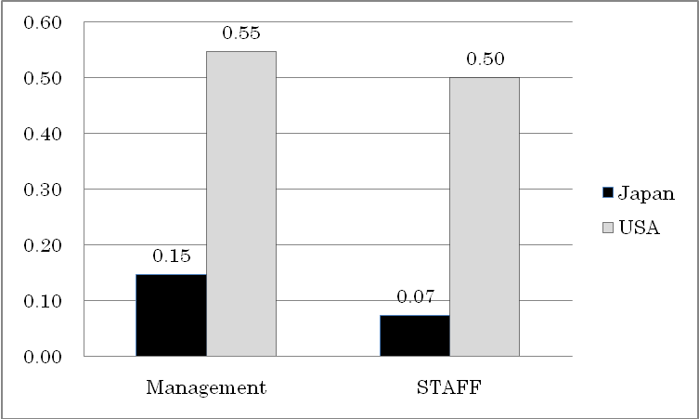
Fig.4 The United States and Japan Comparison on Appearance of Higher Keypersonship. ( N= 479)

The data was also analyzed using the five main factors of Servant Leadership. The results are shown below:

(Table 1) Keypersonship Factorial Analysis
Unweighted Least Squares | Factor |  |  |  |  | Communalities
Equamax with Kaiser Normalization | 1 | 2 | 3 | 4 | 5 | Communalities
First Factor Holistic Belief
Q5 Do you clearly understand your life’s purpose? | .599 | -.155 | -.089 | .026 | -.158 | .431
Q3 Can you see clearly the way which you should go? | .559 | -.076 | -.034 | -.060 | .135 | .328
Q17 To what extent do you try to see yourself objectively? | .523 | .172 | .139 | .169 | .155 | .357
Q4 Do you have spiritual beliefs? | .464 | -.197 | -.084 | -.055 | -.255 | .344
Q11 Can you think and act while seeing the big picture? | .441 | .210 | .031 | .230 | .310 | .344
Q22 Are you willing to risk failure in acting on your beliefs? | .358 | -.098 | -.225 | .032 | .108 | .165
Second Factor Trust & Decision Making
Q15 To what extent are you trusted by other persons? | -.283 | .763 | .545 | -.157 | -.041 | .713
Q18 Can you persuade others and achieve consensus? | .009 | .544 | -.027 | -.063 | .018 | .395
Q10 Do you have an ability to step back and reorient yourself? | -.068 | .486 | .297 | .126 | -.171 | .302
Q16 To what extent are you comfortable making decisions? | .201 | .364 | .242 | -.204 | .223 | .295
Third Factor Foresight
Q20 Do you feel that you are useful to others and to your community? | -.073 | .150 | .675 | -.057 | -.006 | .507
Q19 To what extent do your words gives others healing? | -.274 | .387 | .462 | .240 | -.126 | .357
Q14 Do you think that you have the power of foresight? | .086 | .249 | .461 | .180 | .379 | .357
Q21 To what extent do you make efforts to serve others? | .108 | .157 | .362 | .229 | .126 | .193
Fourth Factor Empathy
Q13 Do you try to show empathy to the feelings of others? | -.049 | .154 | .269 | .633 | .011 | .447
Q6 Do you sincerely try to listen to other people's stories? | .057 | -.086 | -.036 | .571 | .226 | .370
Q12 Can you accept others following their conscience in any case? | .169 | -.087 | -.060 | .455 | .090 | .244
Fifth Factor Intuitive Insight
Q8 Do you have imagination? | .092 | -.099 | .036 | .013 | .712 | .544
Q7 Do you value intuitive thought? | -.131 | -.044 | .174 | .292 | .373 | .275
Q9 Can you express experiences to others by language effectively? | .035 | .066 | -.056 | .210 | .329 | .154
Terms:

Holistic belief: Understanding one’s self and others.

Trust & Decision Making: Seeing the way and persuading others to follow.

Foresight: Merging past and present realities to understand likely future consequences.

Empathy: Recognizing people for their special and unique spirit.

Intuitive Insight: Creativity and mastering shared ideas and vision.

Extraction Method: Unweighted Least Squares/ Rotation Method: Equamax with Kaiser Normalization

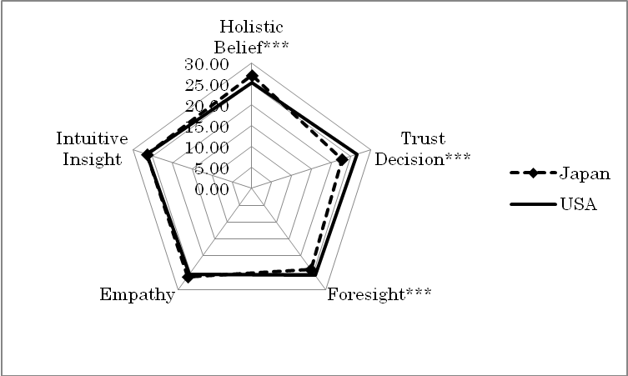
Fig.5 Comparison of five factors for Higher Keypersonship in the United States and Japan ***p<0.000 (N=93)

The five factors which provide the foundation for High Keypersonship are analyzed for Japan and the United States in Fig.5. There are statistical differences in terms of Holistic Belief, Trust & Decision Making, and Foresight in this survey. While these differences warrant further investigation, particularly as the factors could be impacted by structural and cultural conditions, the results show high numerical values for all five factors in both countries.

Turning, now, to the measurement of action efforts for performance, results differ between survey participants in the U.S. and Japan (Fig. 6).
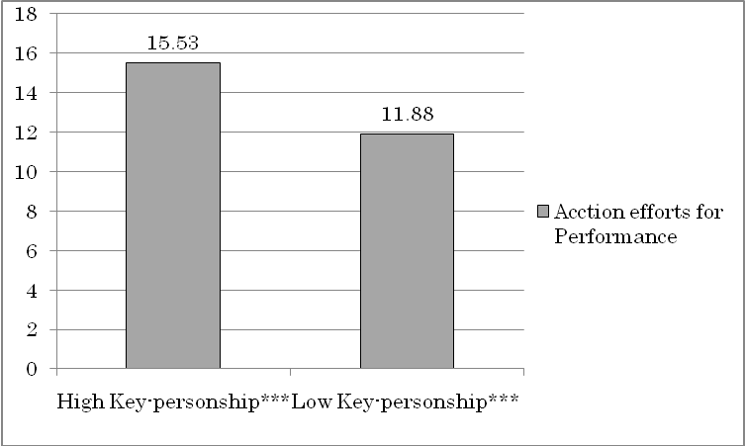
Fig.6 The difference between the High Keypersonship and Low Keypersonship in terms of the action efforts for performance ***p<0.000 (N=479)

The mean value of action performance efforts of High Keypersonship staff in the United States is higher than that of Japan (US 16.09, Japan 15.14; N=245) , but among the persons who had higher Keypersonship (in this survey, over 80), there are few differences in the attitude of performance ( US 16.84, Japan 16.89; N=92) Fig. 7 suggests that the persons who have the higher Keypersonship degree tend to make action efforts beyond boundary of the two countries.

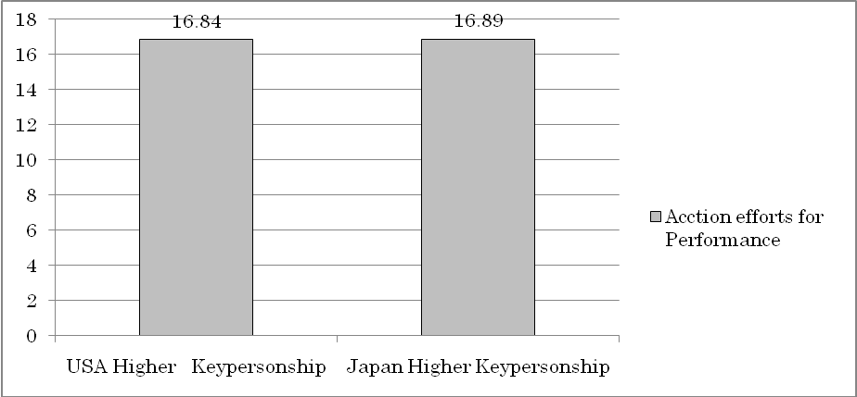

Fig.7 Comparative survey result between the United States and Japan using Higher Keypersonship degree of 80-100. (N= 92)

6. Summary

This survey suggests that Keypersonship is a critical factor in the performance of local government staff, strengthening the case for creating Learning Organizations that value the human spirit and promote higher levels of work improvement and innovation. The concept of the Keypersonship is constructed from Spiritual Leadership which is the all-encompassing principle of the Leadership Perspectives Model. In the United States, extensive use of coaching and mentoring are being used along with traditional leadership training methods to prepare and promote promising talent. Voluntary and independent research at the work site has helped Japanese officials introduce new organizational development practices which are shared and expanded through networking. These approaches are based on a universal leadership model and stand the greatest chance of meeting the universal challenges for human resources development in the future borderless world economy.

? The Pew Research Center for the People and the Press. (2010). The People and their Government: Distrust, Discontent, Anger and Partisan Rancor. http://www.people-press.org/reports/pdf/606.pdf.
American National Election Studies. The ANES Guided to Public Opinion and Electoral Behavior. http://www.electionstudies.org/nesguide/toptable/tab5a_1.htm.
Burns, James MacGregor. (1978).
Bass, BM. (1990). pp.19-31.
Fairholm, Matthew R. (2004). pp. 577-590.
His thought is affected by Alfred North Whitehead (1861-1947).
The term, servant leadership was coined by Robert K. Greenleaf in the essay, The Servant as Leader (1970), which described the servant-leader as one whose desire to lead originates from a natural desire to serve first those who would be led.
Fairholm, Matthew R. (2004).p.580.
Benest, Frank. (2008). Cal-ICMA Coaching Program, California, U.S.A. Presented at the International Leading Practices Symposium, Surfers Paradise, Queensland, Australia. References [1]Bass, B.M. (1990). “From Transactional to Transformational Leadership: Learning to share the vision.” Organizational Dynamics, (Winter). [2]Burns, James MacGregor. (1978). Leadership. New York: Harper & Row. [3]Endo,Tetsuya and Onodera,Tetsuo .(2010). “The reviewing of the Concept of Key person : In order to extract Key factors of Organizational Strategy in terms of Local Government .”Journal of Aomori Public College Study No.15-2,Aomori Public College. [4]Endo,Tetsuya and Onodera,Tetsuo.(2007b).“Organizational Strategy on Local Government Management: Integration with the organizational strategy and the organizational psychology using the data of Japan and the U.S.A.” Journal of Aomori Public College Study No.12-2 ,Aomori Public College. [5]Fairholm,Gilbert W. (2000). Perspectives on Leadership: From the Science of Management to Its Spiritual Heart. Praeger Publishers. [6]Fairholm,Matthew R.and Fairholm,Gilbert W.(2009).Understanding Leadership Perspectives: Theoretical and Practical Application. Springer. [7]Fairholm,Matthew R. (2004). “Different Perspectives on the Practice of Leadership.” Public Administration Review, September/October, Vol. 64, No. 5. [8]Freyss, Siegrun F. (1993). “Professional Norms and Actual Practices in Local Personnel Administration.” Review of Public Personnel Administration. [9]Giddens,Anthony.(1977).Studies in Social and Political Theory. Hutchinson&Co. Ltd,London. [10]Greenleaf, Robert K.(1977). Servant Leadership. Paulist Press. [11]Hersey,P and Blanchard,K.(2007). Management of Organizational Behavior-9nd edition, Prentice Hall. [12]Ichii, Saburo.(1963). Philosophical Analysis.Iwanami. [13]Senge,Peter.(1990). The Fifth Discipline. Currency Doubleday. [14]Senge,Peter. et al.(1999). The Dance of Change. Nicholas Brealey. [15]Whitehead, Alfred North(1978). Process and Reality. The Free Press.

