CITY OF HICKORY
OPERATION NO VACANCY INITIATIVE

Project Summary and Background

Operation No Vacancy is an economic development initiative which aims to attract reinvestment in distressed commercial and industrial corridors in Hickory, North Carolina. An innovative vacant building inventory tool and grant program provide the means to encourage new and existing businesses to locate in vacant and under-utilized buildings within six target redevelopment zones of the City referred to as the Commercial Revitalization Area.

From 2000 – 2009 Hickory’s metropolitan statistical area lost 38,695 jobs. In 2000, manufacturing jobs made over 42 percent of jobs in the region. A decline in manufacturing employment has led to a marked increase in the number of vacant properties, especially along the city’s two rail corridors. Over 3,000,000 square feet of space is available in non-residential vacant buildings within the City of Hickory. To address this issue, the City developed a vacant building inventory tool, designated a commercial revitalization area, created a vacant building revitalization grant program, unified existing redevelopment programs and reached out to community stakeholders.

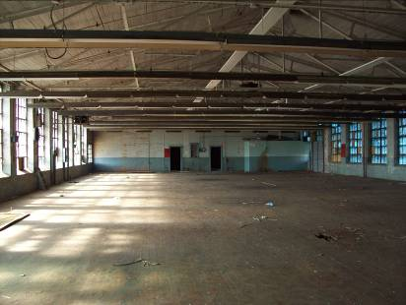
In 2007, a management intern was tasked with developing an inventory of all vacant commercial and industrial buildings in Hickory. The February 2008 City Council retreat packet included a memo and map which outlined the vacant building inventory. During an open comment session entitled, “Look to the Future” Alderwoman Sally Fox expressed concern about the increasing number of vacant buildings in Hickory’s older commercial and industrial areas. Ms. Fox suggested staff develop a grant program, streamline the permitting process for redevelopment and provide incentives for major employers to retain employees or expand their business and to “think out of the box” to address this problem. This discussion led to creation of the Operation No Vacancy initiative.

Operation No Vacancy improves customer service to developers and citizens with an interest in investing in the City center and continues to facilitate reinvestment of vacant buildings found through the vacant building inventory tool and partially funded through the Vacant Building Grant program. The Alliance for Innovation presented the City of Hickory one of their Outstanding Achievement in Local Government Innovation Awards for Operation No Vacancy at its annual conference in May 2009. The City also presented the initiative at the conference. A June 2009 article in Government Finance Review highlighted the initiative.

Implementation of Operation No Vacancy

In response to the 2008 City Council Retreat, staff formed a committee including representatives from the City Manager’s Office, Planning, Fire, Community and Economic Development, Public Services, Police Department, Catawba County Building Services, a Commercial Real Estate Representative and a Citizen Representative. The committee’s major work tasks focused on (1) enhancing the vacant building inventory tool, (2) designating a commercial revitalization area, (3) creating a vacant building revitalization grant program, (4) unifying existing redevelopment programs, (5) receiving and considering applications for vacant building grant funds for redevelopment projects and (6) reaching out to community stakeholders.
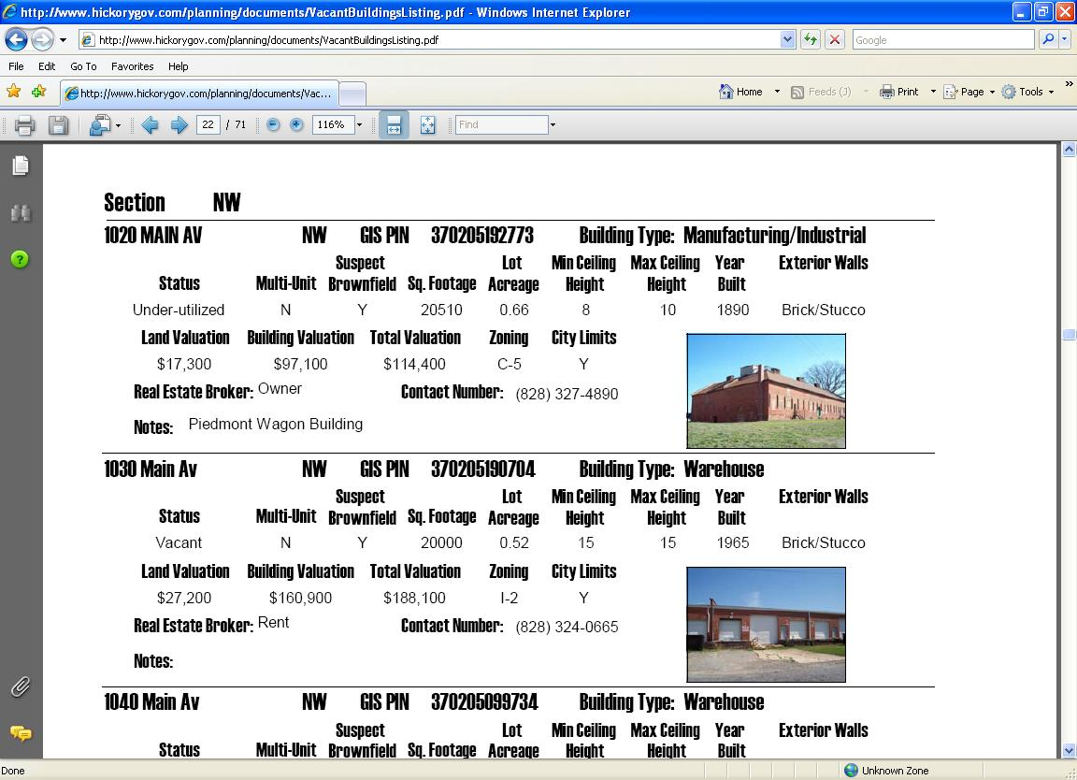
Vacant Building Inventory. The Fire Department historically tracked vacant buildings within the City for fire prevention purposes. However, this list only tracked the building’s address and occupancy status. The intern worked to enhance this listing by including additional property information including building square footage, ceiling heights, zoning information, photos, real estate contact information, historic designation, etc. All of this information was easily obtainable through city and county GIS websites and field visits to vacant properties. This additional information gives developers, site selectors, preservation groups and other interested parties the information necessary to see which buildings fit their needs. Property listings in PDF form are currently available on the City website.
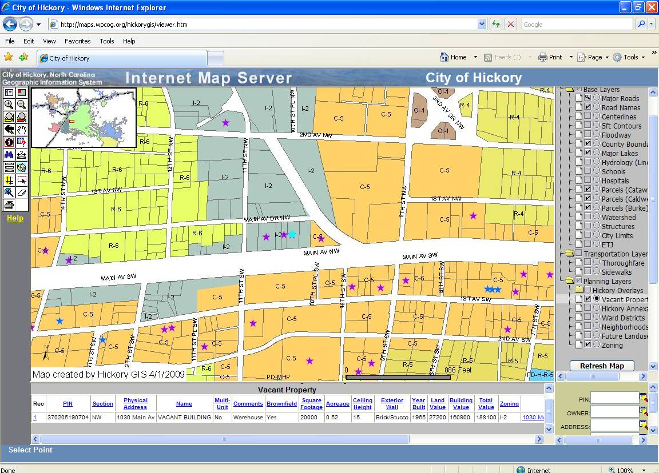
In addition, the inventory is available as a layer on the City’s GIS site, which is also available online. This allows users to access a wealth of additional information such as the location of the floodplain, infrastructure locations, topographical information and aerial photography. The GIS site has a query function which allows users to search for buildings that meet specific criteria.

Commercial Revitalization Area. GIS software allowed staff to plot all vacant structures on a map. Mapping the vacant buildings from the inventory into a layer of the City’s
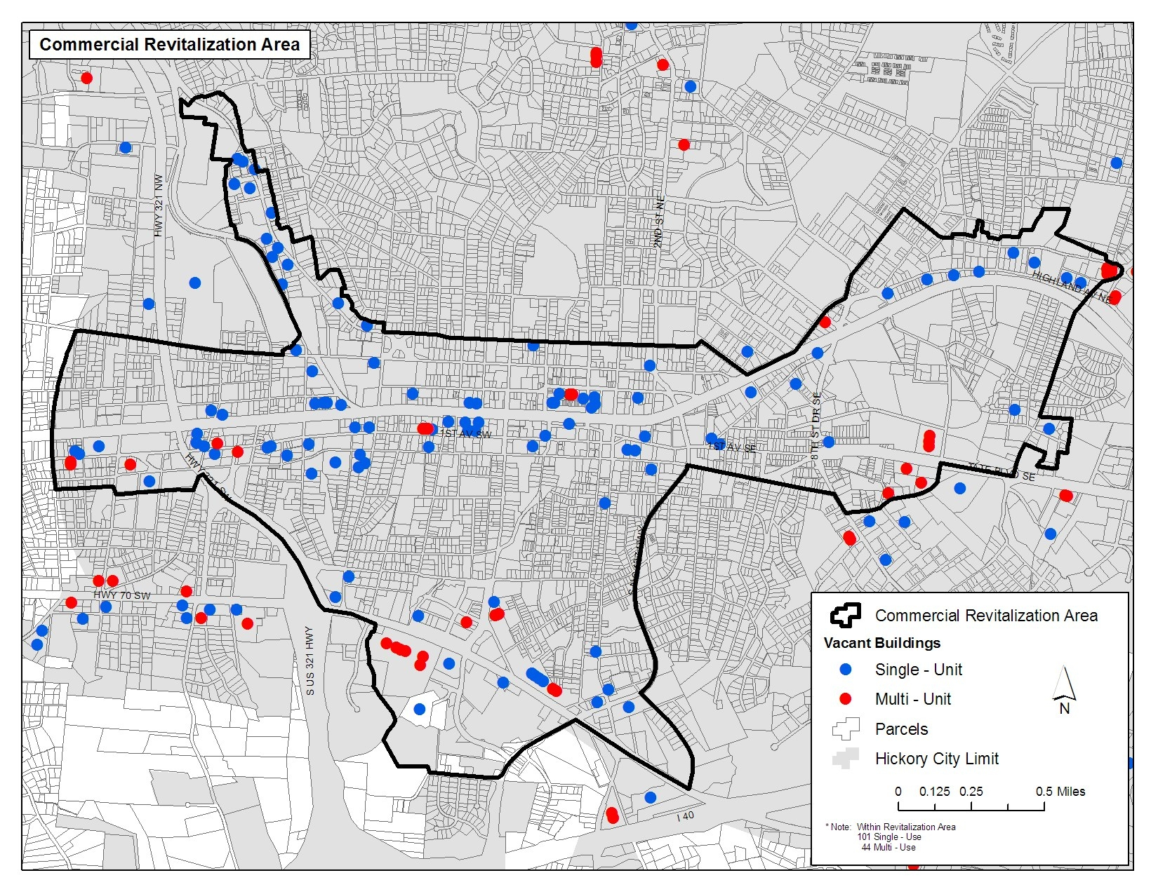
GIS website has helped staff identify corridors in need of redevelopment and enhanced staff ability to create realistic plans for redevelopment of distressed areas. Staff noticed that the highest concentration of vacant buildings was along the City’s railroad corridors and older commercial strip areas. This area was designated the Commercial Revitalization Area. After identifying the area of need, staff conducted a comprehensive reassessment of existing redevelopment programs to ensure that redevelopment dollars were target to the areas of greatest. Staff also looked to develop new programs to facilitate redevelopment of distressed areas In addition, citizens benefit from improved quality of life, aesthetics, increased property values and improved transportation within the redevelopment of corridors they live, work, recreate or travel. This area serves as the eligibility area for the Vacant Building Revitalization Grant, Community Appearance Grant, and the Commercial Revitalization Area Tax Incentives. The City also targets additional redevelopment funding for infrastructure improvements into these areas. Common improvements include sidewalk construction, bus shelter installation and streetscape improvements that are in compliance with the City’s Sidewalk Master Plan and Neighborhood Plans. Redevelopment planning efforts are also focused in this area.

Vacant Building Revitalization Grant Program. This grant is one of the core programs of Operation No Vacancy. The grant is intended to encourage the reuse of existing buildings that have been identified by City staff as vacant or under-utilized within the designated Commercial Revitalization Area. This grant program is designed to help owners of vacant and under-utilized property make improvements that will result in the occupancy and reuse of the buildings. The program offers matching funds of up to $25,000 for projects that renovate vacant or under-utilized buildings in the commercial revitalization area. Funds can be used for exterior improvements, demolition of substandard buildings and interior improvements necessary to protect the structural integrity of buildings. Brownfield sites are given priority. The Redevelopment Committee reviews the grant applications. City Council has set aside approximately $250,000 for these grants, which would provide approximately 10 grants per year. Since the program’s inception, City Council has approved 9 Vacant Building Revitalization Grants totaling $182,601. These grants have leveraged approximately $847,064 in private investment.

Streamlining and Coordinating Existing Redevelopment Programs. Another important aspect of Operation No Vacancy is marketing and improving the City’s current redevelopment programs. The City already offered a number of programs that encouraged redevelopment including landscape incentive grants, façade improvement grants and tax incentives for projects in a commercial revitalization area. One of the goals of Operation No Vacancy is to unify each of these programs under one eligibility map. This not only helps target program impacts, but it also makes it easier for citizens to understand the programs for which a particular property is eligible. Staff has developed brochures and other promotional materials to use for targeted mailings, presentations and distribution to potential stakeholders. Improved web content also helps promote the City’s redevelopment programs.

Hickory’s revised Economic Development Assistance Guidelines now promote the reuse of vacant industrial buildings as a result of the success of Operation No Vacancy. The guidelines, revised in June of 2008, now provide an additional 10 percent property tax grant for qualifying economic development projects if a company locates within an existing building rather than a Greenfield site. The Commercial Revitalization Area Tax Incentives also provide a lower job creation and investment is also the eligibility area for the Commercial Revitalization Area Tax incentives. This program offers tax incentives at a lower investment and job creation threshold for new development and redevelopment that chooses to locate within the Commercial Revitalization Area as opposed to more prosperous areas of town.

The program also works in conjunction with Hickory’s Brownfield and Community Development Block Grant (CDBG) programs. The city received two Brownfield Assessment grants from the US EPA in 2007. These three-year grants have been used to fund environmental site assessments and redevelopment planning on a number of properties in the Commercial Revitalization Area. In addition, CDBG funds have been used for sidewalk and other infrastructure investment in low and moderate income areas, which includes much of the designated Commercial Revitalization Area. CDBG funds are also used for a first-time homebuyers program and a housing rehab loan program. This helps strengthen many of the residential neighborhoods adjacent to the commercial and industrial corridors where a number of the vacant buildings are located. Staff has compiled information about these programs and applicable state and federal programs as a resource to citizens, realtors and developers.

Stakeholder Outreach. As an ongoing process, the committee works with stakeholders to improve the process for occupying existing buildings and solicit feedback on potential programs. Staff has worked with Catawba County’s Building Services Division to develop a training program on the NC Rehabilitation Building Code and a document which explains some of the issues that people may come across when trying to occupy existing buildings. These tools are presented in a workshop for builders, engineers, architects and contractors co-hosted by the City and the County. The committee has consulted with local real estate professionals to gain perspective on potential needs of clients to more easily access information, and this resulted in improvements to the vacant building inventory. The committee makes presentations to City Council and Neighborhood Associations to get feedback on how the initiative can assist property owners. The committee has also partnered with a local historic preservation organization, the Hickory Landmarks Society, to help develop resources about programs available for historic properties. The group continually works with local professionals to gain additional information about sites and get input about potential redevelopment strategies.

Scope, Importance and Value of Activity

A common barrier to the redevelopment of vacant buildings in Hickory is a lack of available and easily accessible information. The vacant building inventory includes building square footage, ceiling heights, zoning information, photos, realtor information, historic designation, etc. Developers, site selectors, preservation groups and other interested parties are able to see which buildings fit their needs. Property listings are currently available in PDF on the City website. The inventory is also available as a layer on the City’s GIS online site making accessible information such as the location of the floodplain, infrastructure locations, topographical information and aerial photography. The PDF files also contain a link to the Catawba County GIS web site so interested parties can access property tax assessment reports.

In Hickory, many nonresidential buildings are not listed with the Multiple Listing Service. Therefore, the inventory serves as the only comprehensive list of vacant commercial and industrial buildings in the city of Hickory. Before the vacant building inventory was completed, staff had to make numerous phone calls to commercial realtors to fulfill economic development requests for business owners looking to locate in an existing building. The inventory has greatly improved staff response time to these requests. Small business owners also have the ability to search the list themselves to find buildings which meet their needs. The vacant building inventory tool also serves as free advertising for vacant commercial and industrial buildings within Hickory. The inventory has been well received by commercial realtors, property owners, and entrepreneurs.

Importance, Impacts, Benefits

Operation No Vacancy identified the need for the City to do a better job of educating the public about the process for redeveloping vacant buildings. This led to the creation of a document that outlines implications of changes in use or occupancy classification when occupying an existing building. This allows citizens and developers to look more critically at some of the issues that may arise when adaptively reusing a vacant building. Staff also made improvements that effectively unify the City’s redevelopment programs. By creating one eligibility map for all of the City’s redevelopment programs, staff is able to simplify the process for citizens by making it easier to explain whether or not a property is located in the redevelopment area. While the different programs have different target audiences, simplifying the eligibility area made it easier to market the redevelopment programs. Staff also created brochures, marketing materials, improved the website and made presentations to local realtor and builder groups.

Operation No Vacancy positively impacts the health and sustainability of the Hickory community by encouraging and enabling the reduction of sprawl, utilizing existing infrastructure, revitalizing old industrial and rail corridors, preserving historic mill structures and proactively addressing the major, abrupt shift in the City’s economy.

Parties involved include:
- Citizens of Hickory
- City of Hickory staff/departments
- Commercial realtors
- Developers and contractors
- Vacant building owners
- Entrepreneurs and investors
- Hickory Landmarks Society
- Catawba County (Tax Assessor and County Building Services)
- Owners of adjacent properties and surrounding neighborhoods

Lessons learned that could be shared with other local governments

- How to utilize common information collected by local governments and develop an innovative tool for marketing and redeveloping vacant commercial buildings.
- How to effectively use and maintain the vacant building inventory tool.
- Sharing guidelines and templates of the applicable grant programs used.
- Examples of success and also lessons learned in both the preparation and implementation processes.
- Having the ability to target the problem with an annual plan of work and not get too fragmented with ideas.

Results and outcomes of the project include:

- A streamlined and simplified process that makes it easier to market vacant commercial and industrial buildings.
- Improved partnerships with other jurisdictions, the private sector and citizens to educate applicable stakeholders on redevelopment opportunities and benefits.
- Increased interest from potential developers and potentially expanding companies in redeveloping existing buildings.
- A grant programs that encourage property owners and businesses to locate in vacant and under-utilized buildings.
- Using in-house resources to conduct the inventory of vacant buildings has saved the City over $15,000 during the inventory process for its Brownfield program. This has allowed the City to perform more environmental site assessments than previously anticipated.
- A successful program that unifies staff of many divisions, elected officials, citizens and private investors to revitalize distressed areas of the city and jointly fulfill the needs of each group.
- Three recent projects have committed to occupy over 375,000 square feet of manufacturing and office space in vacant buildings.
- The City will invest approximately $300,000 in the current and upcoming fiscal years for sidewalk projects within the Commercial Revitalization Area and designated in the West Hickory Action Plan in addition to the $250,000 for the grant program per year and in-house services.
- City Council has approved 9 Vacant Building Revitalization Grants totaling $182,601. These grants have leveraged approximately $847,064 in private investment.

