AGREEMENT FOR PROFESSIONAL SERVICES
(Under $25,000 Total Compensation)

This Agreement made and entered on the date hereinafter stated, between the CITY OF ASPEN, Colorado, ("City") and NATIONAL RESEARCH CENTER INC., ("Professional").

For and in consideration of the mutual covenants contained herein, the parties agree as follows:

1. Scope of Work. Professional shall perform in a competent and professional manner the Scope of Work as set forth at Exhibit "A" attached hereto and by this reference incorporated herein.

2. Completion. Professional shall commence work immediately upon receipt of a written Notice to Proceed from the City and complete all phases of the Scope of Work as expeditiously as is consistent with professional skill and care and the orderly progress of the Work in a timely manner. The parties anticipate that all work pursuant to this agreement shall be completed no later than October 30, 2009. Upon request of the City, Professional shall submit, for the City's approval, a schedule for the performance of Professional's services which shall be adjusted as required as the project proceeds, and which shall include allowances for periods of time required by the City's project engineer for review and approval of submissions and for approvals of authorities having jurisdiction over the project. This schedule, when approved by the City, shall not, except for reasonable cause, be exceeded by the Professional.

3. Payment. In consideration of the work performed, City shall pay Professional on a time and expense basis for all work performed. The hourly rates for work performed by Professional shall not exceed those hourly rates set forth at Exhibit “B” appended hereto. Except as otherwise mutually agreed to by the parties the payments made to Professional shall not initially exceed $12,205.00 . Professional shall submit, in timely fashion, invoices for work performed. The City shall review such invoices and, if they are considered incorrect or untimely, the City shall review the matter with Professional within ten days from receipt of the Professional's bill.

4. Non-Assignability. Both parties recognize that this contract is one for personal services and cannot be transferred, assigned, or sublet by either party without prior written consent of the other. Sub-Contracting, if authorized, shall not relieve the Professional of any of the responsibilities or obligations under this agreement. Professional shall be and remain solely responsible to the City for the acts, errors, omissions or neglect of any subcontractors officers, agents and employees, each of whom shall, for this purpose be deemed to be an agent or employee of the Professional to the extent of the subcontract. The City shall not be obligated to pay or be liable for payment of any sums due which may be due to any sub-contractor.

5. Termination. The Professional or the City may terminate this Agreement, without specifying the reason therefor, by giving notice, in writing, addressed to the other party, specifying the effective date of the termination. No fees shall be earned after the effective date of the termination. Upon any termination, all finished or unfinished documents, data, studies, surveys, drawings, maps, models, photographs, reports or other material prepared by the Professional pursuant to this Agreement shall become the property of the City. Notwithstanding the above, Professional shall not be relieved of any liability to the City for damages sustained by the City by virtue of any breach of this Agreement by the Professional, and the City may withhold any payments to the Professional for the purposes of set-off until such time as the exact amount of damages due the City from the Professional may be determined.

6. Covenant Against Contingent Fees. The Professional warrants that s/he has not employed or retained any company or person, other than a bona fide employee working for the Professional, to solicit or secure this contract, that s/he has not paid or agreed to pay any company or person, other than a bona fide employee, any fee, commission, percentage, brokerage fee, gifts or any other consideration contingent upon or resulting from the award or making of this contract.

7. Independent Contractor Status. It is expressly acknowledged and understood by the parties that nothing contained in this agreement shall result in, or be construed as establishing an employment relationship. Professional shall be, and shall perform as, an independent Contractor who agrees to use his or her best efforts to provide the said services on behalf of the City. No agent, employee, or servant of Professional shall be, or shall be deemed to be, the employee, agent or servant of the City. City is interested only in the results obtained under this contract. The manner and means of conducting the work are under the sole control of Professional. None of the benefits provided by City to its employees including, but not limited to, workers' compensation insurance and unemployment insurance, are available from City to the employees, agents or servants of Professional. Professional shall be solely and entirely responsible for its acts and for the acts of Professional's agents, employees, servants and subcontractors during the performance of this contract. Professional shall indemnify City against all liability and loss in connection with, and shall assume full responsibility for payment of all federal, state and local taxes or contributions imposed or required under unemployment insurance, social security and income tax law, with respect to Professional and/or Professional's employees engaged in the performance of the services agreed to herein.

8. Indemnification. Professional agrees to indemnify and hold harmless the City, its officers, employees, insurers, and self-insurance pool, from and against all liability, claims, and demands, on account of injury, loss, or damage, including without limitation claims arising from bodily injury, personal injury, sickness, disease, death, property loss or damage, or any other loss of any kind whatsoever, which arise out of or are in any manner connected with this contract, if such injury, loss, or damage is caused in whole or in part by, or is claimed to be caused in whole or in part by, the act, omission, error, professional error, mistake, negligence, or other fault of the Professional, any subcontractor of the Professional, or any officer, employee, representative, or agent of the Professional or of any subcontractor of the Professional, or which arises out of any workmen's compensation claim of any employee of the Professional or of any employee of any subcontractor of the Professional. The Professional agrees to investigate, handle, respond to, and to provide defense for and defend against, any such liability, claims or demands at the sole expense of the Professional, or at the option of the City, agrees to pay the City or reimburse the City for the defense costs incurred by the City in connection with, any such liability, claims, or demands. If it is determined by the final judgment of a court of competent jurisdiction that such injury, loss, or damage was caused in whole or in part by the act, omission, or other fault of the City, its officers, or its employees, the City shall reimburse the Professional for the portion of the judgment attributable to such act, omission, or other fault of the City, its officers, or employees.

9. Professional's Insurance. (a) Professional agrees to procure and maintain, at its own expense, a policy or policies of insurance sufficient to insure against all liability, claims, demands, and other obligations assumed by the Professional pursuant to Section 8 above. Such insurance shall be in addition to any other insurance requirements imposed by this contract or by law. The Professional shall not be relieved of any liability, claims, demands, or other obligations assumed pursuant to Section 8 above by reason of its failure to procure or maintain insurance, or by reason of its failure to procure or maintain insurance in sufficient amounts, duration, or types.

(b) Professional shall procure and maintain, and shall cause any subcontractor of the Professional to procure and maintain, the minimum insurance coverages listed below. Such coverages shall be procured and maintained with forms and insurance acceptable to the City. All coverages shall be continuously maintained to cover all liability, claims, demands, and other obligations assumed by the Professional pursuant to Section 8 above. In the case of any claims-made policy, the necessary retroactive dates and extended reporting periods shall be procured to maintain such continuous coverage.

(i) Worker's Compensation insurance to cover obligations imposed by applicable laws for any employee engaged in the performance of work under this contract, and Employers' Liability insurance with minimum limits of FIVE HUNDRED THOUSAND DOLLARS ($500,000.00) for each accident, FIVE HUNDRED THOUSAND DOLLARS ($500,000.00) disease - policy limit, and FIVE HUNDRED THOUSAND DOLLARS ($500,000.00) disease - each employee. Evidence of qualified self-insured status may be substituted for the Worker's Compensation requirements of this paragraph.

(ii) Commercial General Liability insurance with minimum combined single limits of ONE MILLION DOLLARS ($1,000,000.00) each occurrence and ONE MILLION DOLLARS ($1,000,000.00) aggregate. The policy shall be applicable to all premises and operations. The policy shall include coverage for bodily injury, broad form property damage (including completed operations), personal injury (including coverage for contractual and employee acts), blanket contractual, independent contractors, products, and completed operations. The policy shall contain a severability of interests provision.

(iii) Comprehensive Automobile Liability insurance with minimum combined single limits for bodily injury and property damage of not less than ONE MILLION DOLLARS ($1,000,000.00) each occurrence and ONE MILLION DOLLARS ($1,000,000.00) aggregate with respect to each Professional's owned, hired and non-owned vehicles assigned to or used in performance of the Scope of Work. The policy shall contain a severability of interests provision. If the Professional has no owned automobiles, the requirements of this Section shall be met by each employee of the Professional providing services to the City under this contract.

(iv) Professional Liability insurance with the minimum limits of ONE MILLION DOLLARS ($1,000,000) each claim and ONE MILLION DOLLARS ($1,000,000) aggregate.

(c) The policy or policies required above shall be endorsed to include the City and the City's officers and employees as additional insureds. Every policy required above shall be primary insurance, and any insurance carried by the City, its officers or employees, or carried by or provided through any insurance pool of the City, shall be excess and not contributory insurance to that provided by Professional. No additional insured endorsement to the policy required above shall contain any exclusion for bodily injury or property damage arising from completed operations. The Professional shall be solely responsible for any deductible losses under any policy required above.

(d) The certificate of insurance provided by the City shall be completed by the Professional's insurance agent as evidence that policies providing the required coverages, conditions, and minimum limits are in full force and effect, and shall be reviewed and approved by the City prior to commencement of the contract. No other form of certificate shall be used. The certificate shall identify this contract and shall provide that the coverages afforded under the policies shall not be canceled, terminated or materially changed until at least thirty (30) days prior written notice has been given to the City.

(e) Failure on the part of the Professional to procure or maintain policies providing the required coverages, conditions, and minimum limits shall constitute a material breach of contract upon which City may immediately terminate this contract, or at its discretion City may procure or renew any such policy or any extended reporting period thereto and may pay any and all premiums in connection therewith, and all monies so paid by City shall be repaid by Professional to City upon demand, or City may offset the cost of the premiums against monies due to Professional from City.

(f) City reserves the right to request and receive a certified copy of any policy and any endorsement thereto.

(g) The parties hereto understand and agree that City is relying on, and does not waive or intend to waive by any provision of this contract, the monetary limitations (presently $150,000.00 per person and $600,000 per occurrence) or any other rights, immunities, and protections provided by the Colorado Governmental Immunity Act, Section 24-10-101 et seq., C.R.S., as from time to time amended, or otherwise available to City, its officers, or its employees.

10. City's Insurance. The parties hereto understand that the City is a member of the Colorado Intergovernmental Risk Sharing Agency (CIRSA) and as such participates in the CIRSA Property/Casualty Pool. Copies of the CIRSA policies and manual are kept at the City of Aspen Finance Department and are available to Professional for inspection during normal business hours. City makes no representations whatsoever with respect to specific coverages offered by CIRSA. City shall provide Professional reasonable notice of any changes in its membership or participation in CIRSA.

11. Completeness of Agreement. It is expressly agreed that this agreement contains the entire undertaking of the parties relevant to the subject matter thereof and there are no verbal or written representations, agreements, warranties or promises pertaining to the project matter thereof not expressly incorporated in this writing.

12. Notice. Any written notices as called for herein may be hand delivered to the respective persons and/or addresses listed below or mailed by certified mail return receipt requested, to:

City: Professional:
City Manager Thomas Miller
City of Aspen National Research Center, Inc.
130 South Galena Street 2005 30th Street Aspen, Colorado 81611 Boulder, CO 80301

13. Non-Discrimination. No discrimination because of race, color, creed, sex, marital status, affectional or sexual orientation, family responsibility, national origin, ancestry, handicap, or religion shall be made in the employment of persons to perform services under this contract. Professional agrees to meet all of the requirements of City's municipal code, Section 13-98, pertaining to non-discrimination in employment.

14. Waiver. The waiver by the City of any term, covenant, or condition hereof shall not operate as a waiver of any subsequent breach of the same or any other term. No term, covenant, or condition of this Agreement can be waived except by the written consent of the City, and forbearance or indulgence by the City in any regard whatsoever shall not constitute a waiver of any term, covenant, or condition to be performed by Professional to which the same may apply and, until complete performance by Professional of said term, covenant or condition, the City shall be entitled to invoke any remedy available to it under this Agreement or by law despite any such forbearance or indulgence.

15. Execution of Agreement by City. This agreement shall be binding upon all parties hereto and their respective heirs, executors, administrators, successors, and assigns.

16. Illegal Aliens – CRS 8-17.5-101 & 24-76.5-101.

a. Purpose. During the 2006 Colorado legislative session, the Legislature passed House Bills 06-1343 (subsequently amended by HB 07-1073) and 06-1023 that added new statutes relating to the employment of and contracting with illegal aliens. These new laws prohibit all state agencies and political subdivisions, including the Owner, from knowingly hiring an illegal alien to perform work under a contract, or to knowingly contract with a Contractor who knowingly hires with an illegal alien to perform work under the contract. The new laws also require that all contracts for services include certain specific language as set forth in the statutes. The following terms and conditions have been designed to comply with the requirements of this new law.

b. Definitions. The following terms are defined in the new law and by this reference are incorporated herein and in any contract for services entered into with the Owner.

1. “E-verify program” means the electronic employment verification program created in Public Law 208, 104th Congress, as amended, and expanded in Public Law 156, 108th Congress, as amended, that is jointly administered by the United States Department of Homeland Security and the social security Administration, or its successor program.

2. “Department program” means the employment verification program established pursuant to Section 8-17.5-102(5)(c).

3. “Public Contract for Services” means this Agreement.

4. “Services” means the furnishing of labor, time, or effort by a Contractor or a subcontractor not involving the delivery of a specific end product other than reports that are merely incidental to the required performance.

c. By signing this document, Contractor certifies and represents that at this time:

1. Contractor shall confirm the employment eligibility of all employees who are newly hired for employment to perform work under the public contract for services; and

2. Contractor has participated or attempted to participate in either the e-verify program or the department program in order to verify that new employees are not illegal aliens.

d. Contractor hereby confirms that:

1. Contractor shall not knowingly employ or contract with an illegal alien to perform work under the Public Contract for Services.

2. Contractor shall not enter into a contract with a subcontractor that fails to certify to the Contractor that the subcontractor shall not knowingly employ or contract with an illegal alien to perform work under the Public Contract for Services.

3. Contractor has confirmed the employment eligibility of all employees who are newly hired for employment to perform work under the public contract for services through participation in either the e-verify program or the department program.

4. Contractor shall not use the either the e-verify program or the department program procedures to undertake pre-employment screening of job applicants while the Public Contract for Services is being performed.

5. If Contractor obtains actual knowledge that a subcontractor performing work under the Public Contract for Services knowingly employs or contracts with an illegal alien, Contractor shall:

i. Notify such subcontractor and the Owner within three days that Contractor has actual knowledge that the subcontractor is employing or subcontracting with an illegal alien; and

ii. Terminate the subcontract with the subcontractor if within three days of receiving the notice required pursuant to this section the subcontractor does not stop employing or contracting with the illegal alien; except that Contractor shall not terminate the Public Contract for Services with the subcontractor if during such three days the subcontractor provides information to establish that the subcontractor has not knowingly employed or contracted with an illegal alien.

6. Contractor shall comply with any reasonable request by the Colorado Department of Labor and Employment made in the course of an investigation that the Colorado Department of Labor and Employment undertakes or is undertaking pursuant to the authority established in Subsection 8-17.5-102 (5), C.R.S.

7. If Contractor violates any provision of the Public Contract for Services pertaining to the duties imposed by Subsection 8-17.5-102, C.R.S. the Owner may terminate this Agreement. If this Agreement is so terminated, Contractor shall be liable for actual damages to the Owner arising out of Contractor’s violation of Subsection 8-17.5-102, C.R.S.
.

17. General Terms.

(a) It is agreed that neither this agreement nor any of its terms, provisions, conditions, representations or covenants can be modified, changed, terminated or amended, waived, superseded or extended except by appropriate written instrument fully executed by the parties.

(b) If any of the provisions of this agreement shall be held invalid, illegal or unenforceable it shall not affect or impair the validity, legality or enforceability of any other provision.

(c) The parties acknowledge and understand that there are no conditions or limitations to this understanding except those as contained herein at the time of the execution hereof and that after execution no alteration, change or modification shall be made except upon a writing signed by the parties.

(d) This agreement shall be governed by the laws of the State of Colorado as from time to time in effect.

IN WITNESS WHEREOF, the parties hereto have executed, or caused to be executed by their duly authorized officials, this Agreement in three copies each of which shall be deemed an original on the date hereinafter written.

[SIGNATURES ON FOLLOWING PAGE]

ATTESTED BY: CITY OF ASPEN, COLORADO:

By: ____________________________________

Title: ___________________________________

Date: _______________________

PROFESSIONAL:

WITNESSED BY: National Research Center, Inc.

By: ___________________________________

Title: ___________________________________

Date: _______________________

EXHIBIT “A” to Professional Services Agreement

The Agreement with National Research Center is for a period of one year with two (2) one-year options to renew if the City chooses to exercise those options. The detailed Scope of Work begins on the next page.

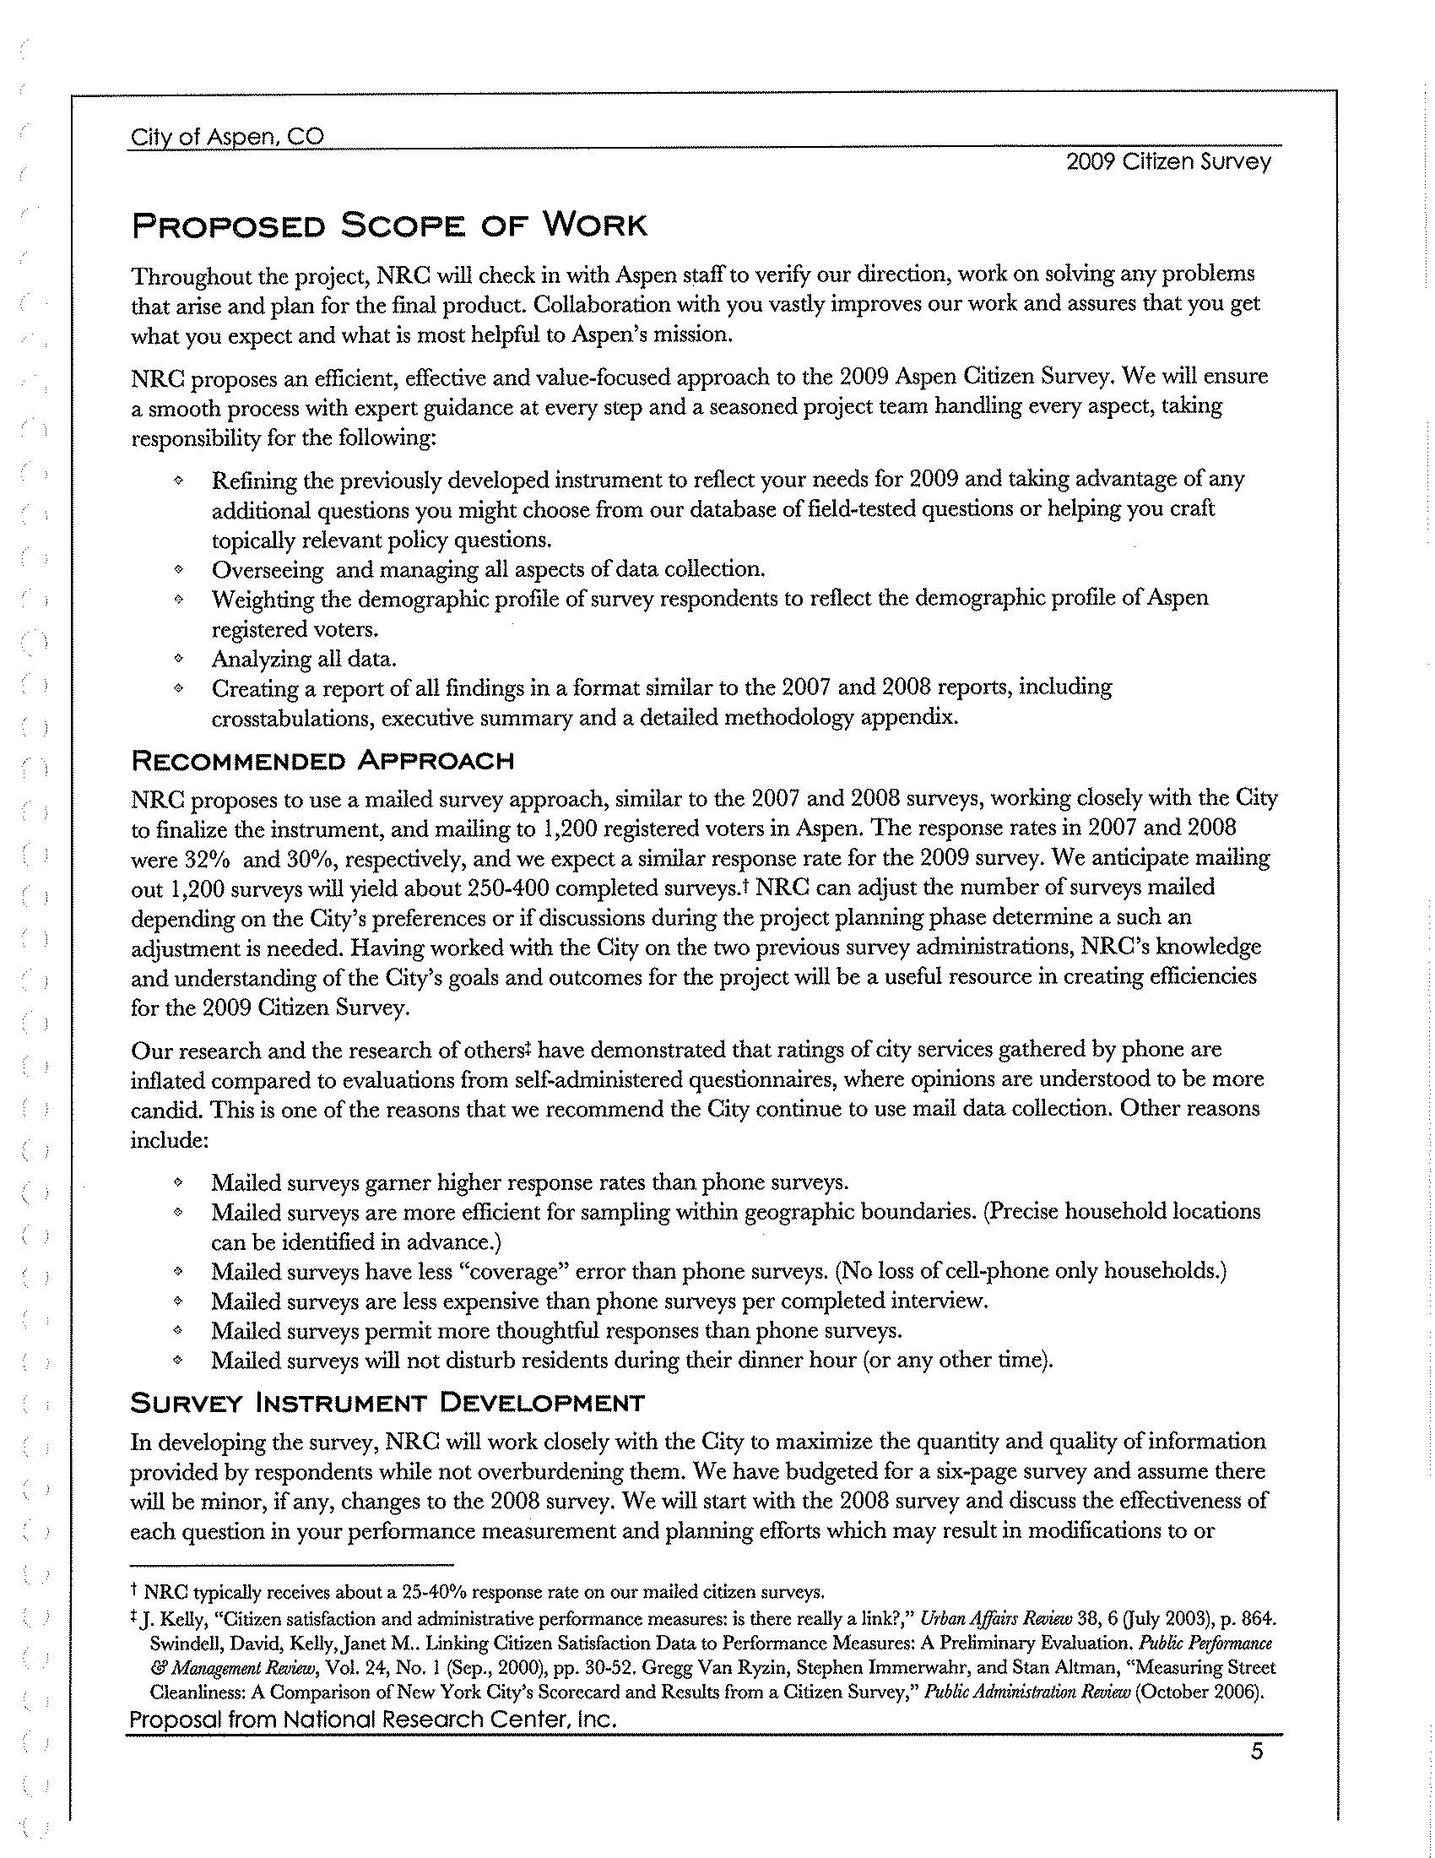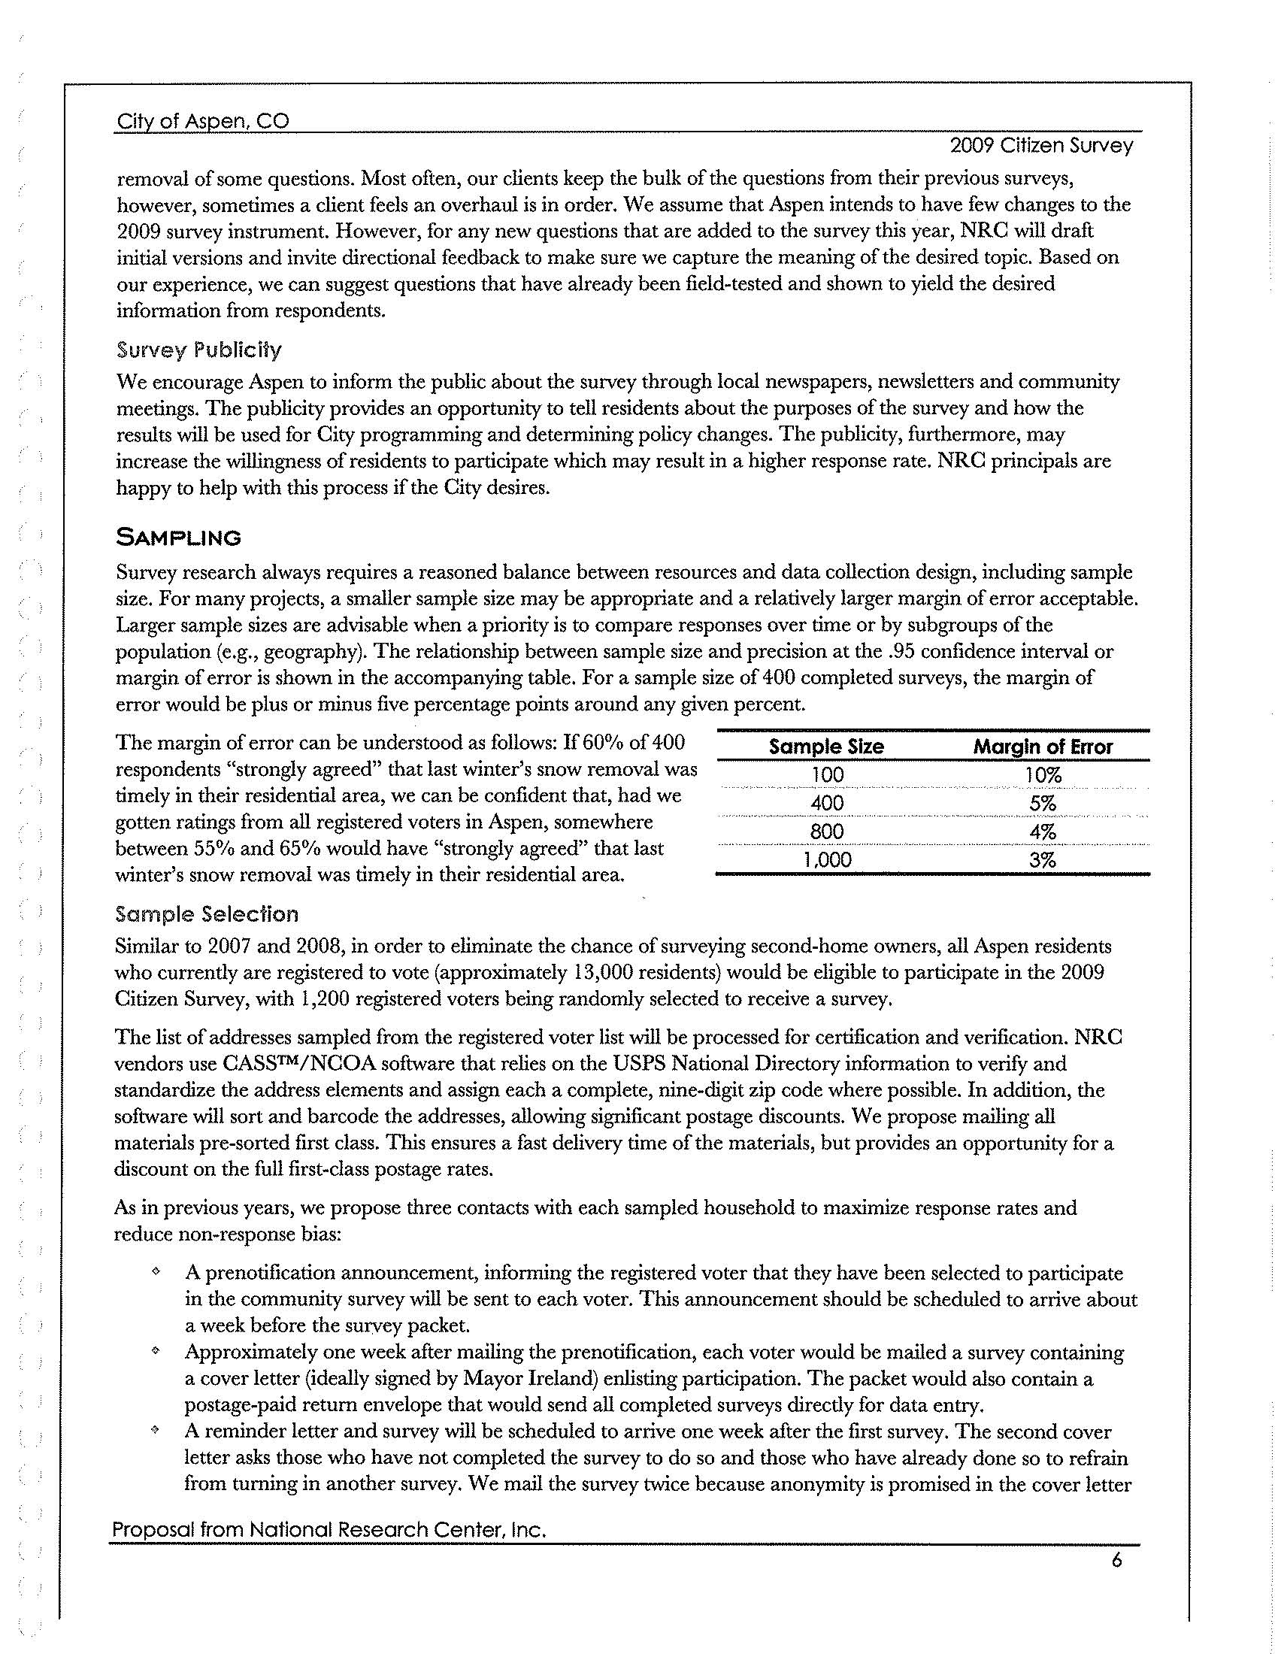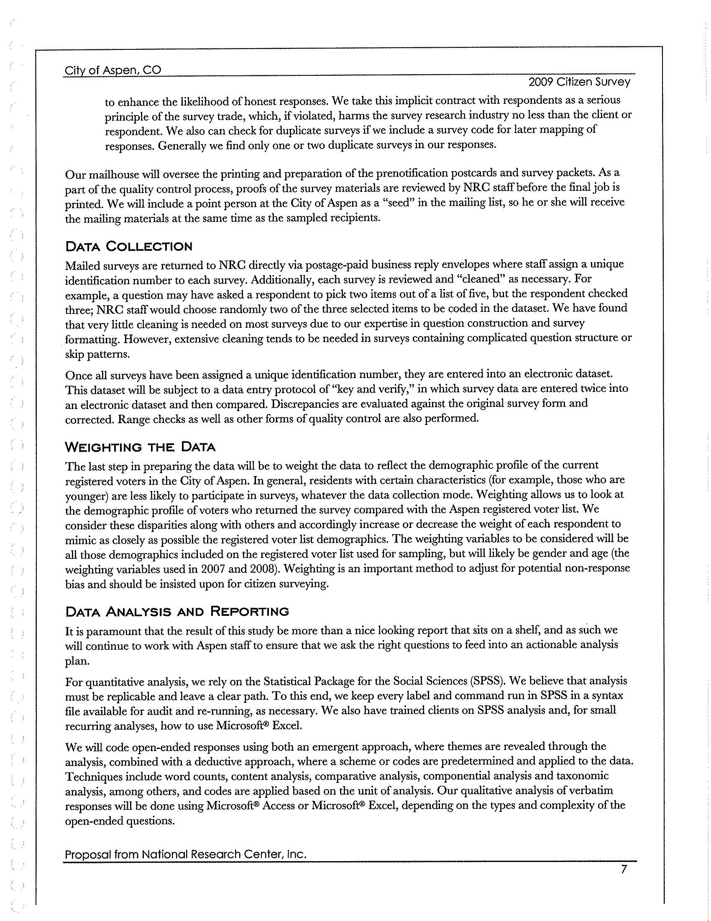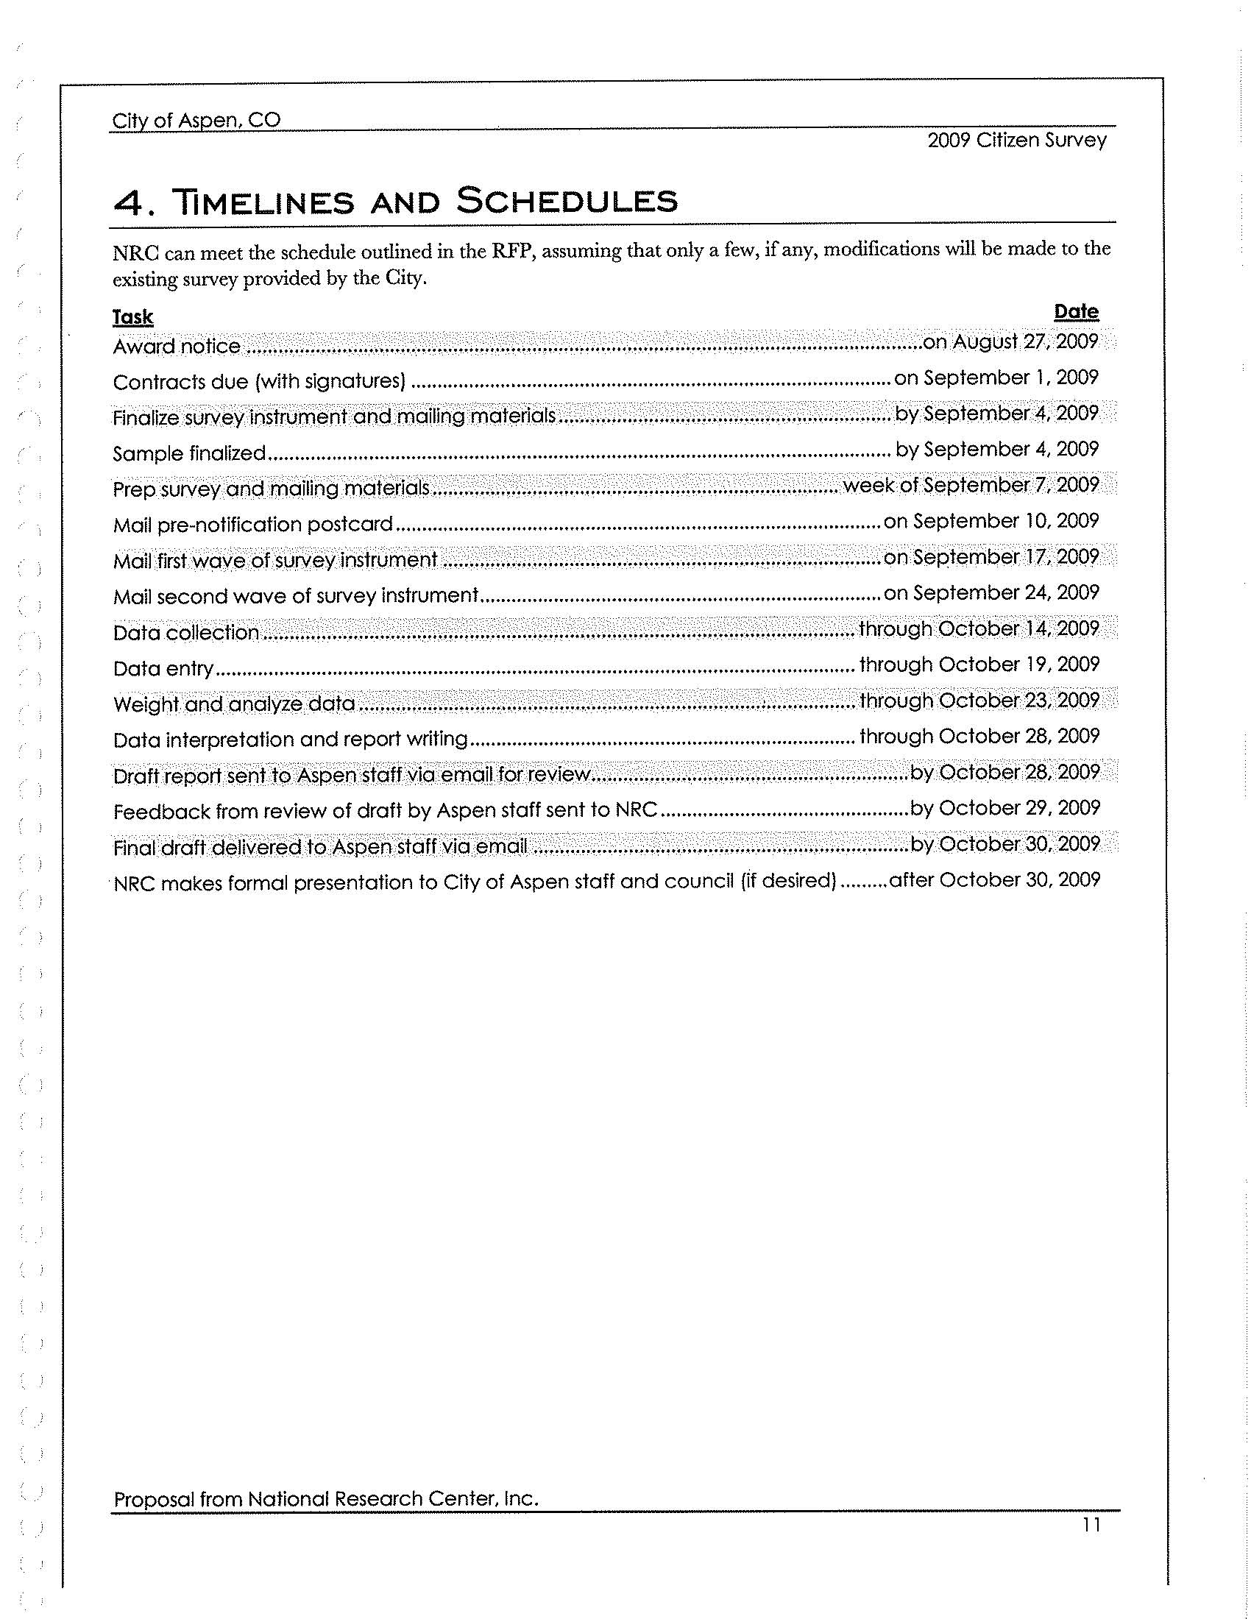

EXHIBIT “B” to Professional Services Agreement

Rate Schedule

