ICMA Career Development Award
In Memory of L. P. Cookingham
Nomination of Kenneth Pulskamp
City of Santa Clarita, CA
2010

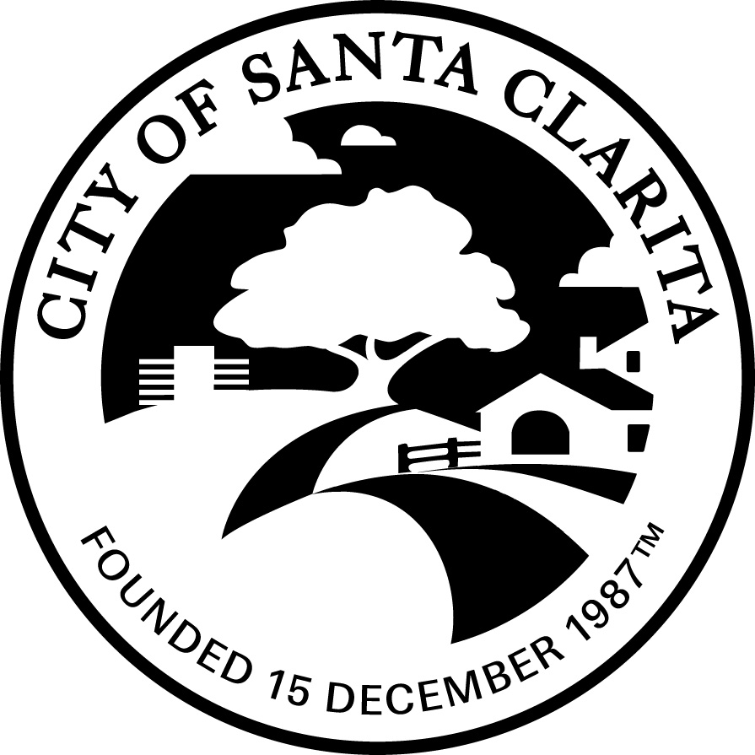
ICMA 2010 ANNUAL AWARDS PROGRAM
Award for Career Development in Memory of L.P. Cookingham

Kenneth Pulskamp
City Manager, City of Santa Clarita

With over 30 years of experience in local government administration, Ken Pulskamp has demonstrated an outstanding and sustained contribution to the public sector and has continuously fostered his personal mission of creating opportunities to further the development of individuals advancing within the profession. Ken is currently the City Manager for the City of Santa Clarita. He is also the current president of the League of California Cities City Managers Department He has been with the City nearly since its inception in 1987, and over the years he has served as the Acting Department Head of every City department. He became City Manager in 2002.

Ken understands the responsibility he has as the City Manager to lead employees in a manner that professionally strengthens them and solidifies the organization. Through open dialogue and the implementation of effective programs within the workplace and the community, Ken has created an environment that fosters creativity while challenging employees to rise above expectations and realize their personal best.

Mentoring Program…
In light of the shortage of qualified government employees on the national front and the City of Santa Clarita’s young workforce, Ken made it his responsibility to address this issue by implementing a formal Mentoring Program. He pioneered the City’s Mentoring Program to develop future leaders from within the organization, strengthen the mentoring skills of existing leaders, and to honor and protect the future of the public service profession.

The Mentoring Program was created with the following goals in mind: to provide employees with growth and development opportunities; institutionalize mentoring and support the City’s Philosophy and core values; address issues identified in an employee survey that showed desire among employees to engage in mentoring relationships; to invest in our human capital; to identify leaders and potential leaders; to build and deepen leadership capacity; to provide training and resources; and provide a support and recognition network for those seeking growth and development opportunities.

During the process of developing the Mentoring Program, Ken purposefully sought extensive input from the City’s executive and senior level management. This input process allowed the Program to receive acceptance throughout the organization and empower a sense of responsibility among top level management to prepare the City’s next generation of rising stars.

In addition to his advisory and advocacy roles, Ken makes a point to allow room in his workload to participate in the program. It is not uncommon for him to agree to mentor three or four employees, giving them each his undivided time and guidance. He also meets with the all of the mentors to facilitate a discussion about key values they should be passing on to their protégés. This is to ensure that mentors are giving protégés advice that is consistent with the City’s Philosophy and core standards for excellence in municipal operations.

Other agencies aware of Santa Clarita’s Mentoring Program have sought Ken’s advice on implementing similar programs in their agencies. The successful program, which approximately 35% of staff participates in each session, is also the recipient of the prestigious League of California Cities Helen Putnam Award for Excellence, a competitive program that recognizes outstanding cities that deliver the highest quality and level of service in the most effective manner possible.

Since Ken’s implementation of the program, mentoring has become more than just a program; it is what the City values. With this philosophy, Ken fosters a workplace environment that contributes to the professional growth and development of every employee in the organization.

Becoming Better Leaders…
With an eye on developing the future, Ken kicked off 2009 by introducing the City’s Leadership Academy, designed for emerging leaders as well as employees currently in leadership positions. Ken enlisted fellow members of the City’s Executive Team, comprised of the Assistant City Manager and the City’s four department heads, to join him in facilitating a program that provides participants with fundamental skills to be a successful leader at the City. Participants also gain an understanding of their leadership style as well as the City’s expectations for leaders.

The Academy consists of monthly sessions over a ten-month period and includes training workshops, assessments, open discussions, and access to members of the Executive Team. Ken personally reviewed the 50 applications and selected the 16 participants of the inaugural class.

To compliment the Leadership Academy, Ken introduced to staff the Supervisory Series, a program designed to help current supervisors develop a foundation and strengthen the skills needed to effectively manage others. Core courses are designed to provide participants with an understanding of state and federal employment laws; knowledge of the City’s personnel rules, policies, and Memorandum of Understanding as well as how to apply them; awareness of the City’s expectations for supervisors; and take away information and tips to enable participants to more effectively perform their jobs each and every day.

Preparing the Next Generation…
Through Ken’s “open dialogue” management style and the implementation of effective programs within the workplace, the City of Santa Clarita has garnered a reputation for being an organization where professional growth is encouraged and celebrated. This is evidenced in the number of current employees who began their careers with the City of Santa Clarita as an intern.

Ken truly believes that it is his professional responsibility to mentor young and mid-career professionals. As part of this philosophy he spearheaded the hiring of interns for every department within the City. Numerous employees, many of whom where once Ken’s interns, have gone on to have successful careers in local government, rising through the ranks as city managers and all points in between.

Just last year Ken co-published the Cal-ICMA book “Local Governments Preparing the Next Generation: Successful Case Studies”. The book was assembled for the purpose of showcasing all the hard work being done by cities to help attract and prepare the next generation of government professionals. It was Ken’s goal for the book to be used as a resource for cities to use when inspiring their own programs designed to prepare the next generation.

Out of Your Comfort Zone…
As a matter of principle, Ken does not believe in the status quo. He challenges his staff to think outside the box on a daily basis, valuing both creativity and innovation. As part of fostering such an innovative work environment, under Ken’s direction the City of Santa Clarita has become known in the public sector as a pioneer in the field of mentoring and preparing the next generation of local government leaders.

Often we hear stories about government being too slow, bureaucratic, corrupt, unavailable and unhelpful. Ken is sensitive to this negative perception and has taken great strides to make sure that Santa Clarita is opposite of this view. Ken’s genuine pride for the community and public service has inspired him to create a comprehensive vision for making Santa Clarita a premier City in California.

To support this vision, Ken pioneered and implemented a city-wide organizational improvement program that would enhance the way the City does business and interacts with the community and make Santa Clarita a desirable City to work for. This City-wide effort required Ken to develop an all staff training program for every City employee called Service Excellence that focused on empowering staff to take pride in their work and to value the important role that public service has on the community.

As part of this comprehensive effort, Ken implemented a city-wide employee survey to identify issues that impacted staff’s ability to provide exceptional service. This process could not have been successful without Ken’s willingness to accept feedback, his patience, integrity and desire to have a positive impact on Santa Clarita’s future. The organizational improvement program led to staff members feeling empowered and inspiring creative approaches to service delivery and public communication.

An Honorable Career Path…
Ken is truly a living example of a personal commitment to mentoring young and mid-career professionals. In Ken’s own words he states, “A career in local government can be very rewarding and is certainly an honorable career path. I find it very unfortunate that government work is often mislabeled as being bureaucratic, second-rate work that does not attract the best and brightest employees. For this reason, it is crucial that we strive to correct this fallacy by enhancing the development and attraction of talented employees.”

From mentoring, to fostering career succession, to encouraging leadership, each of these efforts represents Ken Pulskamp’s outstanding and sustained commitment to furthering the profession and creating opportunities for the next generation of local government leaders.
.

