Innovation Study Title | City of Tyler Performance Excellence Program
Category | Performance Excellence
Jurisdiction Name | City of Tyler
City/County Manager | Mark McDaniel
Population | 104,083
Submit Innovation Study for an Alliance Innovation Award Yes [ X ] No [ ]
Submit Innovation Study for Rapid Fire Session Yes [ X ] No [ ]
Project Leader/Primary Contact
Name | Guillermo Garcia
Title | Manager for Innovation
Department | Lean Six Sigma
Phone Number | (903) 595-7174
Email | ggarcia@tylertexas.com
Mailing Address | 304 N. Border Ave., Tyler, TX 75703
Presentation Team Member
Name | Kristi Boyett
Title | Manager for Organizational Development
Department | City University
Phone Number | (903) 595-7172
Email | kboyett@tylertexas.com
Mailing Address | 212A N. Border Ave., Tyler, TX 75703

Intent of Project/Program/Service
The City of Tyler has long enjoyed a reputation for innovative, forward-thinking management, focused on performance excellence. That reputation was strengthened when the City invested in programs such as Lean Six Sigma, City University (a continuing education program for employees), began participating in the Alliance for Innovation, and focused on internal communications, tri-annual department budget forecasts and review, monthly department budget forecasts, strategic planning and quarterly departmental business planning. These programs were integrated in January 2012 along with the use of the Malcolm Baldrige criteria, to form the City of Tyler Performance Excellence Program (PEP). Through the use of these systems, leaders can make decisions and allocate resources in the most effective and innovative ways, while focusing on results. PEP helps the organization’s employees better understand how several different programs work together to accomplish the vision “to be the standard for performance excellence in local government.”

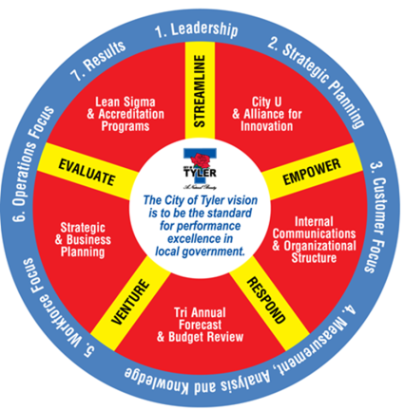
At the heart of PEP is the evaluation process that is conducted by City employees, who are Lean Six Sigma Black Belts and have also attended training to be Quality Texas examiners. The evaluation is designed to measure the leadership, strategic planning, customer focus, measurement analysis/knowledge sharing, workforce focus, operational focus, and results of each department. The seven criteria areas are used to identify opportunities of improvement and recognize strengths within each department that can be shared as best practices. By providing feedback and a score, the departments learn where they are in their journey.

Cost/Savings
The City has spent $8,942 for Quality Texas training of eight City employees, $450 for graphic design of the PEP logo and posters and $1,947 for PEP printed materials.

Through the use of PEP, the City has been able to maintain and continually improve upon services and products which results in millions of dollars of savings for the citizens of Tyler. For example, the City has saved more than $3.7 million dollars thanks to Lean Six Sigma projects. The use of an in-house training program, City University, has saved the City $575,560 since its inception and employees have spent 19,038 hours in training.

Innovation Characteristics
The fact that City employees were trained in the Baldrige criteria and are serving as internal evaluators is one of the most innovative characteristics. In addition, each department is held accountable to the criteria instead of only applying the criteria to the organization as a whole. PEP requires that all departments submit a quarterly Business Plan and answers to questions within the aforementioned seven criteria. PEP Evaluators conduct a review of the Business Plan and PEP Questionnaire prior to an actual site visit with each department. During this evaluation, the departments are asked to clarify or show evidence of the responses that they provided. The PEP Evaluators provide each department with a Feedback Report that identifies the overall strengths and opportunities for improvement in each criteria section. The department receives a score in each section and an overall score based on 1,000 points. This score is then averaged together to provide an overall score for the City. To increase their score, the departments are required to improve upon their identified opportunities and show progress toward achieving performance excellence. This quarterly review of work systems and operations has greatly improved the organization as a whole. The first evaluation was completed in January 2012 and resulted in a citywide average score of 439. The most recent evaluation was completed in July 2013, and resulted in a citywide average score of 584, a difference of 145 points.

Obstacles
The major obstacle that we faced was communicating that this was not another program but the accumulation of all the current programs that provides one common direction. The other obstacle was helping employees understand how the PEP Evaluation process would help improve their department. To combat these obstacles, the Communications Department created a PEP Employee Brochure that describes how each employee can make a difference and help the organization reach the goal of becoming the standard for performance excellence.

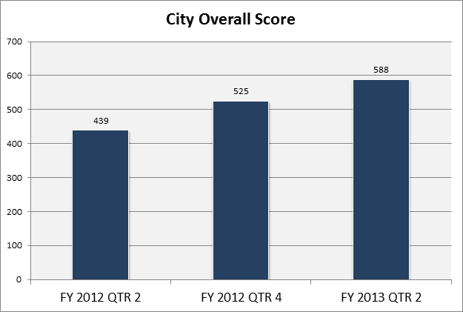
Applicable Results and Real World Practicality
The following outcomes are a result of the PEP efforts:
- Increase in City Overall PEP Score:
- Only the second city in Texas to achieve the Quality Texas Engagement Award
- The city has maintained one of the lowest property tax rates for a city its size in Texas:
- The City has maintained zero general obligation debt and a AAA Bond Rating.
- The Police Department has attained accreditation from the Commission on Accreditation for Law Enforcement Agencies.

The PEP Evaluation process is applicable to all organizations, both private and public.

Consultant Information
A private consultant was not involved in the design of PEP or its deployment throughout the city. The consultant’s main objective was to provide feedback as to the effectiveness of the program and deployment.

Presentation Style
Our presentation will involve PowerPoint, video snippets, handouts and role play of a department on-site evaluation.

