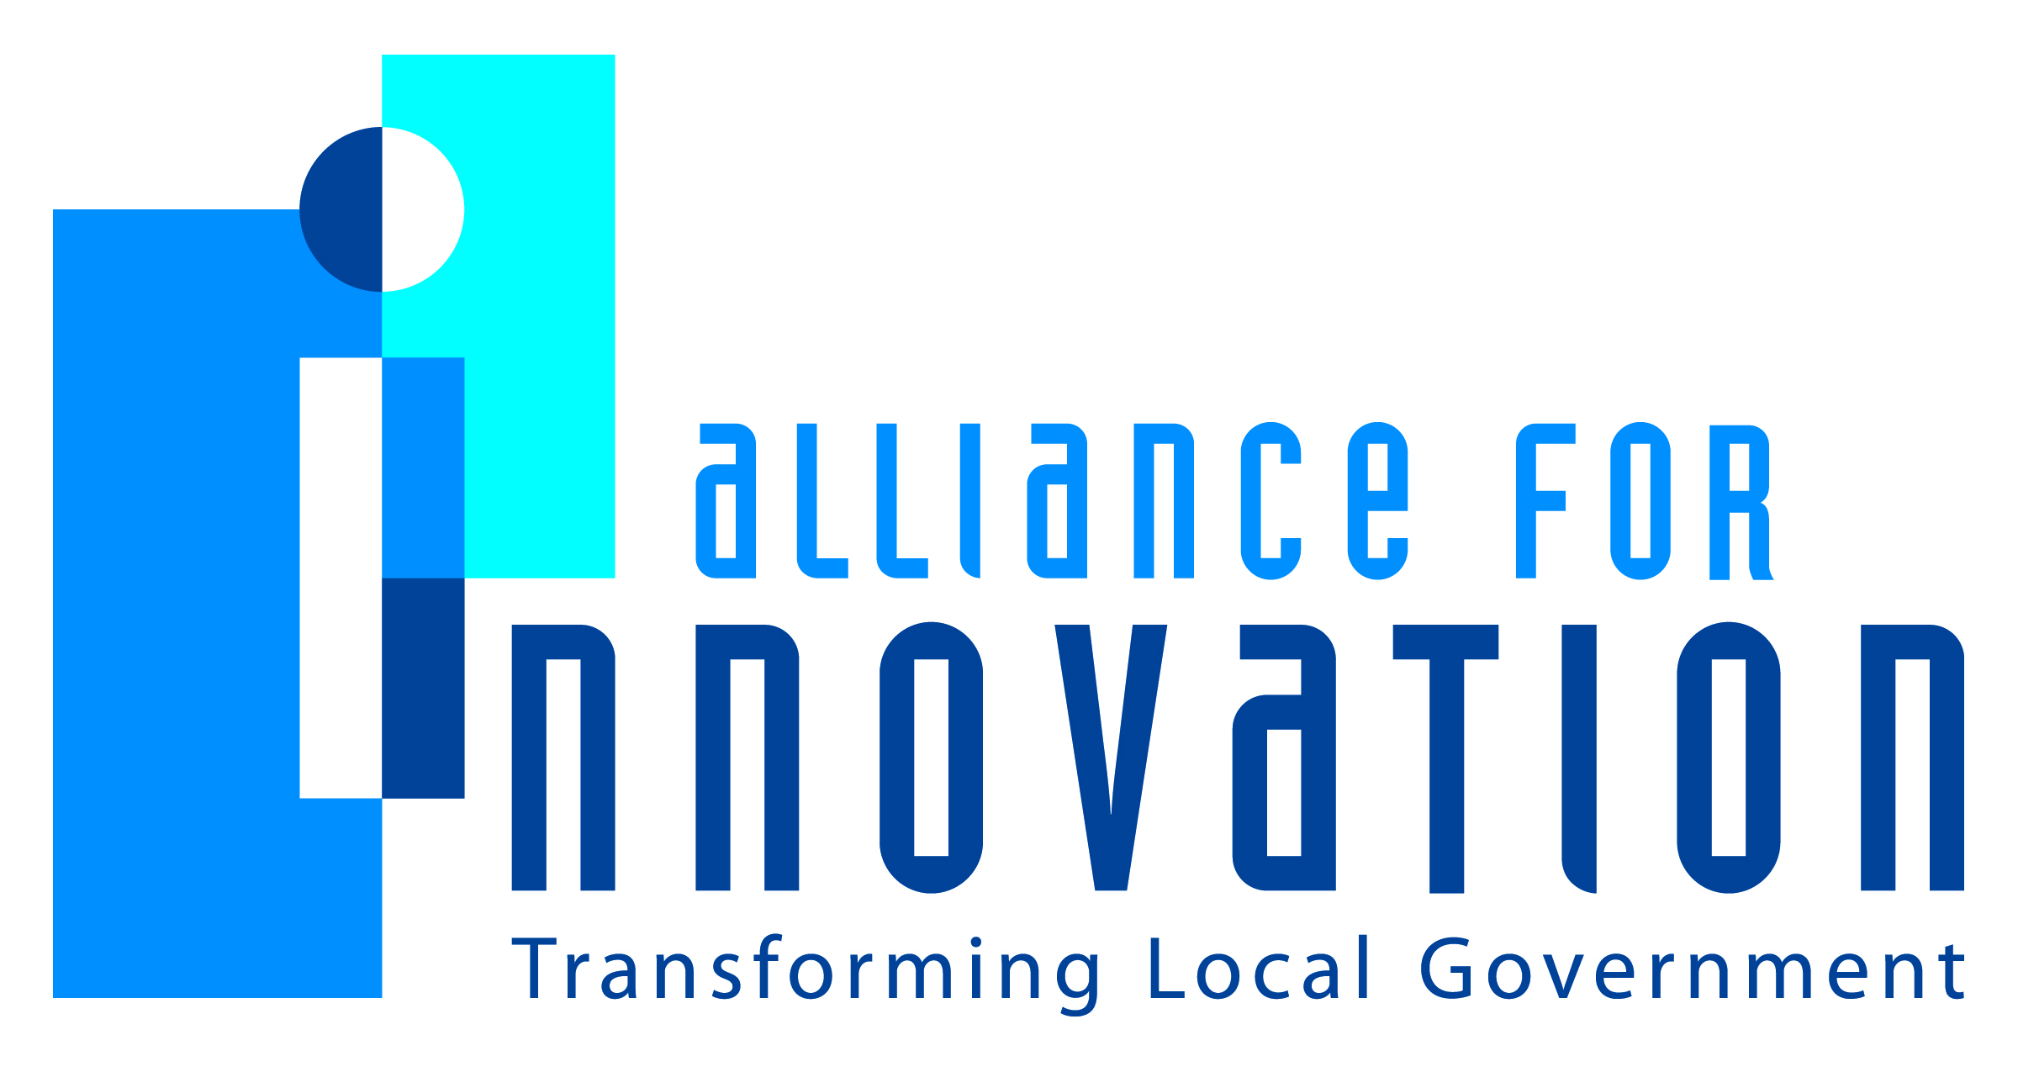

Innovation Award Application 2014



City Social and Collaborative Intranet/Extranet
Kerry Goode
CIO/Director of Technology Solutions
City of Durham, NC
101 City Hall Plaza, Durham NC, 27701
919-560-4122
Kerry.Goode@durhamnc.gov

Describe the Program/project/ product/ service innovation:
Business Problem:
Three years ago, the City faced a business need to better manage information and communication internally and externally along with fostering effective collaboration. Before the new City of Durham Intranet (CODI), the City utilized several software platforms to meet manage information and communicate such as: Coldfusion web pages and applications; Info Path forms; html web pages; and Outlook rules. These platforms required centralized content management and administration of the City's Intranet to one department. This resulted in delays in keeping content up-to-date and an inconsistency in the delivery of functionality and delivery of solutions.
Innovative Solution:
After much analysis and thought, the idea of having a single platform that should empower the business units (Departments) employees to manage their content, communication, and collaboration. In addition the platform should give the employees their own Intranet presence for personal communication and collaboration. The City IT Department researched the market and decided that the SharePoint 2013 platform would meet the needs of the aforementioned innovative idea. The City migrated the Intranet to the SharePoint platform, termed the City of Durham Intranet (CODI). The City then structured the Content Management and Administration of the Sites by empowering the departments to maintain their own content. The City also implemented Microsoft SharePoint MySites which gives each employee the ability to have a voice on the intranet by maintaining their own contact information, documents, and create/join conversations.
For Additional Information please visit: http://codinetx.durhamnc.gov/transformgov/
Short description of the importance, internal impact, and community benefits:
Importance:
One of the City’s primary goals is to improve employee engagement. An engaged employee is one that that willingly stays informed about the City, participates in City activities, and performs well on the job/task/project assigned. The more employees are engaged contributes to the City becoming a high performing organization. The new Intranet (CODI) fosters a climate that allows employees to easily become engaged with the City. For additional information please view: http://codinetx.durhamnc.gov/transformgov/SitePages/Intranet.aspx
Internal Impact:
Since going live with CODI, employees are staying more informed on current events and activities within the City. Website statistics report that there are 600-800 daily unique visitors to the home page. This has greatly increased the dissemination of news and stopped City Wide event scheduling conflicts. Because Departments are empowered to maintain their own content, information is now up to date. With the centralization of information by category, employees can now find information and applications they need regardless of the department that offers it at the Resource/Information Center, Service Center, and Application Center. For additional information please view: http://codinetx.durhamnc.gov/transformgov/SitePages/Intranet.aspx
Community benefits:
The benefit to the community through CODInetX the community will be invited to easily and securely collaborate with the City while participating on projects, boards, committees, and commissions, etc. This benefit includes document transfers, blogs, announcements, event calendar, discussion boards, etc. For additional information please view: http://codinetx.durhamnc.gov/transformgov/SitePages/Extranet.aspx
For Additional Information please visit: http://codinetx.durhamnc.gov/transformgov/SitePages/Extranet.aspx
What makes this a quantum leap of creativity?
In our analysis, what makes this a quantum leap is that on a single platform the city is able to offer robust social intranet and extranet that is accessible anywhere and mobile ready, with a very unique and innovative icon driven visual design. This quantum leap empowers the departments and employees to maintain information without IT oversight. The employee can also build their own social network within the city across departmental boundaries, very similar to Facebook and LinkedIn. Departments can maintain permissions on who has access to their data both on the Intranet and Extranet.
For Additional Information please visit: http://codinetx.durhamnc.gov/transformgov/
Who benefits?
City Employees: Employees are now empowered to stay informed, contribute content, collaborate with other employees throughout the city whenever and wherever they want.
City Departments: Departments can maintain permissions on who has access to their data both on the Intranet and Extranet. Departments can update their own announcements, calendar events, and documents. This keeps the information up to date and all employees informed.
City Manager’s Office: Now the homepage of the Intranet is the single landing page for all Employees to get City Announcements and City Events.
Community: Citizens and Partners; City/County Boards Committees; and Commissions, all benefit from this new platform. Previously all interaction was done through FTP and emails. Now the City can securely communicate with not only documents, but also calendars, announcements, and discussion boards within the extranet.
For Additional Information please visit: http://codinetx.durhamnc.gov/transformgov/
How was the program/project/product/service initiated and implemented?
This Project was initiated at the request of the City Manager’s Office, Technology Solutions Department, and Public Affairs Division, and desire of all Departments and Employees to have a better platform to collaborate. To implement the project, the Technology Solutions department partnered with six key Departments and Public Affairs Division for a proof of concept. During the proof of concept process, forums where held to give all employees a voice in the direction of the new Intranet. Implementation was done through a phased approach. First the 6 key departments were implemented. City Wide service and regulator providing departments were identified. These Governing and Administrative Departments were migrated first as most of the service, resource, and information documents and processes are performed by these departments. Then the remaining departments were migrated and deployed. While departments were being deployed, marketing and training videos, guides, and classes were being developed, deployed, and held to inform the employees of the project and ease the transition onto the new platform.
What risks were taken?
There were several risks that presented themselves during this project. The first risk was to build CODI on a newly release SharePoint 2013 platform. The second risk is that the funding for the project was not at the level to allow for consultants to assist. The third risk was committing to a short timeline. The fourth risk was committing to an empowering model for departments and employees.
What, if any were the costs and/or savings?
The project was originally budgeted for $205,000. The City saved the $100,000 by taking the design and lessons learned from the Internet Project to build the Intranet with City Staff.
What are the lessons learned that other local governments can learn from?
Benchmarking is very important. The City searched for proven successes in local government and the private sector: Virginia Beach, VA; Reno, NV; SAS. These successes were utilized in the structure and features offered in the new Intranet. The Technology Solutions department formed a Vision Team comprised of employees from several departments to foster ideas. Employee buy-in is very important. The Technology Solutions department invited all employees to join in several forums to provide suggestions on how to restructure the Intranet and on what features to provide. The Empowerment Model gains the trust and buy-in of the Business Units (Departments) because the value that they seek from the project is reflected from their input. By using this model and establishing Project Champions at the highest level of each Department, the department process now flows more smoothly. Marketing the new product is also very important. When the new Internet was deployed there was an announcement made to Employees and Citizens; however, there was no additional information on the new structure of the data, guides, or training offered on using the new site. With the CODI project, emphasis was placed on marketing to promote the benefits of the new site’s structure. Video Presentations (can you attach a video presentation), User Guides, and class room training was scheduled prior to deploying the new site.
What department and/or individual(s) championed the innovation? If a contractor was used, please list the name and their contact information.
The new Technology Solutions Web Support Division Manager, John Stinson, championed the innovation along with his divisional staff throughout the City. The CIO, Kerry Goode, championed the innovation with the City Manager’s Office. Each Department Director Championed the move for their department to the new platform. This also included petitioning their employees to build their MySite.
Any additional information you would like to share?
The next phase of the CODI project is to allow access for all employees anywhere regardless of City Wifi or City issued devices with VPN. To enhance the user experience with ‘Bring Your Own Device’ (BYOD), the site will utilize Responsive Design. Responsive Design for web pages will allow the web page to restructure itself based on the device (Desktop, Tablet, Smart Phone) used to view it. This phase is scheduled to complete during the City’s 2014 fiscal year.
Please view the ‘Alliance For Innovation’ site created on CODInetX:
http://codinetx.durhamnc.gov/transformgov/SitePages/Home.aspx
On this site we have placed examples of the Intranet, Extranet, and a Presentation for Phase 2.

