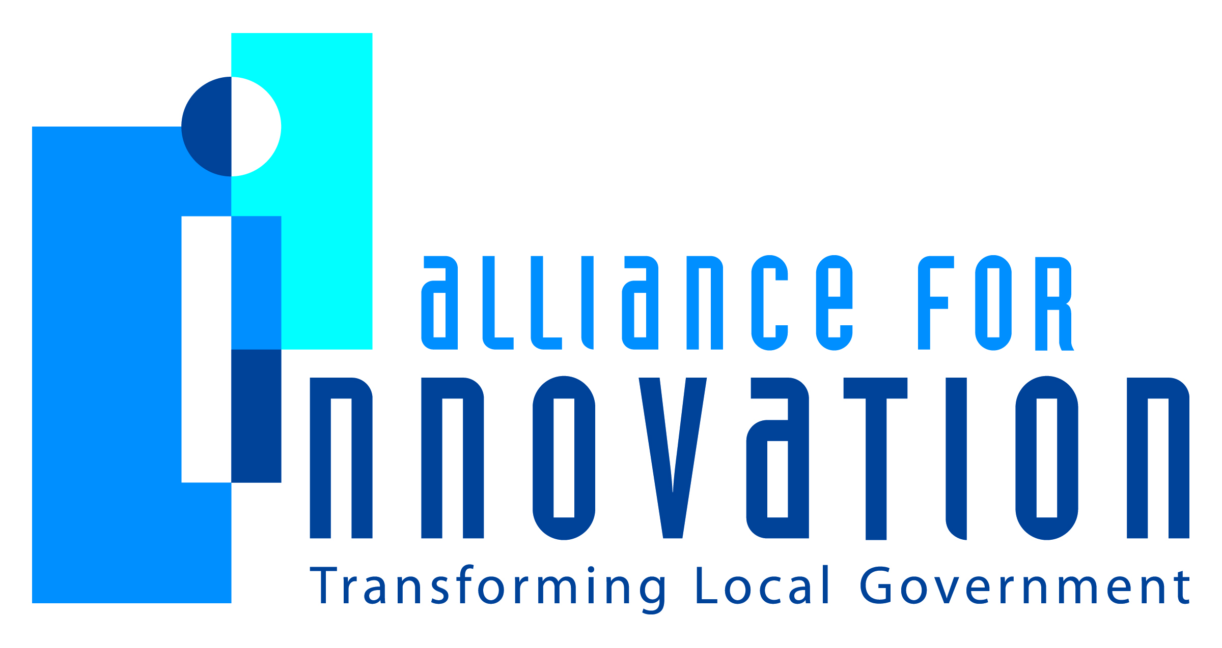

Innovation Award Application 2014



**XPress Consortium Project**

Chris Longshore (Arvada); Leslie Labrecque (Boulder)

City of Arvada & City of Boulder

1101 Arapahoe Ave, Boulder, CO 80302

303-441-4280

labrecquel@bouldercolorado.gov

**Describe the Program/project/ product/ service innovation:**

The XPress Consortium is a project to share and co-develop an open source web content management system (CMS) named XPress. The XPress CMS was originally written by the City of Arvada and is now being co-developed and shared by the City of Boulder.

**Short description of the importance, internal impact, and community benefits:**

When government agencies collaborate and both contribute to shared resources these agencies save time and money. The core enhancements to the system are shared between agencies and immediate improvements are realized when these enhancements are implemented. Additionally, the CMS is built with the specific needs of local governments in mind and the features are designed to meet the needs of our constituents.

**What makes this a quantum leap of creativity?**

To the best of our knowledge a project such as this has not been attempted in the state of Colorado so we are the first agencies in the state to share and co-develop the same CMS. Since the software utilizes open source technology our options for enhancement are only limited to the staff time required to implement the enhancements. Also with utilizing open source technology we are able to integrate with any other city systems with an Application Programming Interface (API).

**Who benefits?**

This project benefits any of the existing and potential future partners in the XPress Consortium. At this time only the City of Arvada and the City of Boulder are partners. Taxpayers also benefit because we are saving staff time and tax payer money.

**How was the program/project/product/service initiated and implemented?**

In 2011 the City of Arvada submitted a bid proposal responding to the City of Boulder’s request for information (RFI) regarding the replacement of the bouldercolorado.gov website. The City of Arvada proposal was to share and co-develop the XPress CMS. The City of Arvada was chosen as the CMS vendor for the RFI and the two cities signed a Memorandum Of Understanding to share and co-develop the XPress CMS. The City of Boulder hired a dedicated programmer position to work on this project and implementation began in 2012. The new bouldercolorado.gov website went live in July 2013 using the XPress CMS.

**What risks were taken?**

The main risk in this project was a risk of an unknown partnership. The municipalities involved took a risk on creating and fostering a successful and fruitful partnership.

**What, if any were the costs and/or savings?**

The City of Boulder saved between $40,000 to $100,000 in one-time software implementation costs. Both agencies are saving between $12,000 to $20,000 per year in annual maintenance costs.

**What are the lessons learned that other local governments can learn from?**

There were several lessons learned during this project. One lesson learned was the importance of communication. Partner agencies need to discuss and agree upon enhancements to the core CMS code as well as the timeframe for implementation. Another lesson learned was the benefit of co-developing allows us to be more responsive to our content managers’ needs. The final lesson is that by being government specific we can limit our focus to only the required functionality.

**What department and/or individual(s) championed the innovation? If a contractor was used, please list the name and their contact information.**

Don Ingle, Nestor Rizo-Patron, Ron Pringle and Leslie Labrecque from the City of Boulder; Michele Hovet, Ron Czarnecki, Chris Longshore, Andrew Senseney and Abi O’Neal from the City of Arvada

**Any additional information you would like to share?**

The XPress CMS was designed with municipal governments in mind and the features and enhancements being added to the core CMS are heavily focused on this sector. The XPress Consortium partners look forward to retaining more partners who will continue this focus.