2006 ICMA Annual awards program
City of Waterloo
community sustainability award submission

Laurel Creek watershed monitoring program
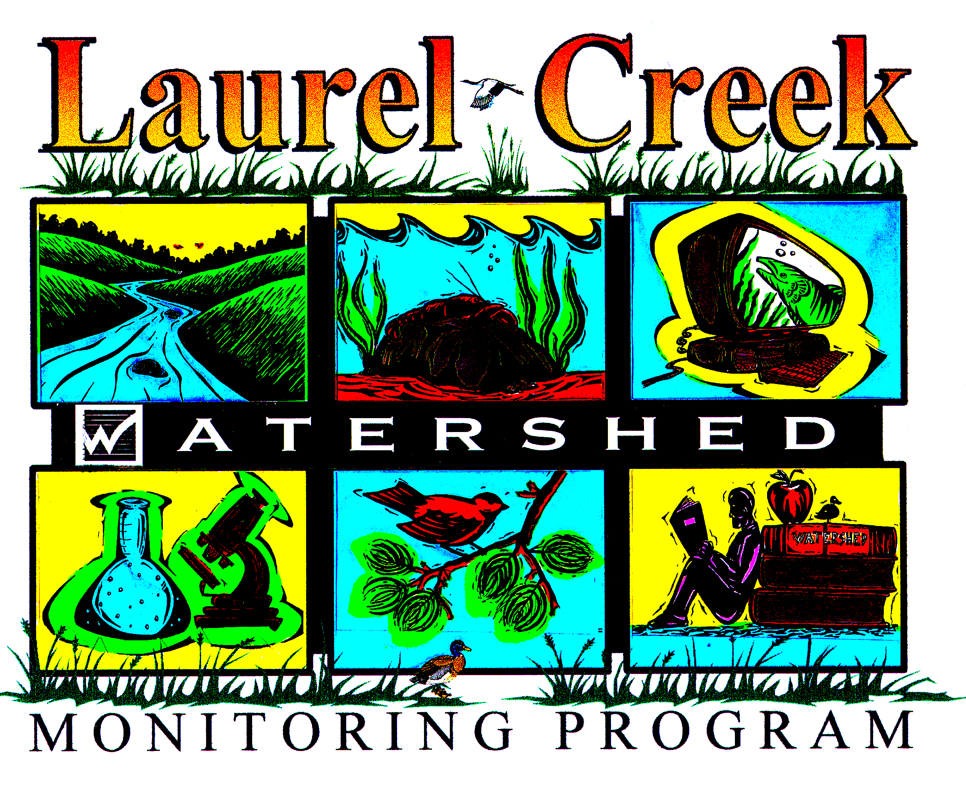
100 regina street south
waterloo onTario Canada n2j 4a8

Laurel creek watershed monitoring program
submission for community sustainability award

2006 ICMA program excellence awards
1. Problem Assessment, the challenge or need that prompted the local government to develop the program

In order to make appropriate management decisions with respect to land use, development, and City operations, it was necessary to understand the current state of the watershed and to identify changes as they occur. In 1993, a Laurel Creek Watershed Study was completed providing a comprehensive strategy for watershed management. A strong recommendation was to develop and implement a long-term watershed monitoring program. 1n 1994, the City of Waterloo’s Official Plan (Amendment #16) reflected this environmental initiative by supporting watershed management through the goal: “To protect, manage and enhance natural resources, including land surface, water and groundwater quality, forest and wildlife”.
In 1996, the Laurel Creek Watershed Monitoring Program was developed by a panel of internal and external experts, including world renowned academics from the University of Waterloo. Recommendations were established and approved by City of Waterloo Council in August 1996 to monitor key indicators of water quality, hydrology, aquatic habitat, and the greenspace system. By collecting long-term baseline data it will be possible to identify future trends throughout the watershed and detect improvements or degradations to these indicators during and after development has occurred. This program is unique in that the City of Waterloo is among few Canadian municipalities that have voluntarily pursued monitoring ecosystem conditions over the long-term.
The objectives of the Laurel Creek Watershed Monitoring Program are:
- To detect on an on-going basis and as development occurs, changes in the environmental health of the Watershed.
- To maintain and improve the health of the Watershed (greenspace and aquatic features).
- To develop a comprehensive database for future comparison and analysis.
- To increase public awareness and encourage community stewardship.
2. Program implementation and costs

Watershed Monitoring began in 1996 with a pilot study to determine monitoring locations, the frequency of monitoring and the environmental parameters to be monitored. The monitoring program consists of three parts:
 | Program Component | Program Purpose | Program Costs  (City of Waterloo share)
1. | System Monitoring | - To monitor the overall health of the watershed  - To establish long-term baseline conditions and to compare future conditions to this baseline to identify trends | $100,000
2. | Development Monitoring | - Confirm the pre-development conditions on a site specific level through pre-development monitoring  - Monitor the impacts of construction through construction monitoring  - Monitor, maintain, and mitigate (if necessary) facilities (e.g. storm water management ponds) until 2 years after substantial completion (90% developed) of the site through post construction monitoring | Developer funded
3. | Post Development Monitoring | - To regularly monitor and maintain environmental conditions and facilities to ensure their continued proper function. | $30,000
System monitoring is carried out in partnership with the University of Waterloo, Grand River Conservation Authority, Canadian Wildlife Service, Ontario Ministry of Natural Resources, Natural Resource Solutions Inc, and other private consulting agencies. Development monitoring work is carried out by engineering consultants on behalf of developers. The developers are responsible for the consulting fees and all other disbursements that are required to conduct the fieldwork and to have the consultants report the results to City of Waterloo Development Services.
The Laurel Creek Watershed Monitoring Program monitors several key environmental indicators to provide a scoped annual assessment of watershed conditions. The selection of monitoring parameters was based on recommendations from the Laurel Creek Watershed Study. These parameters are continually assessed to review their continued relevance as indicators of watershed health and changes to these parameters may occur as new scientific information is made available. The environmental indictors include:
Watershed Category | Indicator Parameter
Water Quality | - Total Phosphorus  - Total Suspended Solids  - Dissolved Oxygen  - Water Temperature  - Bacteria
Aquatic Habitat | - Benthic Macroinvertebrates
Hydrology | - Baseflow  - Stormflow
Greenspace Features | - Greenspace Size & Health  - Amphibians  - Landbirds

An additional component of the Laurel Creek Watershed Monitoring Program includes managing the monitoring data as it is collected. Ongoing efforts are underway by the City of Waterloo, Information Systems Division to incorporate all data into a central data warehouse to allow greater accessibility to the information. Web-based applications are currently being developed to allow information requests to be generated over the City of Waterloo’s website.
3. Tangible results or measurable outcomes of the program

Program Outcome | Importance of Outcome | Effectiveness Measure
Community engagement through hands-on environmental activities and providing interpretive signage helps to create public awareness and positive action on watershed issues | - Gaining community support and understanding will encourage public stewardship and action towards activities which protect and respect the environment. | - Increased participation in public environmental events annually.  - This educational program can be replicated in other communities as seen by the local Neighbourhood Association which has initiated their own events to create environmental awareness.
Identification of problem areas within the watershed | - Allows for targeted approach to watershed rehabilitation  - Short-term visual inspections of the greenspace allows for immediate remedial action to take place. | - Ensures taxpayers dollars are being spent on the areas of priority in the watershed.  - Allows the City to evaluate the effectiveness of remediation techniques and implemented protection measures.
Infrastructure design adjustments | - Design of SWM facilities have been adjusted based on results of Development monitoring data of stormwater performance. | - Improved water quality data  - Allows for adaptive management and encourages design innovation.
10 year database of watershed data | - Allows for trend analysis.  - Helps assess any impacts due to urbanization and other anthropogenic (influences of human beings on nature) effects. | - Allows for cost savings at the project level because baseline data is available.  - Longest municipal monitoring program in Canada.

4. Lessons learned during planning, implementation, and analysis of the program.
- A key element in the success of the Laurel Creek Watershed Monitoring Program has been the support and input of an interagency team that assists in the development and direction of the monitoring program. This team consists of members from:
- City of Waterloo
- Grand River Conservation Authority
- Ministry of Natural Resources
- University of Waterloo
- Development Industry Representatives
- Regional Municipality of Waterloo
- Canadian Wildlife Service
- Ontario Streams
- The Laurel Creek Watershed Monitoring Program has allowed the City of Waterloo to focus on watershed rehabilitation initiatives in those areas that are in most need.
- The Laurel Creek Watershed Monitoring Program has created awareness within the community of watershed issues, which creates momentum for change. At times however, because of the extensive data that is available the Municipality can become a target for not addressing environmental concerns.
- The monitoring data has proven valuable for other communities identifying urban related impacts in their watershed and allowed them to adopt similar mitigation techniques.

