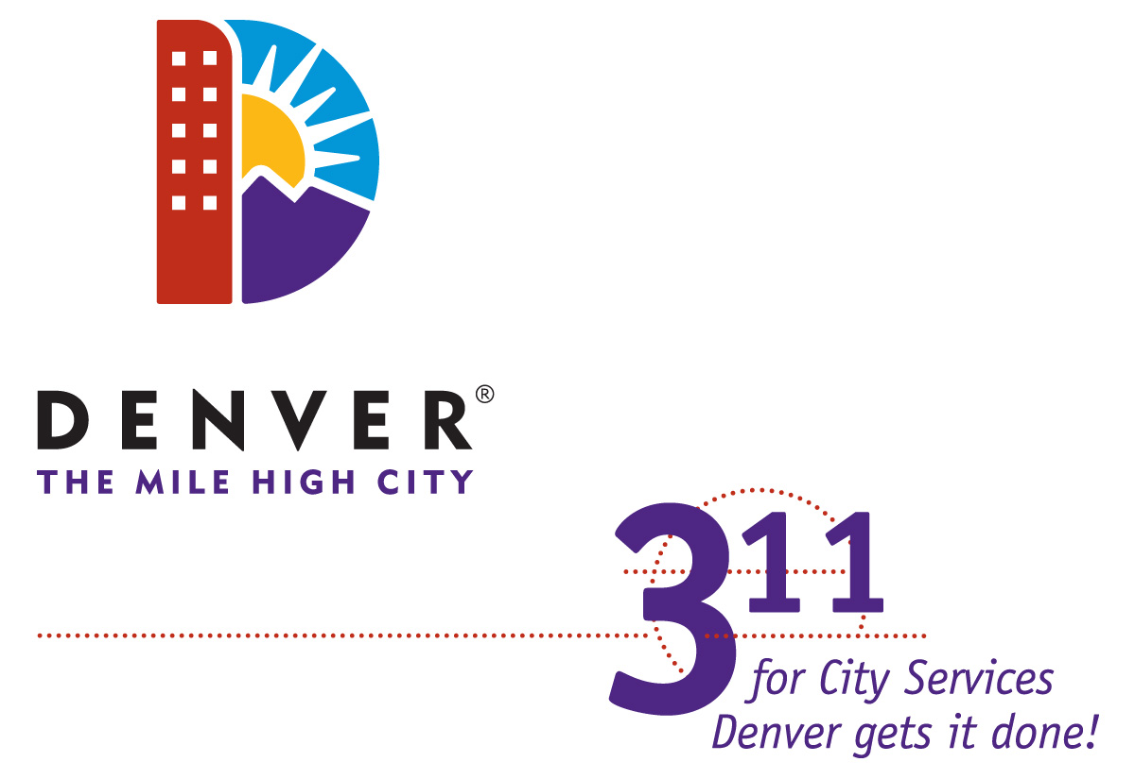 | City and County of Denver  311 and {AGENCY}  Service Level Agreement

Objectives

Denver 311 delivers information to and collects service-related data from its external customers (Citizens and the general public) on behalf of the City and County of Denver. If unable to fulfill a Customer request, 311 will refer the Customer to the appropriate City Agency. To support these objectives, Denver 311 uses a Customer Relationship Management (CRM) software application to manage, track, and categorize Customer requests. CRM will also provide 311 Agents with the information needed to properly resolve or refer the request.

This Service Level Agreement (SLA) and the attached Exhibits define the objectives, roles, and responsibilities of the Service Partnership between Denver 311 and {AGENCY}. This SLA will become effective on {DATE}.

Exhibits

A Current Feedback Procedure
B Current Change/Project Request Form
C Current 311 Hours/Days of Operation
D Call Process Definitions
E Agency Liaison and Agency Decision Maker Contact Rosters
F Agency Liaison and Agency Decision Maker Roles

Denver 311’s Role

Denver 311 will provide the following services and support to {AGENCY} upon execution of this SLA:

- 80% of telephone calls made to the 311 service queue are answered within 20 seconds.
- Customer service channels (telephone, email, online, walk-in) will be provided on behalf of {AGENCY} in concurrence with 311 Hours/Days of Operation (Exhibit C).
- {#}% - {#}% of Customer requests are resolved at 311 on the first call (FCR). The remaining Customer requests are referred to {AGENCY} with the information required to achieve resolution (Exhibit D).
- Customers will be provided with a CRM case identification number for tracking purposes.
- 311 will fully document Customer compliments and complaints referred to {AGENCY} Decision Makers via the CRM application.
- {AGENCY} will be given access to historical CRM data regarding the number of inquiries/requests generated by subject, percentage of cases closed as an FCR, percentage of cases that remain open. 311 and/or {AGENCY} may identify the need for additional data. These needs will be discussed between Partners as they arise.
- 311 Agents will report inconsistencies in {AGENCY}’s CRM Knowledge Base (KB). Inconsistencies and recommendations will be referred to Agency Liaison (Exhibits E and F).
- 311 Decision Makers are available for immediate updates, input, and procedure adjustments (outlined in Exhibits E and F).
- 311 will provide Quality Assurance through its established QA process.

_______
311 Partner
Representative

{AGENCY}’s Role

In order to ensure that Denver 311 provides superior Customer service on behalf of {AGENCY}, upon execution of this SLA, {AGENCY} will provide the following support to 311:

- Assign an Agency Liaison to build and maintain the CRM Knowledge Base (Exhibits E and F).
- Assign an Agency Decision Maker to be available to 311 Leads and Supervisors for quick handling of Customer compliments and complaints or 311 – Agency procedural conflicts (Exhibit E and F).
- Provide access to any Agency-exclusive business tools required for 311 to meet the conditions of this SLA. (lists)
- Ensure that Customer-facing Agency employees are available to Customers to answer calls in a timely manner via telephone during {AGENCY}’s normal business hours.
- Manage all Customer service and information requests using the CRM application. Maintain accurate case status at all times and add pertinent notes to cases. Legacy systems and non-standard applications must be retired.
- Provide {AGENCY}’s organizational chart.
- Ensure that provider group membership is accurate.
- Submit security request forms for additions and removals of CRM access.

_______
Agency
Representative
Mutual Obligations

To ensure mutual success in the execution of this SLA, Denver 311 and {AGENCY} will provide the following support to each other:

- Ensure that any decision/s made that might affect Partner’s ability to conduct business will be made with Partner’s input.
- Inform Partner in advance of planned significant events or operational procedure changes prior to their occurrence and be available to provide training related to the subject.
- Immediately inform Partner of any unplanned events or technical issues that will affect either Partner’s ability to conduct business.
- Take proactive steps in regards to systems and data maintenance so as to provide the best possible technical platform for Partner’s business.
- Ensure that all current and future system and procedure implementations within Partnership are made following the Project Request procedure/s currently in place (Exhibit B), including User Acceptance Testing (formal and informal)
- Attend all meetings, including but not limited to user’s group meetings.

_______ | _______
Agency  Representative | 311 Partner  Representative

Updates or Revisions to SLA

Updates or revisions to this SLA and associated Roles or Procedures may be made at any time that is mutually agreeable to both Partners. In instances where Partners are unable to reach an agreement on an update or revision, an agreement must be reached via mediation. The Partner requesting the revision is responsible for coordinating the mediation session through the Career Service Authority.

______________________________ | ______________________________
{NAME}, {TITLE}  {AGENCY} Representative | {NAME}, {TITLE}  311 Representative
 | ______________________________
 | Date

