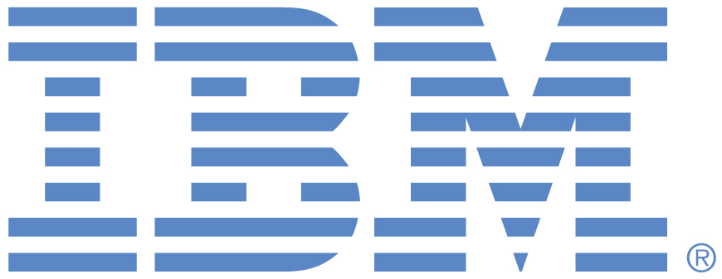 |  | CONTACTS:  Steven Tomasco, IBM  stomasc@us.ibm.com  O: 914.945.1655 C: 917.687.4588  Randy Gehl, City of Dubuque  rgehl@cityofdubuque.org  O: 563.589.4151 C: 563.599.2448

EMBARGOED UNTIL Sept. 17, 2009

IBM and Dubuque, Iowa Partner on Smarter City Initiative
City Aims to Lead in Sustainability to Drive Economic Growth
Dubuque, IA – September 17, 2009 – IBM (NYSE: IBM) and the City of Dubuque, Iowa today announced a new collaboration aimed at making this community of 60,000 one of the first “smarter” sustainable cities in the U.S.
IBM and Dubuque outlined their plans to partner in the development of new “smarter” technologies and implementation strategies to create an international model of sustainability for communities of 200,000 and under, where over 40 percent of the U.S. population resides. Dubuque, a city that is recognized as a national leader in sustainability with its forward-thinking public policy, together with IBM, will address the ever-increasing demands of cities to deliver vital services such as energy and water management, and transportation, all while reducing the community’s impact on the environment.
“The goal of this collaboration is to develop and pilot a systematic mechanism to give consumers and businesses the information they need to make informed decisions about how they consume resources like electricity, water, natural gas, and oil,” said Robert Morris, vice president, IBM Research. “To create such a mechanism, a partnership is needed between a community with a track record of successful public-private partnerships, citizens and businesses that believe in sustainability, and enterprises like IBM that have the information technology and knowledge to apply to this transformative partnership.”

Dubuque has effectively made sustainability a priority since 2006, realizing it was crucial to being economically competitive. In order to define what sustainability meant to the citizens of Dubuque, the Mayor and City Council called upon a community task force to participate in an inclusive process that resulted in a shared definition of sustainability as a community’s ability to meet the environmental, economic, and social equity needs of today without reducing the ability of future generations to meet their needs. The process also yielded the identification of 11 principles of sustainability to guide actions and policies.

New technologies are capable of digitizing and connecting city systems, so they can sense, analyze and integrate data, and respond intelligently to the needs of citizens. IBM, the City of Dubuque, along with future partners will revitalize the city’s systems to become smarter and more efficient in order to meet the city’s vision for sustainability.
“Dubuque, a town of 60,000 in northeast Iowa will create, with Smarter Planet partner IBM, a replicable model for viability, livability and equity for communities of 200,000 or less and create a sustainable legacy for generations to come,” said Dubuque Mayor Roy D. Buol. “It will also save residents and businesses money and create an international brand for this community, helping to recruit businesses and workforce, serve as a major recruitment tool for area colleges, and it will accelerate local business growth.”

"The results of this partnership will give people tools that can change how they impact the world," said Governor Chet Culver. "The State of Iowa is proud to partner in this undertaking and contribute to our global sustainability efforts."

In addition to IBM and the City of Dubuque, the current partnership is planned to include local and regional private businesses, non-profit organizations, local and state government agencies, and several federal agencies. The first phase of the smart city partnership includes two projects to enhance the city’s and its citizens’ understanding of their energy consumption and water management, in order to reduce costs and the overall carbon footprint. To accomplish this, IBM will build a Platform for Real-time Integrated Sustainability Monitoring to provide the city with an integrated view of its energy management, including energy consumed by the electric grid, water system, and general city services.

The City is currently implementing a city-wide water meter replacement project and has worked with local manufacturer A.Y. McDonald to integrate a device called an Unmeasured Flow Reducer (UFR). This locally manufactured device is designed to augment the water meter in providing the most accurate measurement possible during low-flow use. The new system will allow consumers to identify waste and consider corrective measures which will translate into better water utilization and energy savings. Reduction in water use will reduce use of both energy and chemicals, resulting in significant savings. As the City of Dubuque enhances its water management system, IBM’s technology will interface with the water systems to ingest water consumption data and give city staff real-time visibility into the overall city water consumption. IBM Research plans to also build new service systems integration, data management, and analytic technologies that will create new insights for consumers and city policymakers.

According to surveys, 30 percent of households have water leaks (leaky faucet, toilet, etc.). The new system will allow consumers and the City Water Department to identify waste and promote changed behavior which will translate into better water utilization and energy savings. As part of the water meter replacement project, the City of Dubuque is creating a rebate program for costs associated with repairing leaks identified by the new metering system. The City will budget $10,000 annually for matching funds to fix leaks and reduce costs for water customers.

On August 25, IBM and leaders of Iowa's business and governmental communities officially opened a new IBM technology services delivery center -- located in the historic Roshek Building in downtown Dubuque, Iowa. IBM has hired several hundred people to work in the new facility and intends to employ up to 1,300 people there by the end of 2010.
The new facility joined an extensive network of more than 80 IBM delivery centers worldwide where employees maintain, monitor and support computer hardware, software and manage information technology services for thousands of IBM clients.
The opening of IBM's technology services delivery center in Dubuque is a milestone in the ongoing renaissance of the Midwestern city. A model for 21st century economic development, Dubuque was recently awarded the 2009 Excellence in Economic Development Award by U.S. Commerce Secretary Gary Locke for its commitment to research-based, market driven economic development. The U.S. Conference of Mayors named Dubuque the 2008 "Most Livable Small City" in the nation -- for attributes that include historical architecture, diverse arts and cultural amenities, abundant natural beauty, a skilled and educated workforce, and numerous quality private and public institutions of higher learning.
A new report from the IBM Institute for Business Value, “A Vision of Smarter Cities”, makes the case that cities must use new technologies to transform their systems to optimize the use of finite resources. As sustainability for cities and the planet becomes ever more important, the question isn't whether cities will do this; the question is: Which ones are doing it first? And, who will do it best?
Note to registered journalists and bloggers: To view and download b-roll in broadcast or streaming quality, please go to: http://www.thenewsmarket.com/ibm.

For more information, please visit: www.ibm.com/smartercities and www.sustainabledubuque.org.
# # #

