

This is to certify that

***«First_Name» «Last_Name»***

Has satisfactorily completed an ICMA University Workshop in

# Optimizing the Organization: If You Don’t Know Where Your’re Going, Will Alternative Service Delivery Get You There?

July 27, 2017

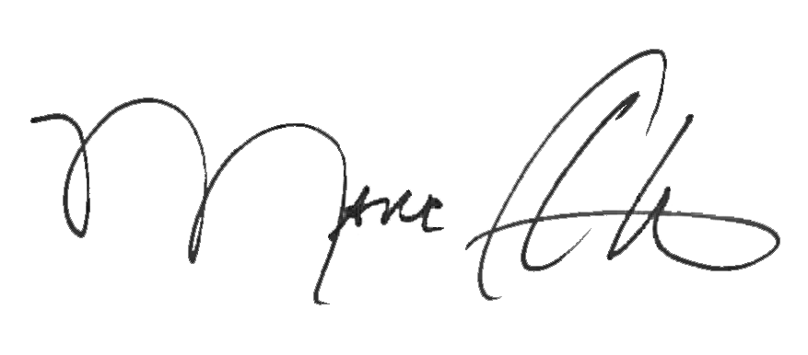



_______________________________ _______________________________

Marc A. Ott Felicia C. Logan

ICMA Executive Director ICMA Leadership Development